**Data Validation of**

**‘HR Data Analysis’**

**Project**

Data validation is the process in which we cross-checked the output numerical values of every visualization chart in a dashboard created for data analysis. To perform data validation for the project ‘HR data Analysis’, we have implemented 140+ advanced SQL queries that were executed using the tool PostgreSQL database management system.

In this document, we included all the 140+ Advance SQL queries and respective outputs, along with the screenshots of all the respective visualization charts in the ‘HR data Analysis’.

This report proofs that every derived numerical values on the ‘HR data analysis’ dashboard is accurate and valid, and do not consists any kind of error in it.

**Preparation:**

To perform data validation for the project, we need to perform a couple of preparation steps. We built our project in Microsoft Power BI, and now we are using the PostgreSQL database to perform data validation using SQL.

Therefore, we need our source data in the PostgreSQL. Hence, we imported the data (tables) from the data model built in the Power BI, into the PostgreSQL database and build the relational data model.

Once we done with this, now we are ready to go and execute the list of queries to perform data validation for every visualization.

**For Dashboard Page- ‘Employees’**

**Note:**

For a set of queries, we have referred to a CTE named “hr”.

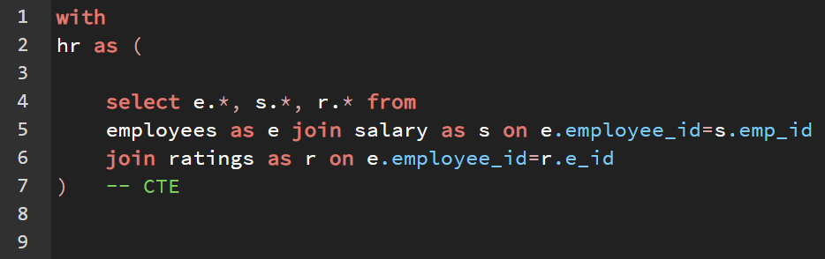

Query-

*with*

*hr as (*

*select e.*, s.*, r.* from*

*employees as e join salary as s on e.employee_id=s.emp_id*

*join ratings as r on e.employee_id=r.e_id*

*)*

* **KPIs**

**For Current Employees**

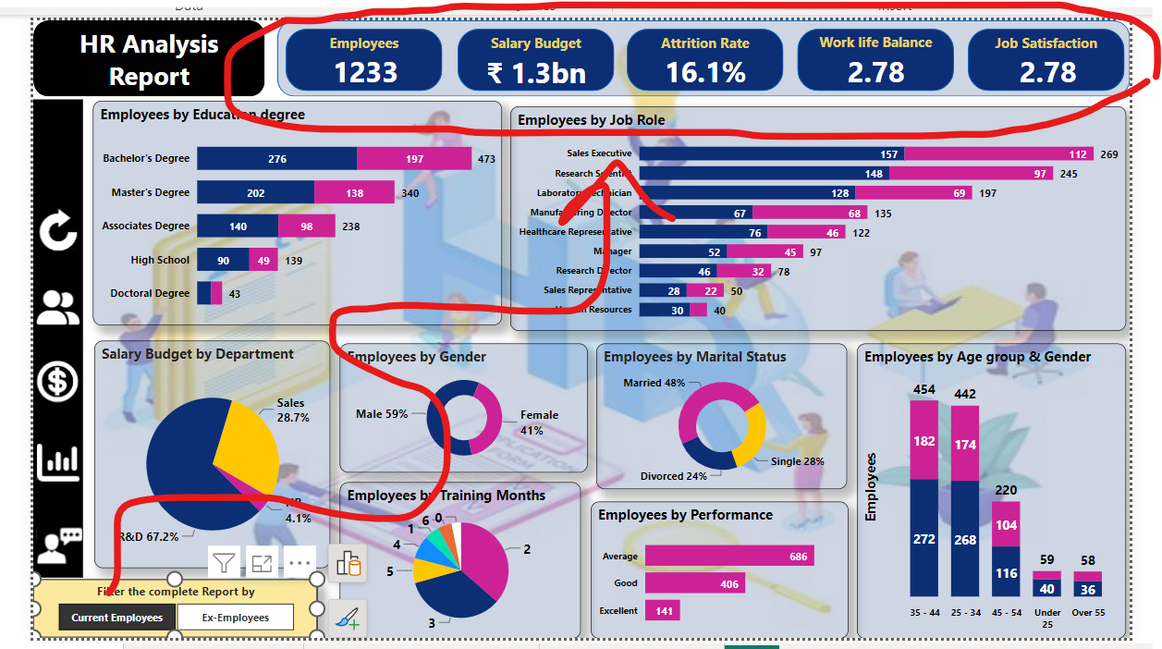

*-- Salary budget for current emp*

*select round(sum(hr.yearly_package_rs)/1000000000, 2) as salary_budget*

*from hr*

*where hr.attrition_label = 'Current Employees';*

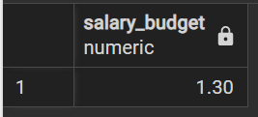

*-- count of current employees*

*select 'Current employees' as employee_status, count(hr.emp_id) from hr*

*where hr.attrition_label = 'Current Employees';*

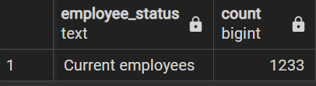

*-- avg rating of work life balance for current employees*

*select 'work life balance',*

*round(avg(hr.work_life_balance_rating) , 2 ) as avgg_rating from hr*

*where hr.attrition_label = 'Current Employees';*

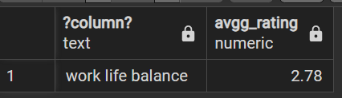

*-- avg rating of job satisfaction for current employees*

*select 'job satisfaction' ,*

*round(avg(hr.job_satisfaction_rating),2 ) as avgg_rating from hr*

*where hr.attrition_label = 'Current Employees';*

**

*t1 as(*

*select count(hr.emp_id) all_e from hr*

*),*

*t2 as(*

*select count(hr.emp_id) x_e from hr*

*where hr.attrition = 'Yes'*

*)*

*select ‘attrition %’, (x_e/all_e)*100 as outputt from t1, t2;*

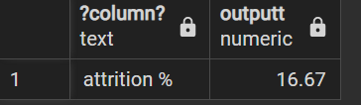

**For Ex-Employees**

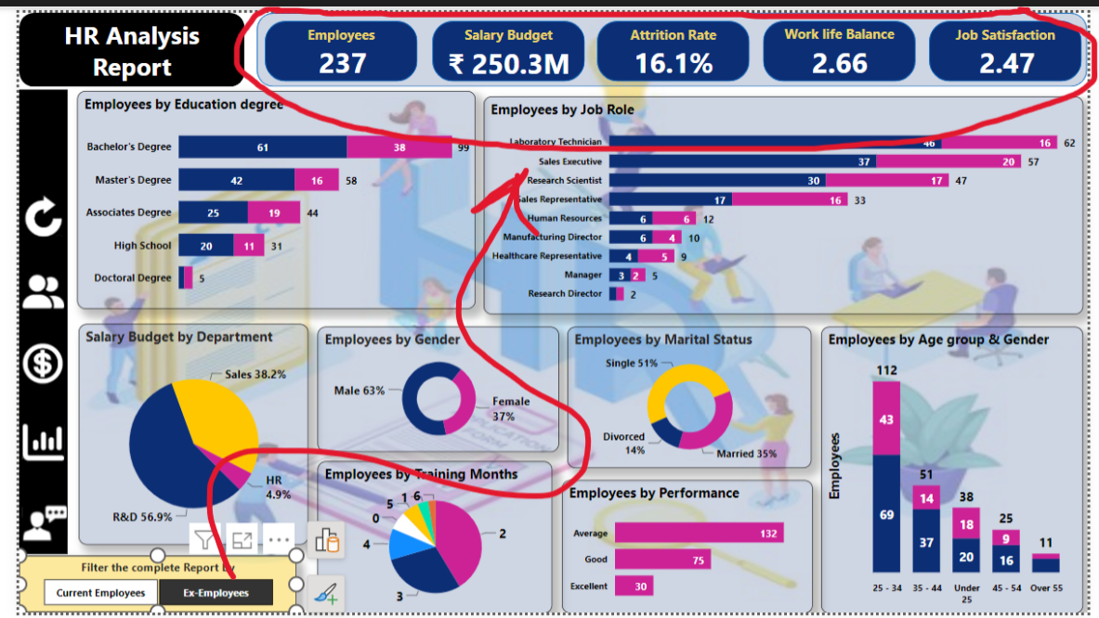

*-- Salary Budget for Ex-emp*

*select round(sum(hr.yearly_package_rs)/1000000, 2) as salary_budget_mn*

*from hr*

*where hr.attrition_label = 'Ex-Employees';*

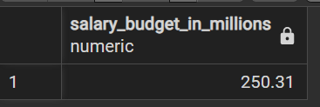

*-- employees count*

*Select ‘Ex employees' as employee_status, count(hr.emp_id) from hr*

*where hr.attrition_label = 'Current Employees';*

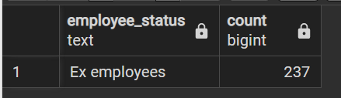

*-- avg rating of work life balance for Ex-employees*

*select 'work life balance' as rating,*

*round(avg(hr.work_life_balance_rating) , 2 ) as avgg_rating from hr*

*where hr.attrition_label = 'Ex-Employees';*

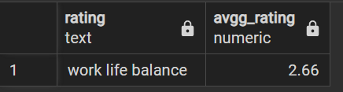

*-- avg rating of job satisfaction for EX-employees*

*select 'job satisfaction' ,*

*round(avg(hr.job_satisfaction_rating),2 ) as avgg_rating from hr*

*where hr.attrition_label = 'Ex-Employees';*

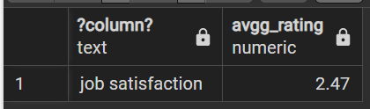

* **Employees by Education degree**

**for current employees**

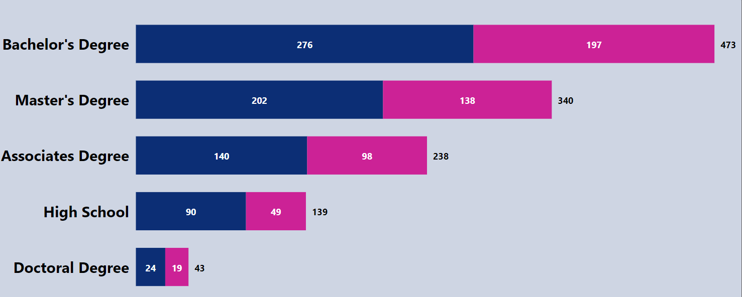

Note: Use the below CTE with ‘hr’ CTE

*female as*

*(*

*select hr.education ed, count(*) as female_countt*

*from hr*

*where hr.attrition ='No' and hr.gender ='Female'*

*group by hr.education*

*order by female_countt desc*

*),*

*male as*

*(*

*select hr.education ed, count(*) as male_countt*

*from hr*

*where hr.attrition ='No' and hr.gender ='Male'*

*group by hr.education*

*order by male_countt desc*

*) ,*

*j as*

*(*

*select male.ed Education, male.male_countt male, female.female_countt female*

*from*

*male join female on male.ed = female.ed*

*)*

*select *, ( j.male + j.female ) as Total*

*from j*

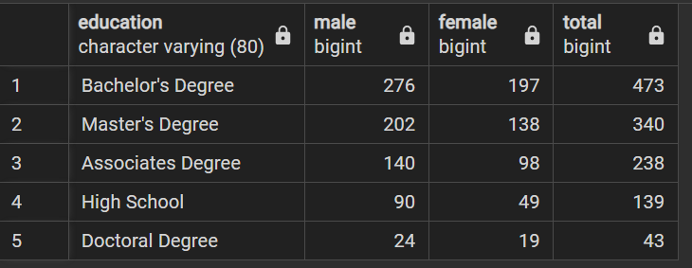

**for Ex-employees**

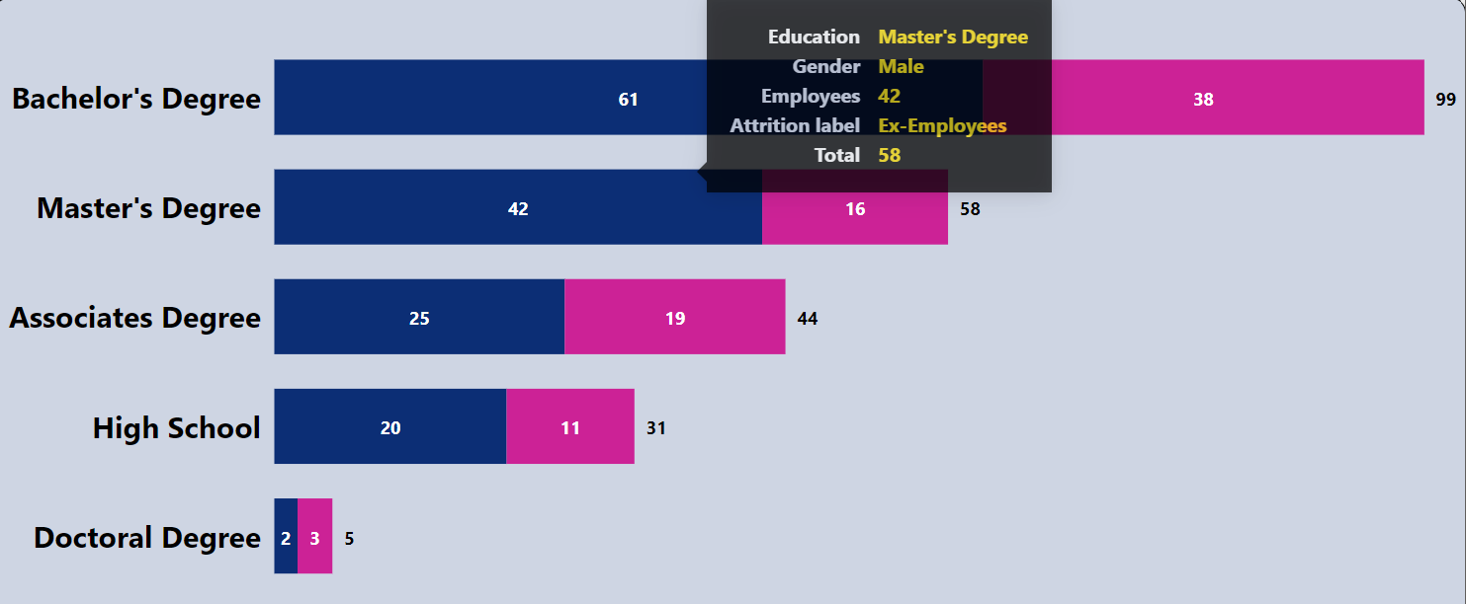

*female as*

*(*

*select hr.education ed, count(*) as female_countt*

*from hr*

*where hr.attrition ='Yes' and hr.gender ='Female'*

*group by hr.education*

*order by female_countt desc*

*),*

*male as*

*(*

*select hr.education ed, count(*) as male_countt*

*from hr*

*where hr.attrition ='Yes' and hr.gender ='Male'*

*group by hr.education*

*order by male_countt desc*

*),*

*j as*

*(*

*select male.ed Education, male.male_countt male, female.female_countt female*

*from*

*male join female on male.ed = female.ed*

*)*

*select *, ( j.male + j.female ) as Total*

*from j;*

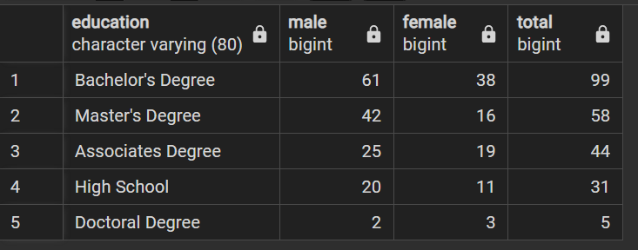

* **Employees by Job roles**

**for current employees**

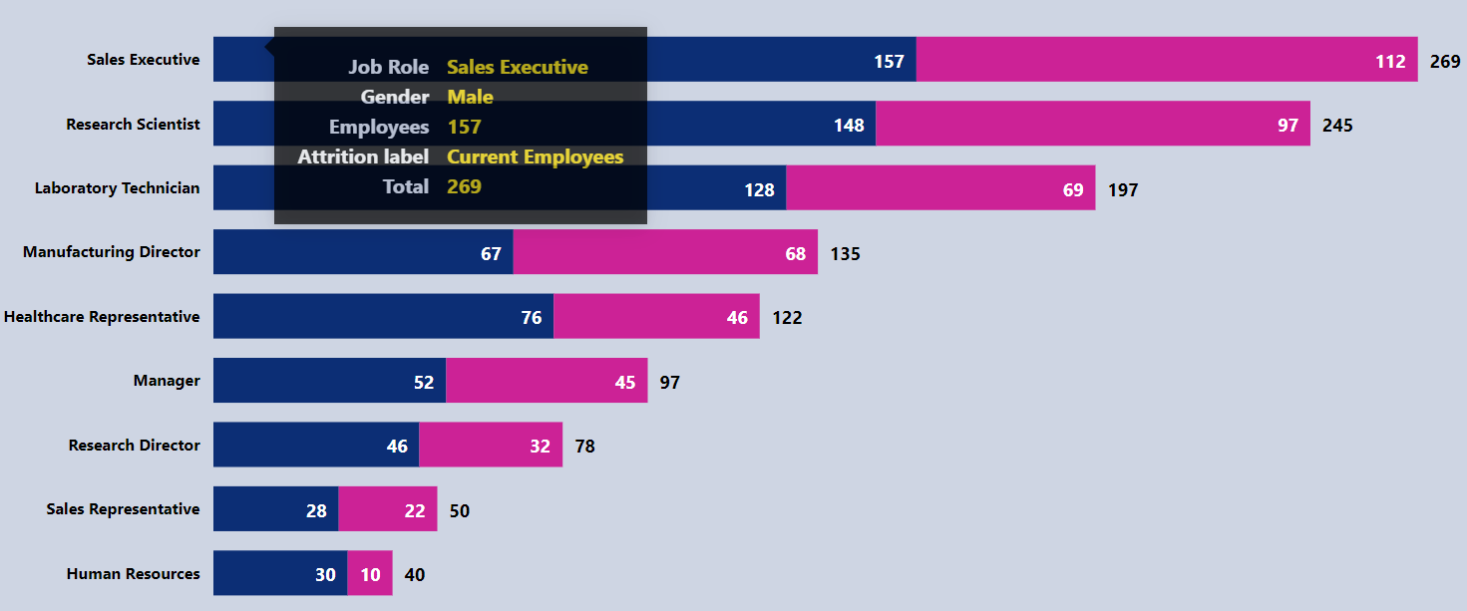

-- For current employees

*with*

*male as (*

*select job_role roles, count(*) males from employees*

*where*

*gender = 'Male' and attrition = 'No'*

*group by job_role*

*),*

*female as(*

*select job_role roles, count(*) females from employees*

*where*

*gender = 'Female' and attrition = 'No'*

*group by job_role*

*),*

*joint as*

*(*

*select male.*, female.females from*

*male join female on male.roles = female.roles*

*)*

*select *, (joint.males + joint.females) as Total*

*from joint*

*order by Total desc;*

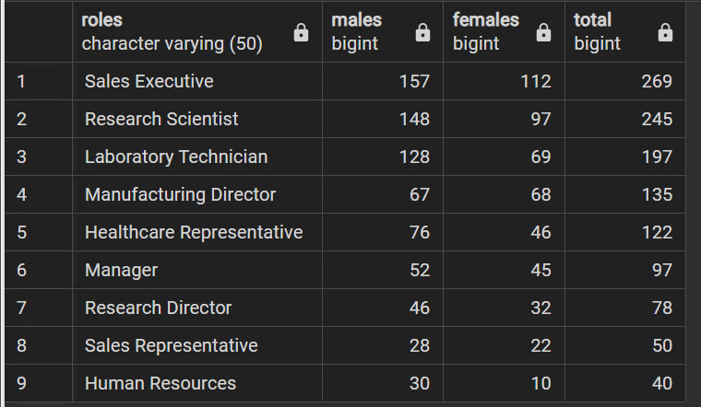

**for Ex-employees**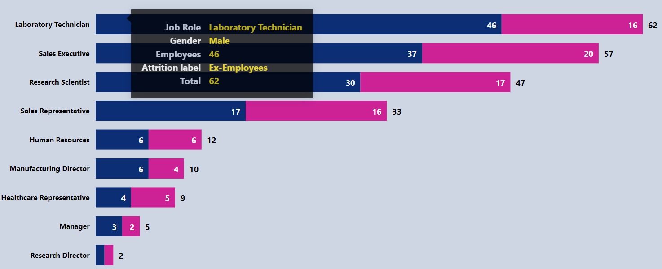

*with*

*male as (*

*select job_role roles, count(*) males from employees*

*where*

*gender = 'Male' and attrition = 'Yes'*

*group by job_role*

*),*

*female as(*

*select job_role roles, count(*) females from employees*

*where*

*gender = 'Female' and attrition = 'Yes'*

*group by job_role*

*),*

*joint as*

*(*

*select male.*, female.females from*

*male join female on male.roles = female.roles*

*)*

*select *, (joint.males + joint.females) as Total*

*from joint*

*order by Total desc;*

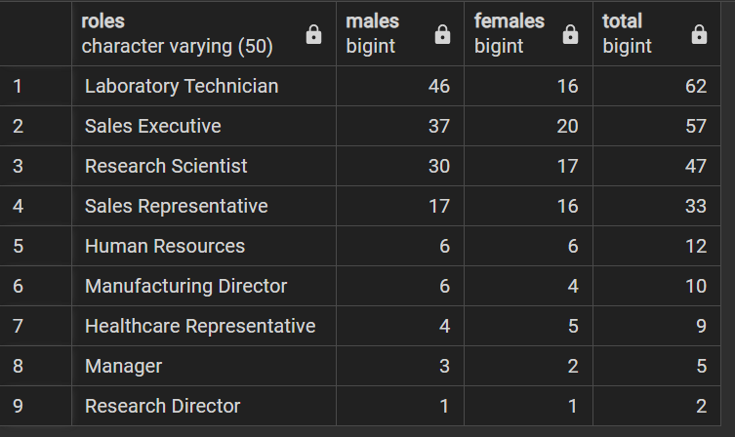

* **Salary Budget by Departments**

**For Current employees**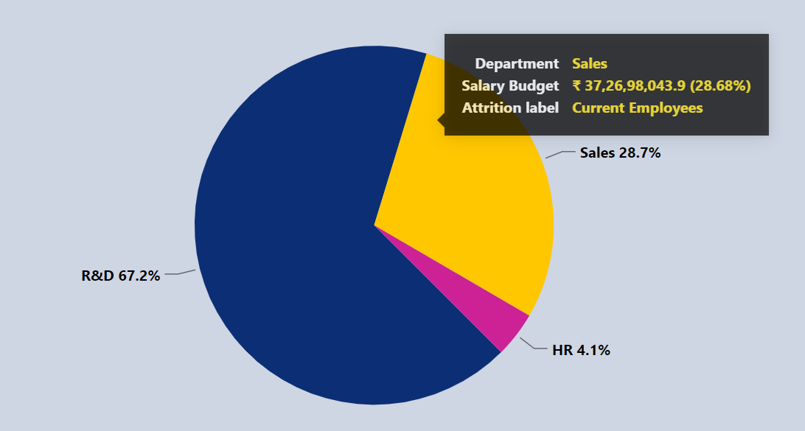

*-- For current Employees*

*with*

*tbl as*

*(*

*select e.employee_id as eid, e.department, s.yearly_package_rs as pkg*

*from employees as e join salary as s*

*on e.employee_id=s.emp_id*

*where e.attrition = 'No'*

*),*

*allbudget as(*

*select sum(pkg) as alll from tbl*

*),*

*d as (*

*select department, sum(pkg) as dept from tbl*

*group by department*

*)*

*select d.department as departments, round((d.dept / allbudget.alll)*100, 2) budget_percent*

*from d, allbudget*

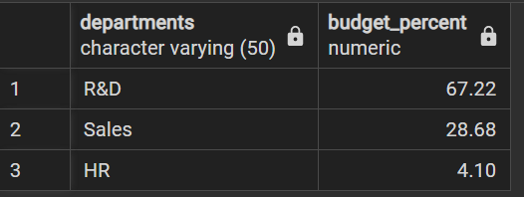

**For Ex-Employees** 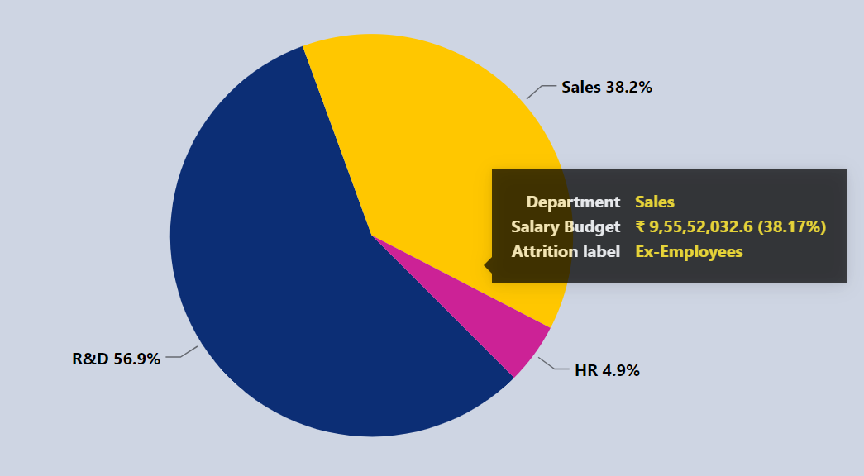

*-- For Ex-employees*

*with*

*tbl as*

*(*

*select e.employee_id as eid, e.department, s.yearly_package_rs as pkg*

*from employees as e join salary as s*

*on e.employee_id=s.emp_id*

*where e.attrition = 'Yes'*

*),*

*allbudget as(*

*select sum(pkg) as alll from tbl*

*),*

*d as (*

*select department, sum(pkg) as dept from tbl*

*group by department*

*select d.department as departments, round((d.dept / allbudget.alll)*100, 2) budget_percent*

*from d, allbudget;*

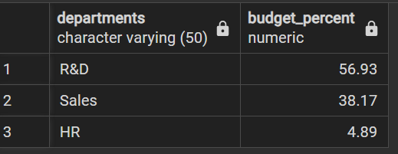

* **Employees by gender**

**For Current Employees**

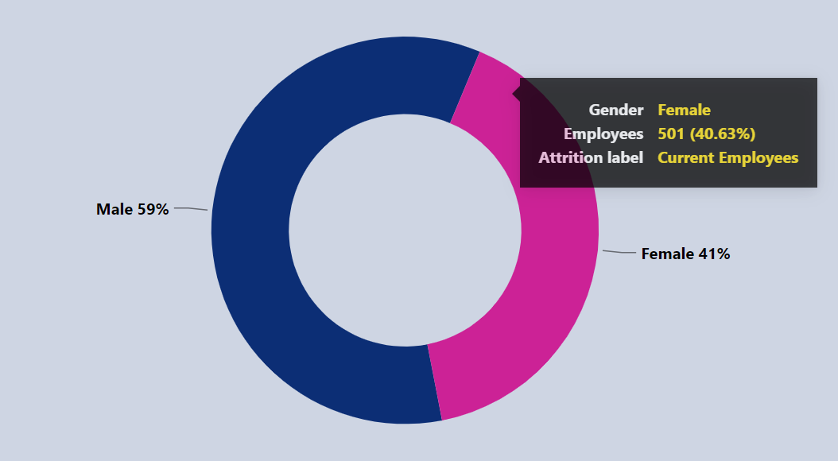

*-- For current employees*

*with*

*total as(*

*select count(*)*1.0 as allcount from employees*

*where attrition_label = 'Current Employees'*

*),*

*eachh as(*

*select gender, count(*)*1.0 as empcount from employees*

*where attrition_label = 'Current Employees'*

*group by gender*

*)*

*select eachh.*, round((eachh.empcount/total.allcount)*100, 2) as emp_percent*

*from eachh, total ;*

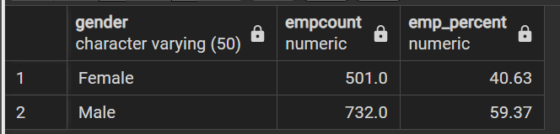

**For Ex-Employees**

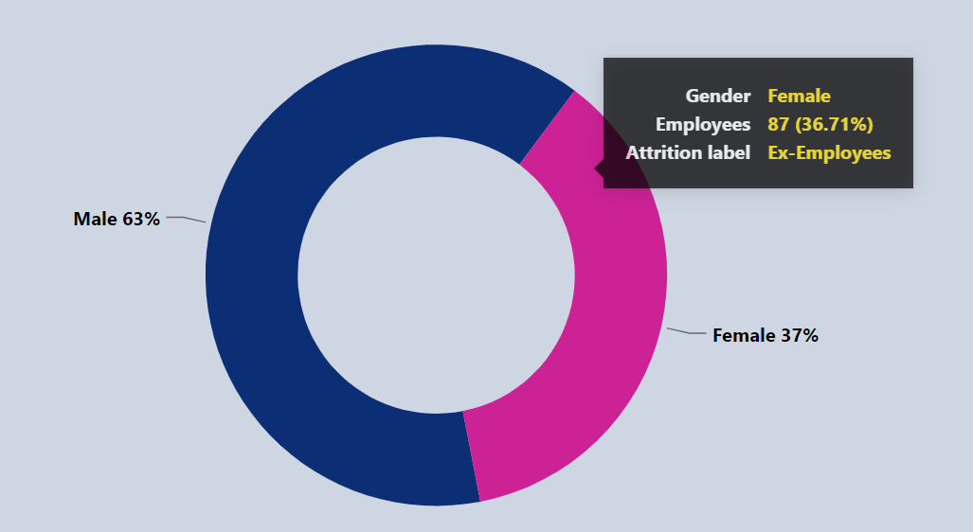

*-- For Ex-employees*

*with*

*total as(*

*select count(*)*1.0 as allcount from employees*

*where attrition_label = 'Ex-Employees'*

*),*

*eachh as(*

*select gender, count(*)*1.0 as empcount from employees*

*where attrition_label = 'Ex-Employees'*

*group by gender*

*)*

*select eachh.*, round((eachh.empcount/total.allcount)*100, 2) as emp_percent*

*from eachh, total;*

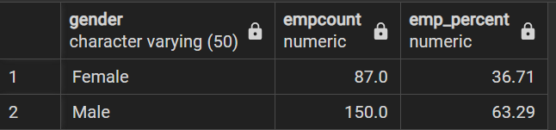

* **Employees by Training months**

**For Current Employees**

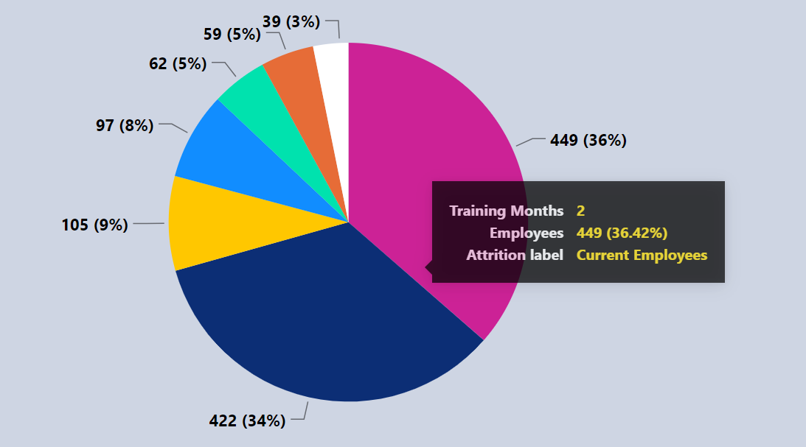

*-- For current employees*

*with*

*tbl as (*

*select e.employee_id as ids, s.training_months as Training_months, e.attrition_label as al*

*from*

*employees as e join salary as s on e.employee_id = s.emp_id*

*where e.attrition_label ='Current Employees'*

*),*

*total as(*

*select count(*)*1.0 as tcount from tbl*

*),*

*eachh as(*

*select tbl.Training_months, count(*) as empcount from tbl*

*where tbl.al = 'Current Employees'*

*group by tbl.Training_months*

*)*

*select eachh.*, round(((eachh.empcount*1.0)/total.tcount)*100, 2) as emp_percent*

*from eachh, total*

*order by emp_percent desc;*

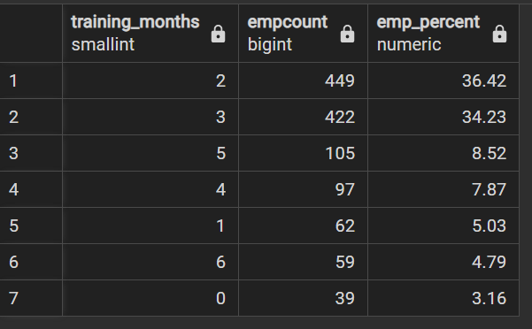

**For Ex-Employees**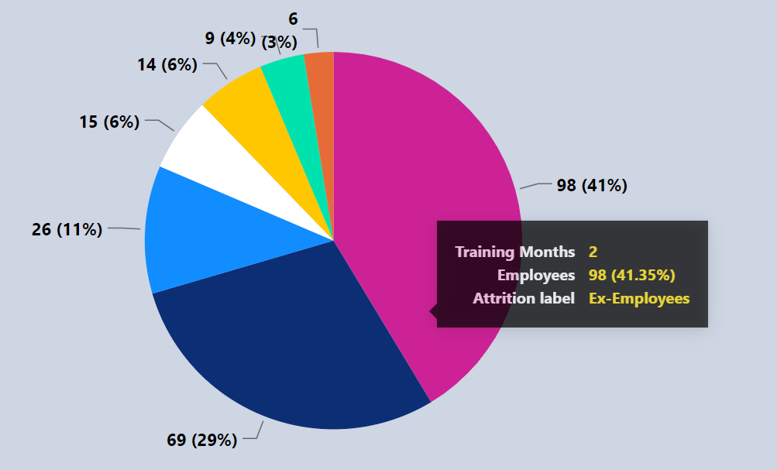

*-- For Ex-employees*

*with*

*tbl as (*

*select e.employee_id as ids, s.training_months as Training_months, e.attrition_label as al*

*from*

*employees as e join salary as s on e.employee_id = s.emp_id*

*where e.attrition_label ='Ex-Employees'*

*),*

*total as(*

*select count(*)*1.0 as tcount from tbl*

*),*

*eachh as(*

*select tbl.Training_months, count(*) as empcount from tbl*

*where tbl.al = 'Ex-Employees'*

*group by tbl.Training_months*

*)*

*select eachh.*, round(((eachh.empcount*1.0)/total.tcount)*100, 2) as emp_percent*

*from eachh, total*

*order by emp_percent desc;*

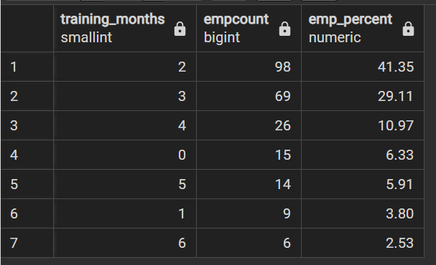

* **Employees by Marital Status**

**For Current Employees**

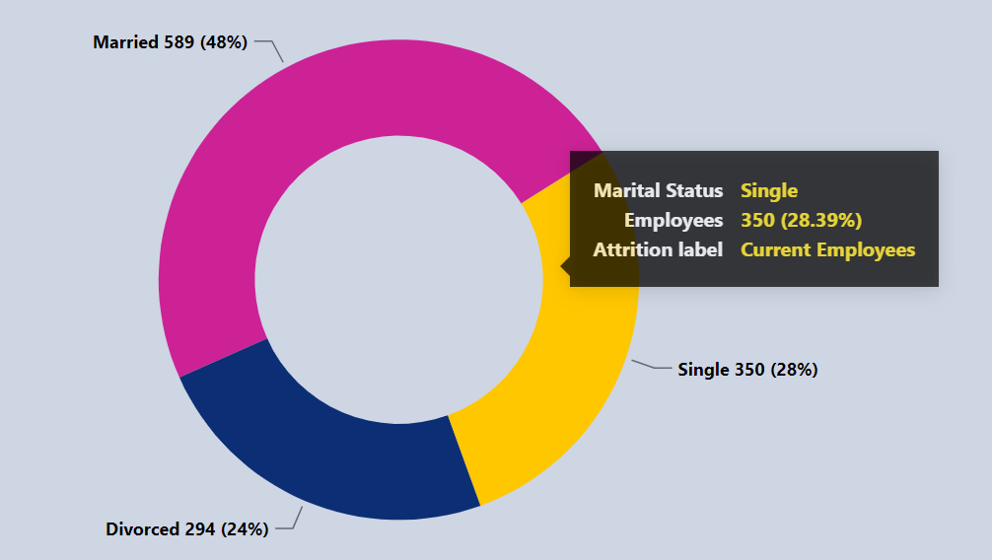

*-- For Current employees*

*with*

*tbl as (*

*select e.employee_id as ids, s.marital_status as status, e.attrition_label as al*

*from*

*employees as e join salary as s on e.employee_id = s.emp_id*

*where e.attrition_label ='Current Employees'*

*),*

*total as(*

*select count(*)*1.0 as tcount from tbl*

*),*

*eachh as(*

*select tbl.status, count(*) as empcount from tbl*

*where tbl.al = 'Current Employees'*

*group by tbl.status*

*)*

*select eachh.*, round(((eachh.empcount*1.0)/total.tcount)*100, 2) as emp_percent*

*from eachh, total*

*order by emp_percent desc;*

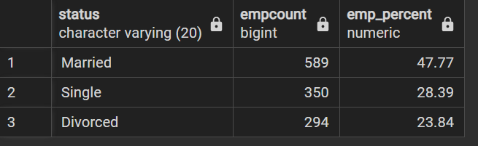

**For Ex-Employees**

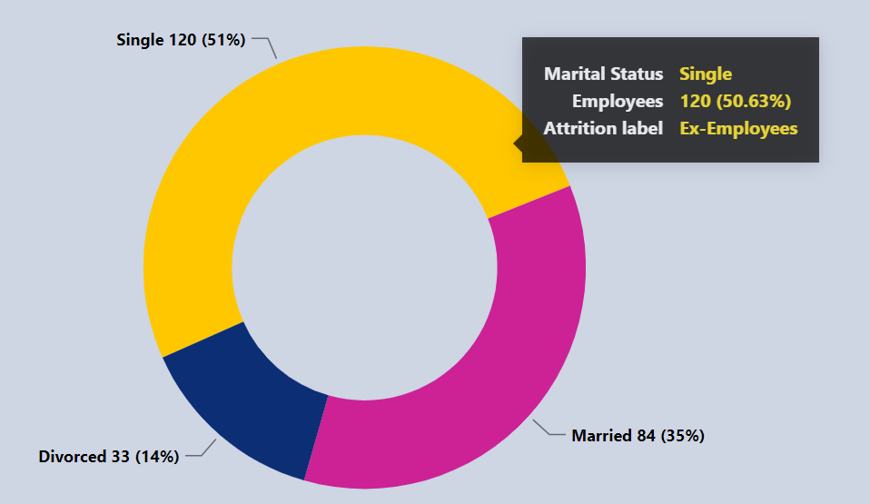

*-- For Ex-employees*

*with*

*tbl as (*

*select e.employee_id as ids, s.marital_status as status, e.attrition_label as al*

*from*

*employees as e join salary as s on e.employee_id = s.emp_id*

*where e.attrition_label ='Ex-Employees'*

*),*

*total as(*

*select count(*)*1.0 as tcount from tbl*

*),*

*eachh as(*

*select tbl.status, count(*) as empcount from tbl*

*group by tbl.status*

*)*

*select eachh.*, round(((eachh.empcount*1.0)/total.tcount)*100, 2) as emp_percent*

*from eachh, total*

*order by emp_percent desc;*

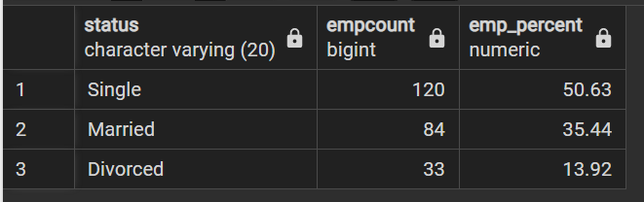

* **Employees by Performance**

**For Current Employees**

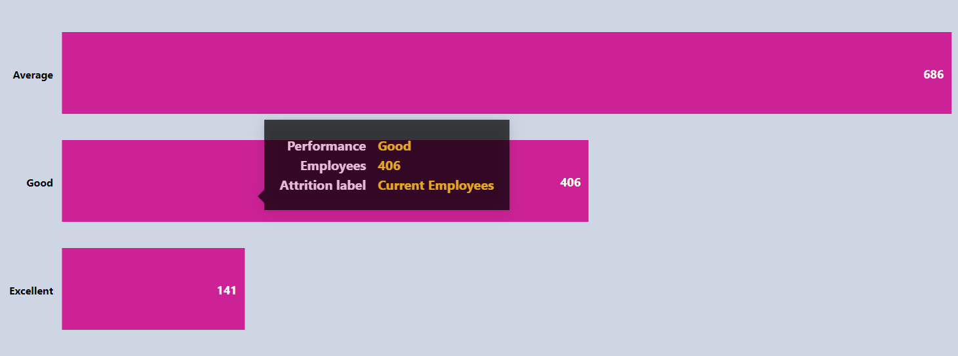

*--For Current Employees*

*with*

*tbl as (*

*select e.employee_id as ids, s.performance as pp, e.attrition_label as al*

*from*

*employees as e join salary as s on e.employee_id = s.emp_id*

*where e.attrition_label ='Current Employees'*

*)*

*select tbl.pp as performance, count(*) as empcount from tbl*

*group by performance*

*order by empcount desc;*

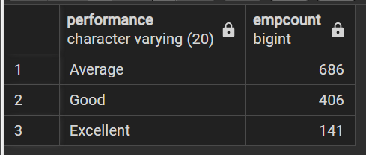

**For Ex-Employees**

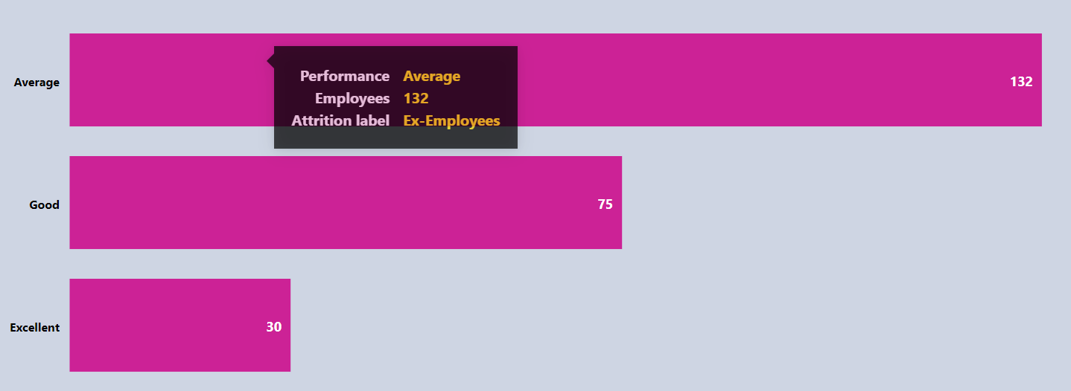

*--For Ex-Employees*

*with*

*tbl as (*

*select e.employee_id as ids, s.performance as pp, e.attrition_label as al*

*from*

*employees as e join salary as s on e.employee_id = s.emp_id*

*where e.attrition_label ='Ex-Employees'*

*)*

*select tbl.pp as performance, count(*) as empcount from tbl*

*group by performance*

*order by empcount desc;*

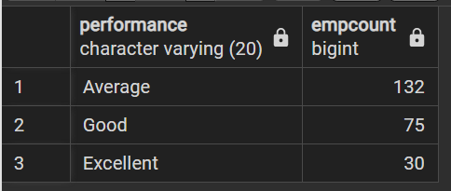

* **Employees by Age group & gender**

**For Current Employees**

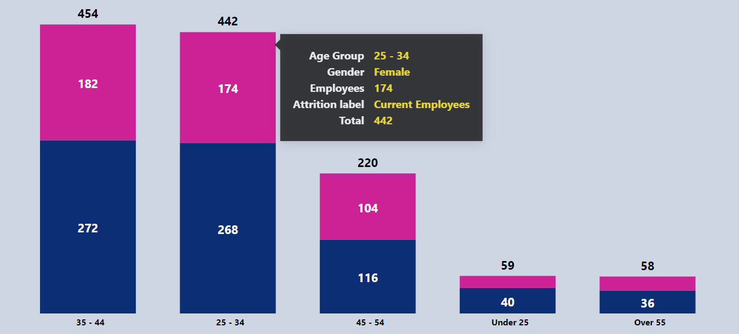

*--For Current Employees*

*with*

*males as (*

*select age_group as ag, count(*) as male*

*from employees*

*where attrition_label ='Current Employees' and gender = 'Male'*

*group by ag*

*),*

*females as (*

*select age_group as ag, count(*) as female*

*from employees*

*where attrition_label ='Current Employees' and gender = 'Female'*

*group by ag*

*),*

*joint as(*

*select m.*, f.female*

*from males as m join females as f*

*on m.ag = f.ag*

*)*

*select *, (male+female) as totalcount*

*from joint*

*order by totalcount desc;*

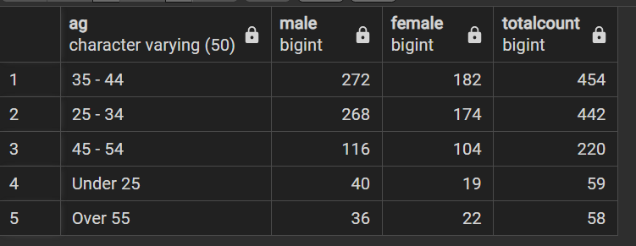

**For Ex-Employees**

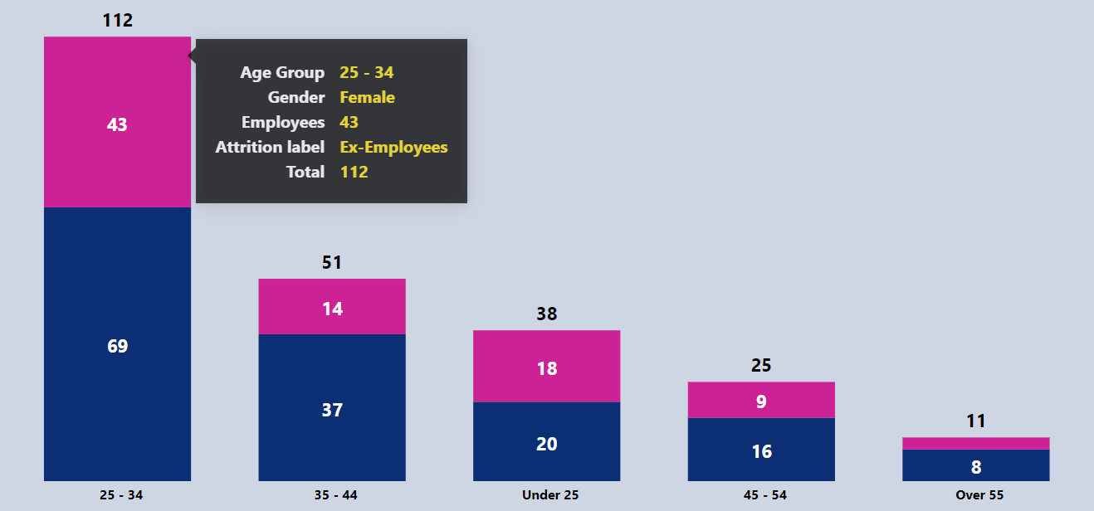

*--For Ex-Employees*

*with*

*males as (*

*select age_group as ag, count(*) as male*

*from employees*

*where attrition_label ='Ex-Employees' and gender = 'Male'*

*group by ag*

*),*

*females as (*

*select age_group as ag, count(*) as female*

*from employees*

*where attrition_label ='Ex-Employees' and gender = 'Female'*

*group by ag*

*),*

*joint as(*

*select m.*, f.female*

*from males as m join females as f*

*on m.ag = f.ag*

*)*

*select *, (male+female) as totalcount*

*from joint*

*order by totalcount desc;*

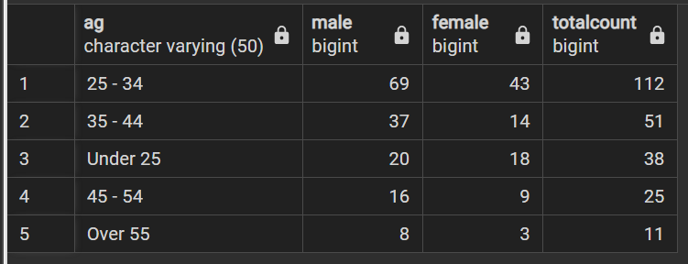

**For Dashboard Page- ‘Salary and Payouts’**

* **KPIs for Salary & Payouts**

**For Current Employees** 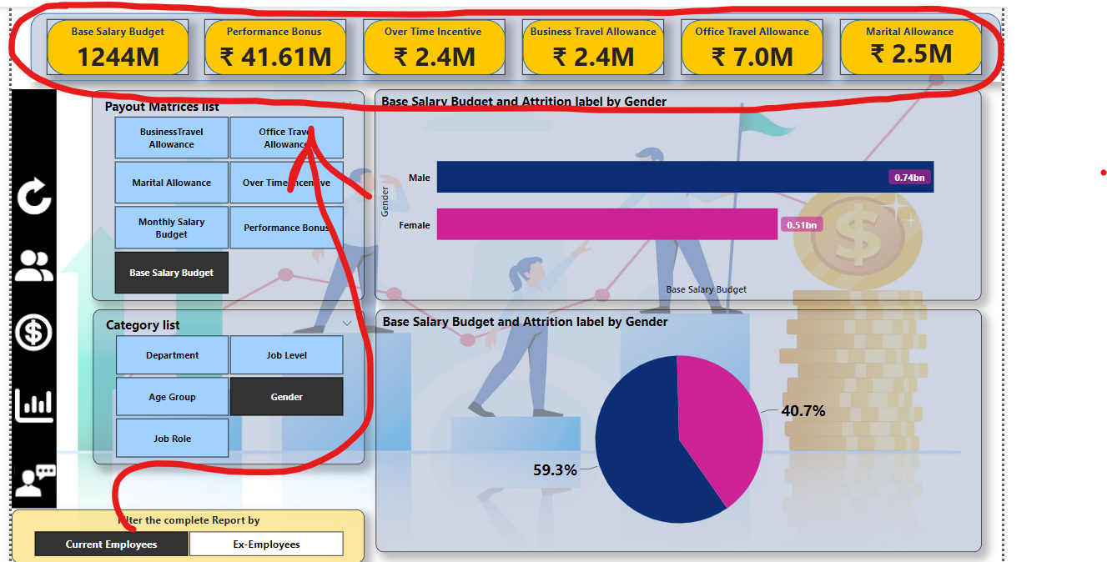

*-- For Current Employees*

*select 'base_salary_budget' as KPI,*

*round(sum(yearly_salary_rs)/1000000, 0) as Value_in_Millions*

*from hr*

*where attrition_label = 'Current Employees';*

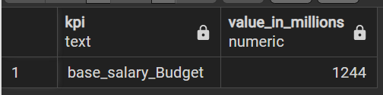

*-- For Current Employees*

*select 'Performance_bonus_Budget' as KPI,*

*round(sum(performance_bonus_rs)/1000000, 1) as Value_in_Millions*

*from hr*

*where attrition_label = 'Current Employees';*

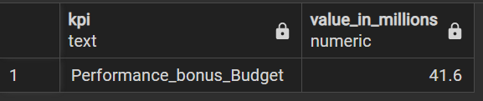

*-- For Current Employees*

*select 'over_time_incentive_Budget' as KPI,*

*round(sum(over_time_incentive_rs)/1000000, 1) as Value_in_Millions*

*from hr*

*where attrition_label = 'Current Employees';*

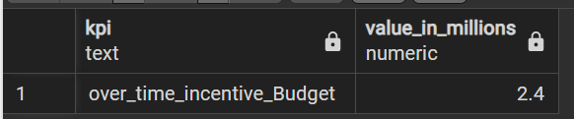

*-- For Current Employees*

*select 'business_travel_allowance_Budget' as KPI,*

*round(sum(business_travel_allowance_rs)/1000000, 1) as Value_in_Millions*

*from hr*

*where attrition_label = 'Current Employees’;*

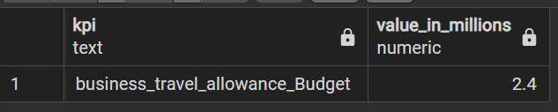

*-- For Current Employees*

*select 'office_travel_allowance_Budget' as KPI,*

*round(sum(office_travel_allowance_rs)/1000000, 1) as Value_in_Millions*

*from hr*

*where attrition_label = 'Current Employees';*

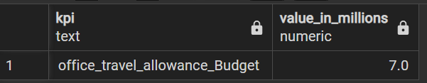

*-- For Current Employees*

*select 'marital_allowance_Budget' as KPI,*

*round(sum(marital_allowance_rs)/1000000, 1) as Value_in_Millions*

*from hr*

*where attrition_label = 'Current Employees';*

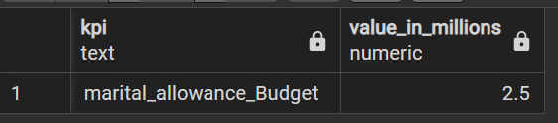

**For Ex-Employees** 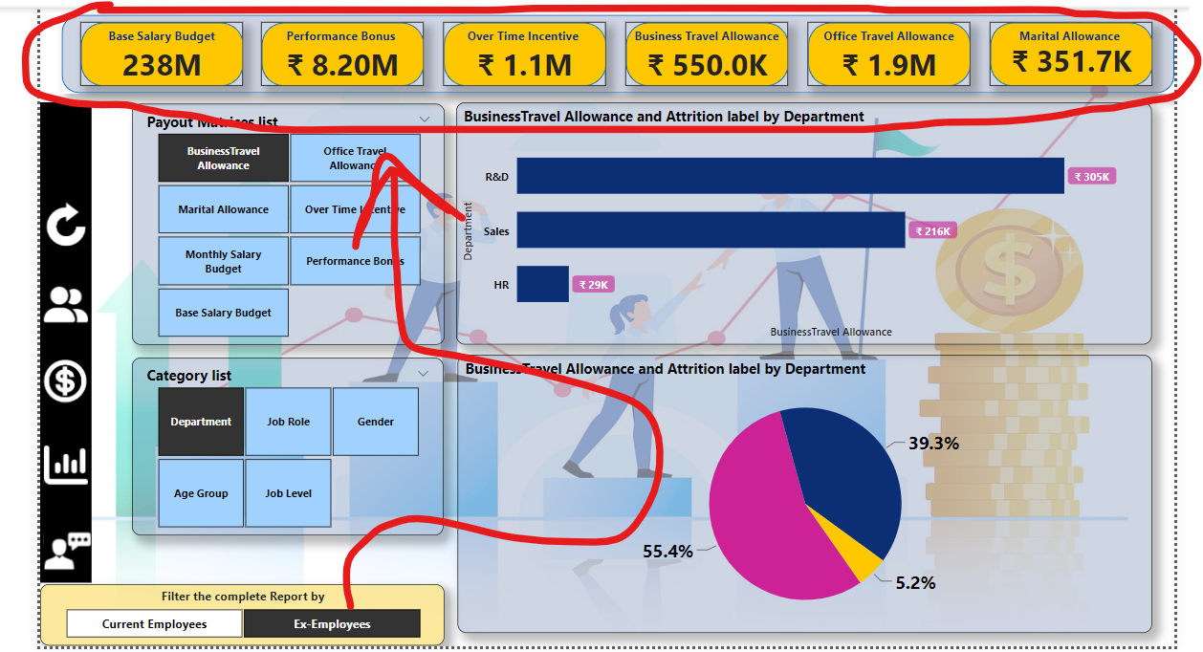

*-- For Ex-Employees*

*select 'base_salary_budget' as KPI,*

*round(sum(yearly_salary_rs)/1000000, 0) as Value_in_Millions*

*from hr*

*where attrition_label = ‘Ex-Employees';*

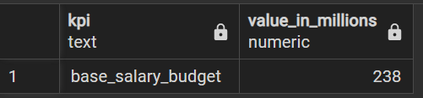

*-- For Ex-Employees*

*select 'Performance_bonus_Budget' as KPI,*

*round(sum(performance_bonus_rs)/1000000, 1) as Value_in_Millions*

*from hr*

*where attrition_label = 'Ex-Employees';*

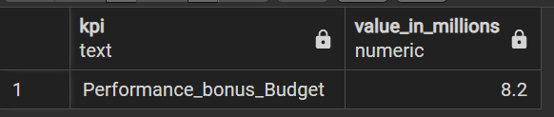

*-- For Ex-Employees*

*select 'over_time_incentive_Budget' as KPI,*

*round(sum(over_time_incentive_rs)/1000000, 1) as Value_in_Millions*

*from hr*

*where attrition_label = 'Ex-Employees';*

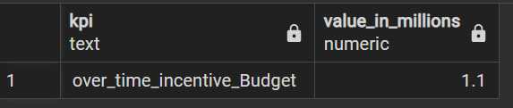

*-- For Ex-Employees*

*select 'business_travel_allowance_Budget' as KPI,*

*round(sum(business_travel_allowance_rs)/1000, 1) as Value_in_k*

*from hr*

*where attrition_label = 'Ex-Employees'*



*-- For Ex-Employees*

*select 'office_travel_allowance_Budget' as KPI,*

*round(sum(office_travel_allowance_rs)/1000000, 1) as Value_in_Millions*

*from hr*

*where attrition_label = 'Ex-Employees';*

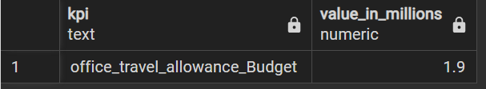

*-- For Current Employees*

*select 'marital_allowance_Budget' as KPI,*

*round(sum(marital_allowance_rs)/1000, 1) as Value_in_k*

*from hr*

*where attrition_label = 'Ex-Employees';*

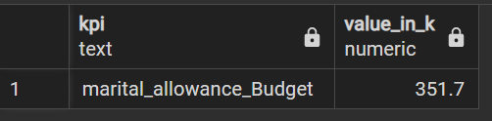

**Payout Matrix by a Specific Category**

Note: Refer to ‘hr’ CTE

* **Business Travel allowance**

1. Business Travel allowance by Age group

**For Current Employees**

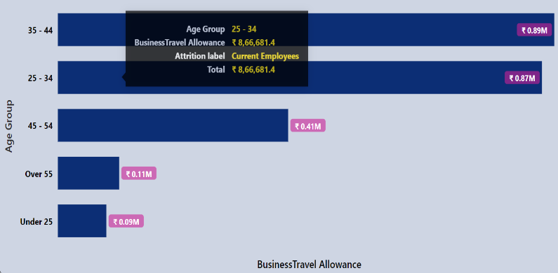

*-- for Current Employees*

*select age_group as category,*

*round(sum(business_travel_allowance_rs)/1000000 ,2) as amount_in_Million,*

*round(sum(business_travel_allowance_rs)/1000 ,2) as amount_in_k*

*from hr*

*where attrition_label = 'Current Employees'*

*group by category*

*order by amount_in_Million desc;*

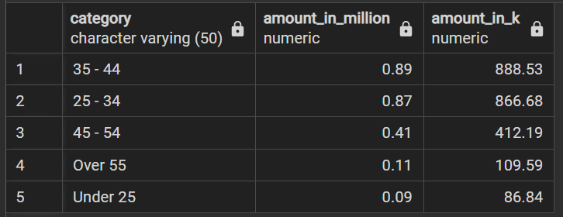

**For Ex-Employees**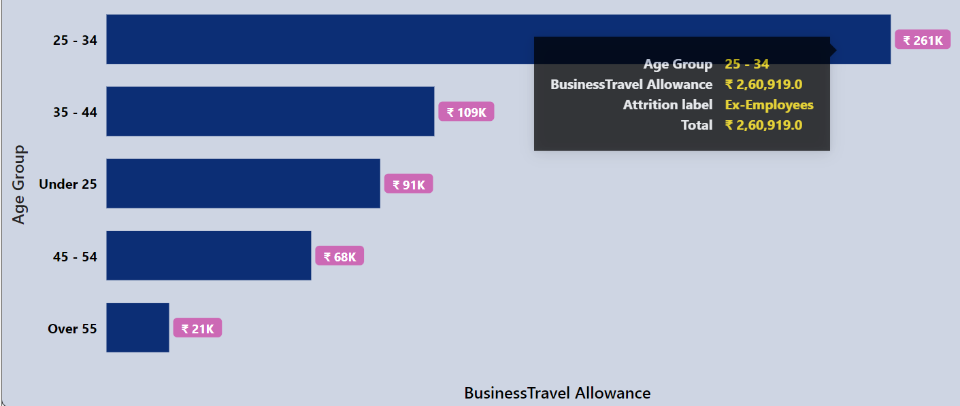

*-- for Ex-Employees*

*select age_group as category,*

*round(sum(business_travel_allowance_rs)/1000000 ,2) as amount_in_Million,*

*round(sum(business_travel_allowance_rs)/1000 ,2) as amount_in_k*

*from hr*

*where attrition_label = 'Ex-Employees'*

*group by category*

*order by amount_in_Million desc;*

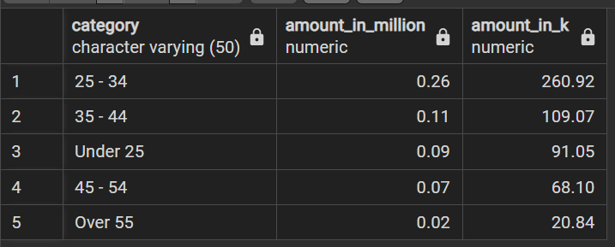

1. Business Travel Allowance by Gender

**For Current Employees**

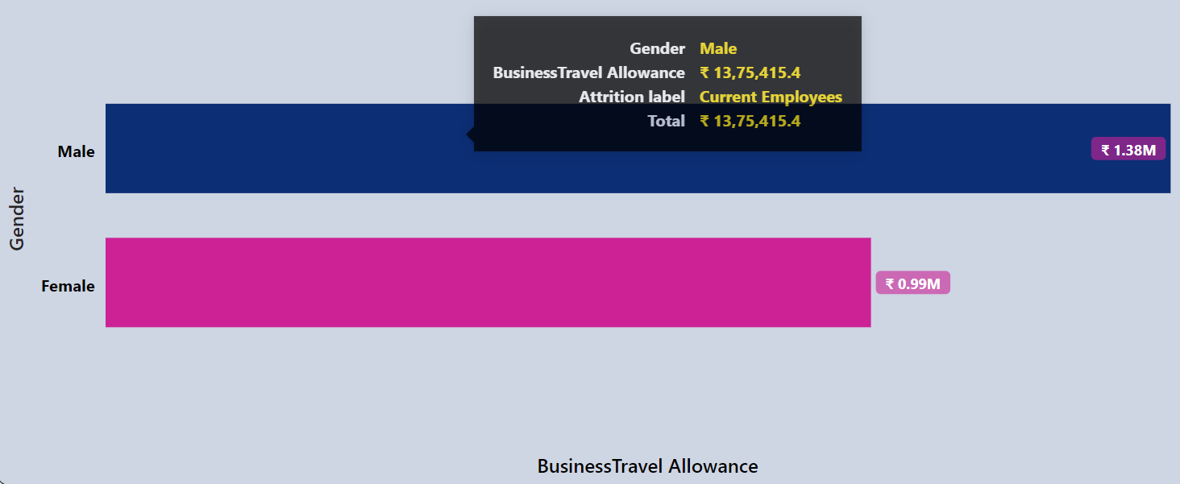

*-- for Current Employees*

*select gender as category,*

*round(sum(business_travel_allowance_rs)/1000000 ,2) as amount_in_Million,*

*round(sum(business_travel_allowance_rs)/1000 ,2) as amount_in_k*

*from hr*

*where attrition_label = 'Current Employees'*

*group by category*

*order by amount_in_Million desc;*

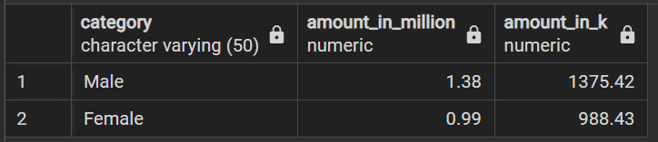

**For Ex-Employees**

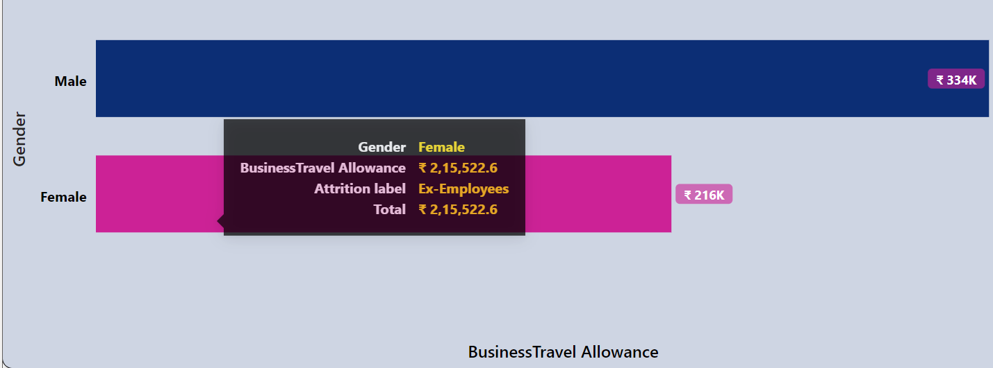

*-- for Ex-Employees*

*select gender as category,*

*round(sum(business_travel_allowance_rs)/1000000 ,2) as amount_in_Million,*

*round(sum(business_travel_allowance_rs)/1000 ,2) as amount_in_k*

*from hr*

*where attrition_label = 'Ex-Employees'*

*group by category*

*order by amount_in_Million desc;*

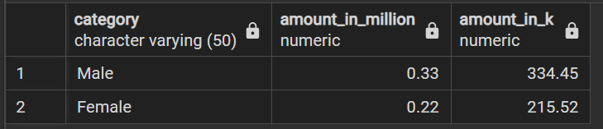

1. Business Travel allowance by Department

**For Current Employees**

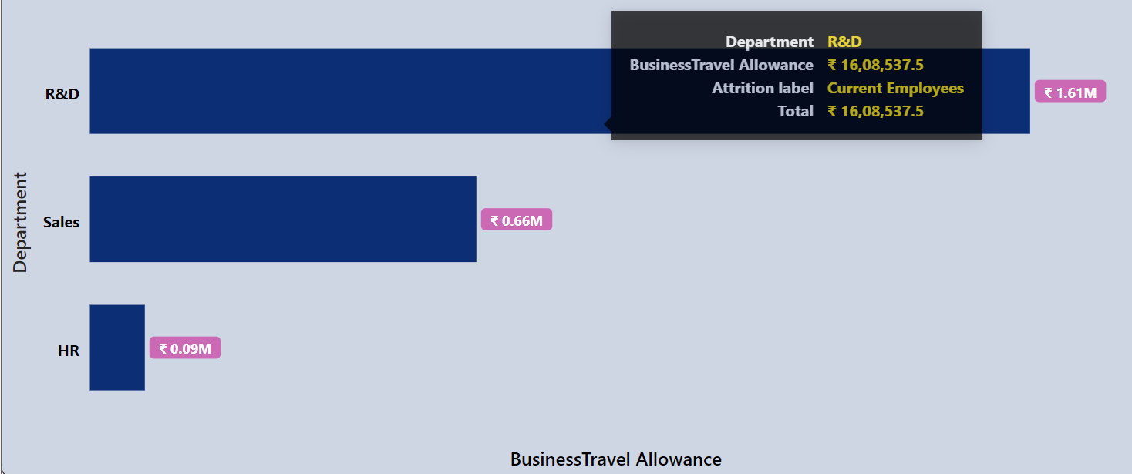

*-- for Current Employees*

*select department as category,*

*round(sum(business_travel_allowance_rs)/1000000 ,2) as amount_in_Million,*

*round(sum(business_travel_allowance_rs)/1000 ,2) as amount_in_k*

*from hr*

*where attrition_label = 'Current Employees'*

*group by category*

*order by amount_in_Million desc;*

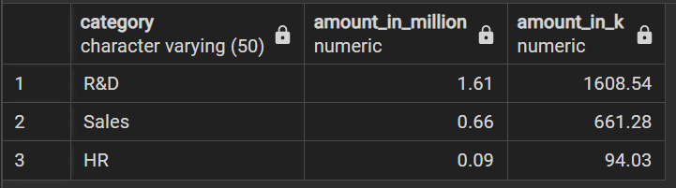

**For Ex-Employees**

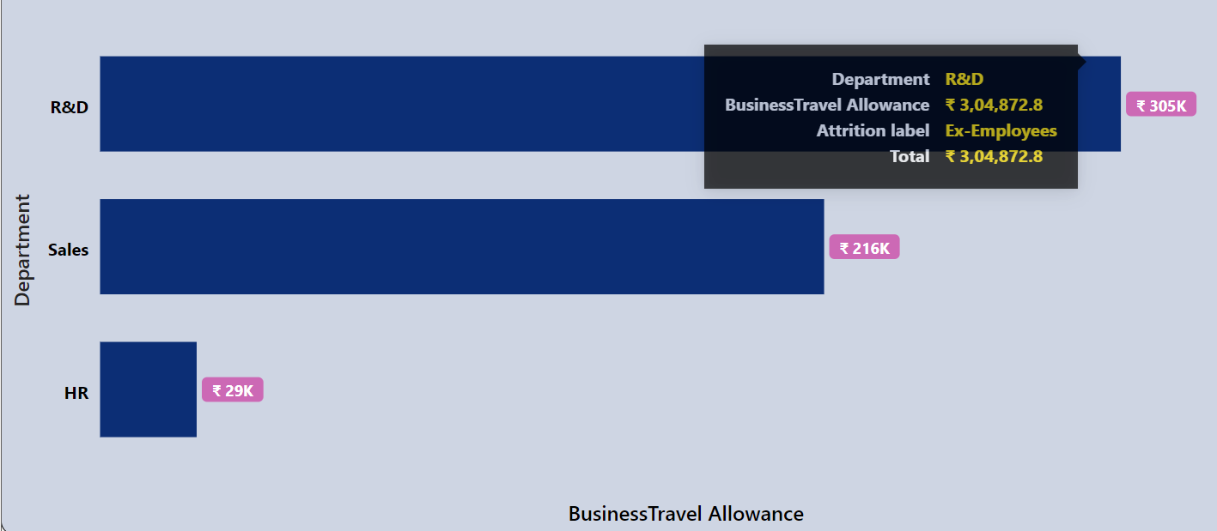

*-- for Ex-Employees*

*select department as category,*

*round(sum(business_travel_allowance_rs)/1000000 ,2) as amount_in_Million,*

*round(sum(business_travel_allowance_rs)/1000 ,2) as amount_in_k*

*from hr*

*where attrition_label = 'Ex-Employees'*

*group by category*

*order by amount_in_Million desc;*

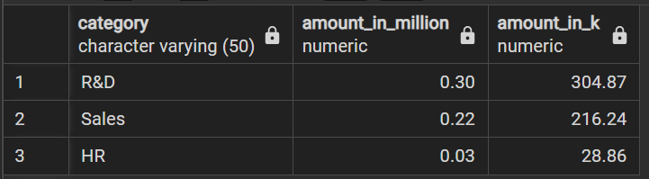

1. Business Travel allowance by Job Role

**For Current Employees**

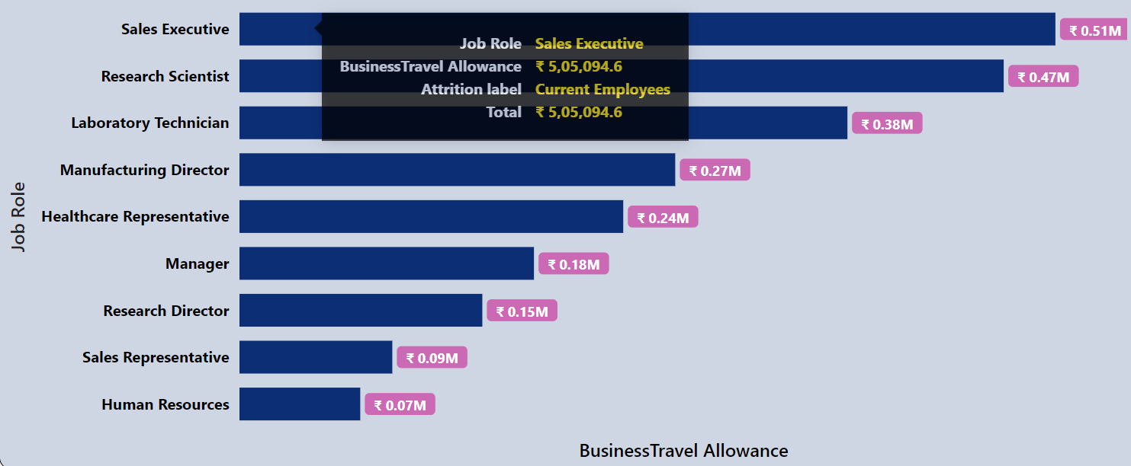

*-- for Current Employees*

*select job_role as category,*

*round(sum(business_travel_allowance_rs)/1000000 ,2) as amount_in_Million,*

*round(sum(business_travel_allowance_rs)/1000 ,2) as amount_in_k*

*from hr*

*where attrition_label = 'Current Employees'*

*group by category*

*order by amount_in_Million desc;*

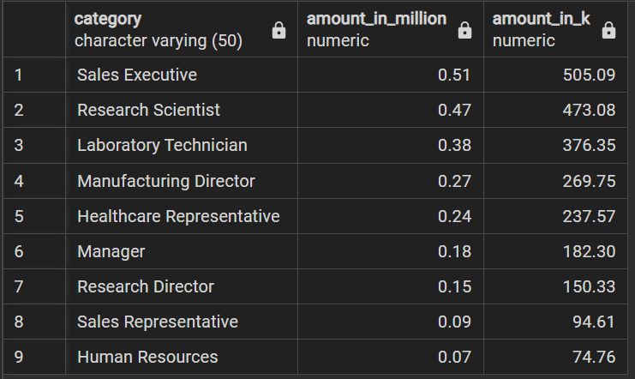

**For Ex-Employees**

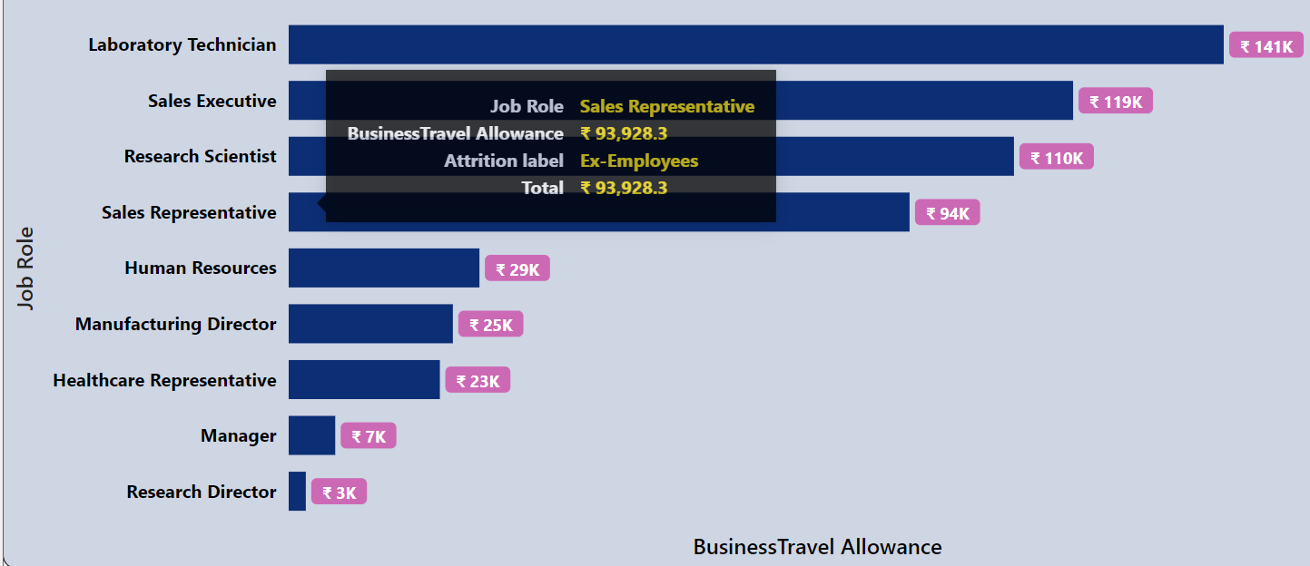

*-- for Ex-Employees*

*select job_role as category,*

*round(sum(business_travel_allowance_rs)/1000000 ,2) as amount_in_Million,*

*round(sum(business_travel_allowance_rs)/1000 ,2) as amount_in_k*

*from hr*

*where attrition_label = 'Ex-Employees'*

*group by category*

*order by amount_in_Million desc;*

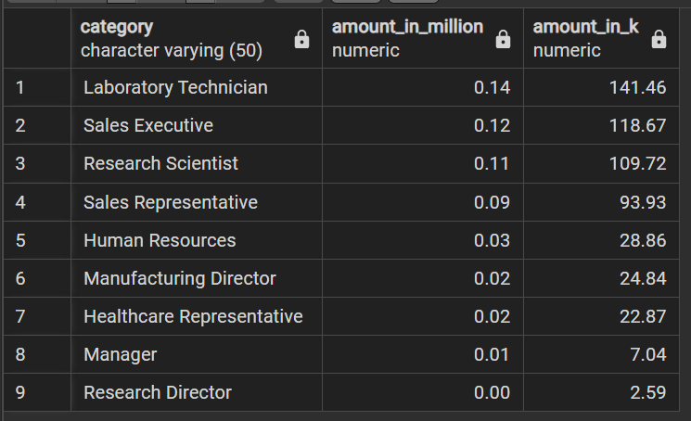

1. Business Travel allowance by Job Level

**For Current Employees**

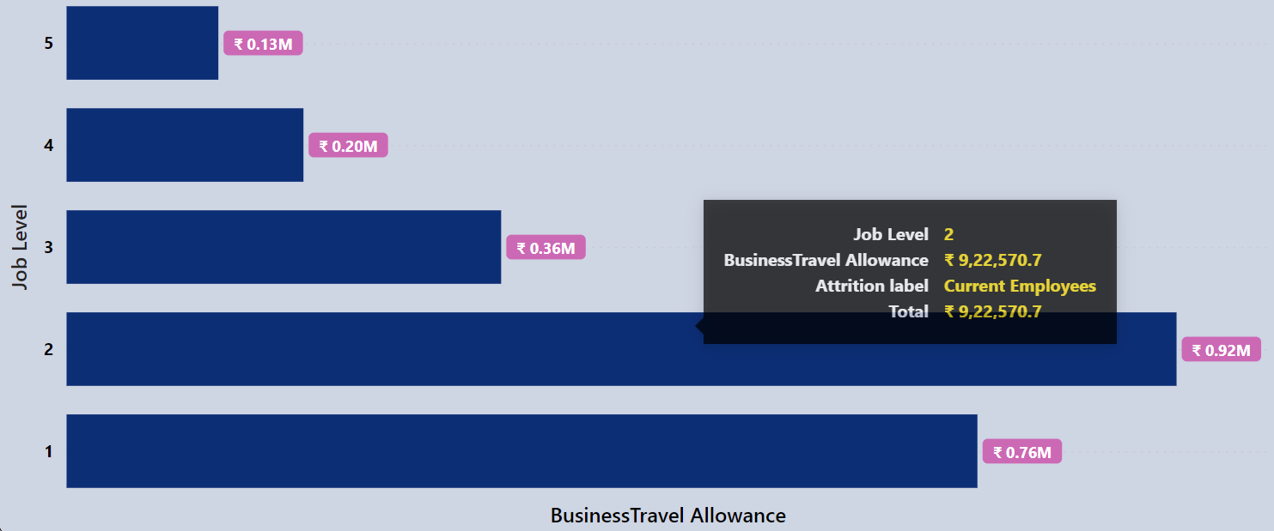

*for Current Employees*

*select job_level as category,*

*round(sum(business_travel_allowance_rs)/1000000 ,2) as amount_in_Million,*

*round(sum(business_travel_allowance_rs)/1000 ,2) as amount_in_k*

*from hr*

*where attrition_label = 'Current Employees'*

*group by category*

*order by category desc;*

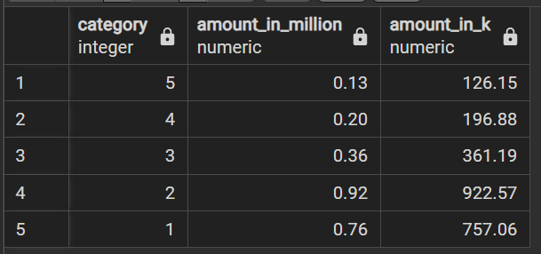

**For Ex-Employees**

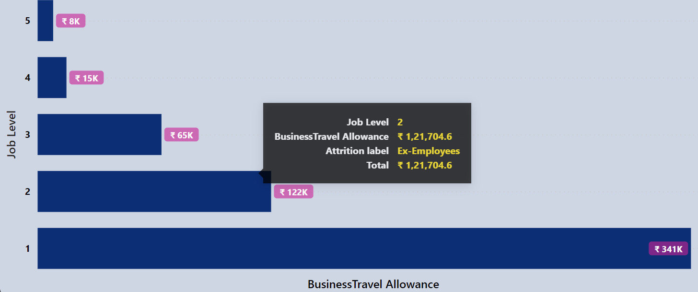

*-- for Ex-Employees*

*select job_level as category,*

*round(sum(business_travel_allowance_rs)/1000000 ,2) as amount_in_Million,*

*round(sum(business_travel_allowance_rs)/1000 ,2) as amount_in_k*

*from hr*

*where attrition_label = 'Ex-Employees'*

*group by category*

*order by category desc;*

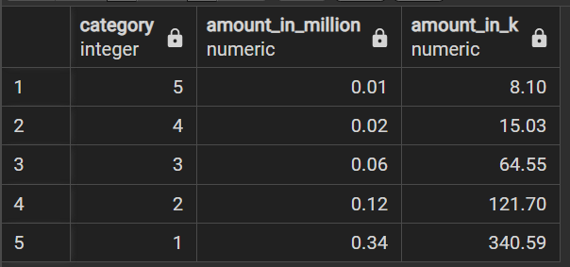

* **Office Travel allowance**

1. Office Travel allowance by Age Group

**For Current Employees**

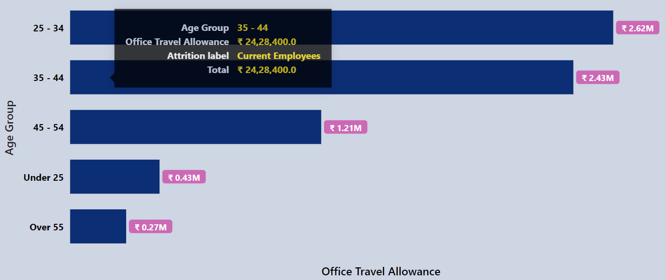

*-- for Current Employees*

*select age_group as category,*

*round(sum(office_travel_allowance_rs)/1000000 ,2) as amount_in_Million,*

*round(sum(office_travel_allowance_rs)/1000 ,2) as amount_in_k*

*from hr*

*where attrition_label = 'Current Employees'*

*group by category*

*order by amount_in_Million desc;*

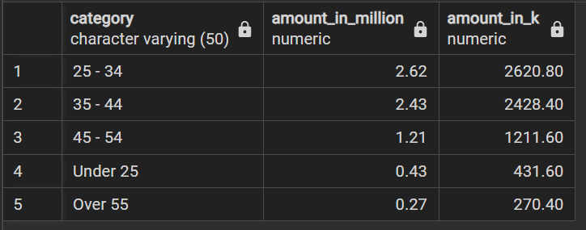

**For Ex-Employees**

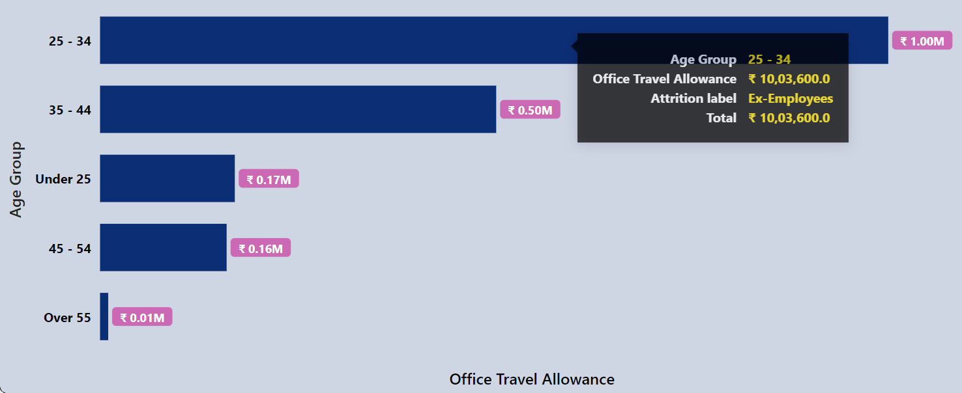

*-- for Ex-Employees*

*select age_group as category,*

*round(sum(office_travel_allowance_rs)/1000000 ,2) as amount_in_Million,*

*round(sum(office_travel_allowance_rs)/1000 ,2) as amount_in_k*

*from hr*

*where attrition_label = 'Ex-Employees'*

*group by category*

*order by amount_in_Million desc;*

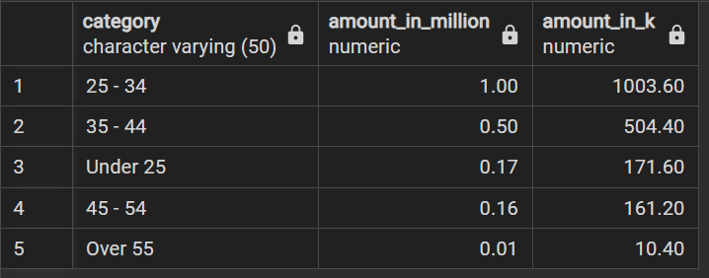

1. Office Travel allowance by Gender

**For Current Employees**

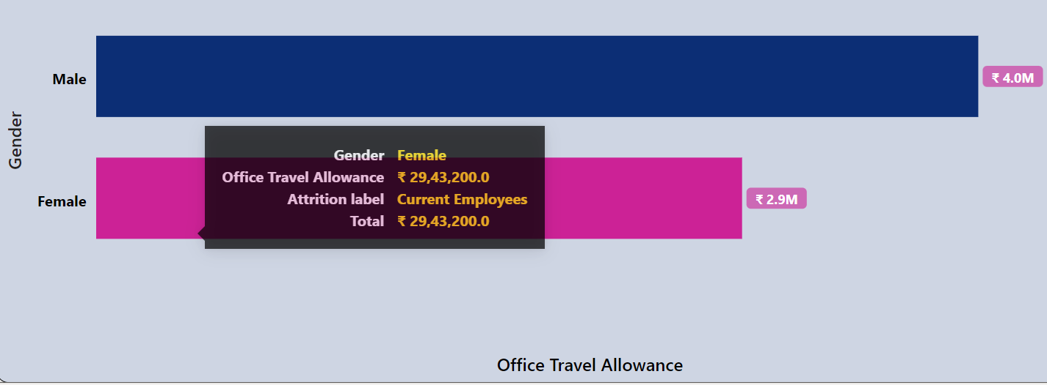

*-- for Current Employees*

*select gender as category,*

*round(sum(office_travel_allowance_rs)/1000000 ,2) as amount_in_Million,*

*round(sum(office_travel_allowance_rs)/1000 ,2) as amount_in_k*

*from hr*

*where attrition_label = 'Current Employees'*

*group by category*

*order by amount_in_Million desc;*

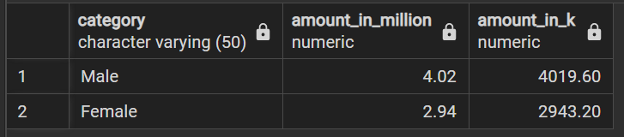

**For Ex-Employees**

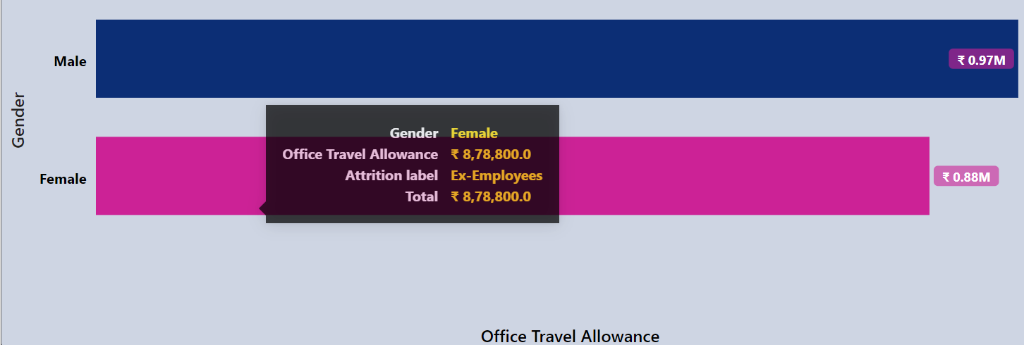

*-- for Ex-Employees*

*select gender as category,*

*round(sum(office_travel_allowance_rs)/1000000 ,2) as amount_in_Million,*

*round(sum(office_travel_allowance_rs)/1000 ,2) as amount_in_k*

*from hr*

*where attrition_label = 'Ex-Employees'*

*group by category*

*order by amount_in_Million desc;*

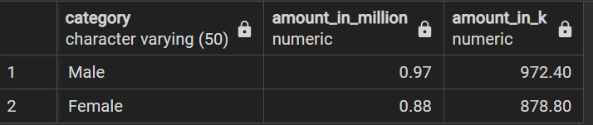

1. Office Travel allowance by Department

**For Current Employees**

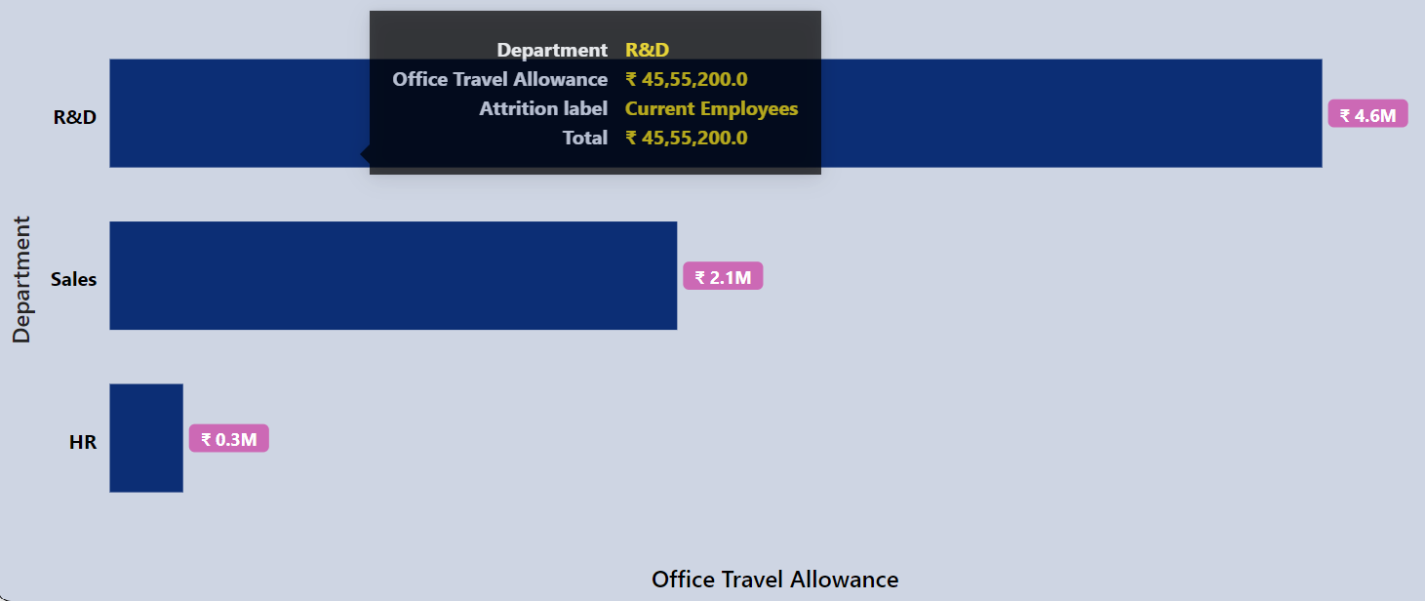

*-- for Current Employees*

*select department as category,*

*round(sum(office_travel_allowance_rs)/1000000 ,2) as amount_in_Million,*

*round(sum(office_travel_allowance_rs)/1000 ,2) as amount_in_k*

*from hr*

*where attrition_label = 'Current Employees'*

*group by category*

*order by amount_in_Million desc;*

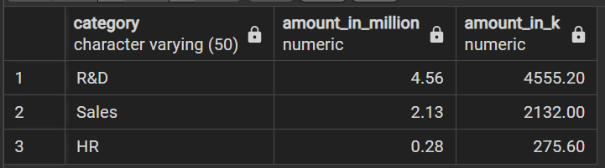

**For Ex-Employees**

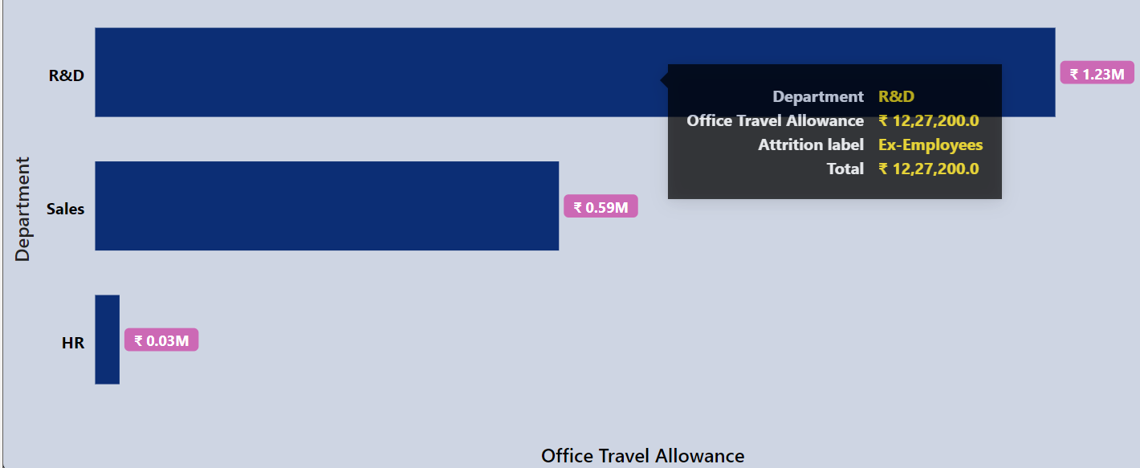

*-- for Ex-Employees*

*select department as category,*

*round(sum(office_travel_allowance_rs)/1000000 ,2) as amount_in_Million,*

*round(sum(office_travel_allowance_rs)/1000 ,2) as amount_in_k*

*from hr*

*where attrition_label = 'Ex-Employees'*

*group by category*

*order by amount_in_Million desc;*

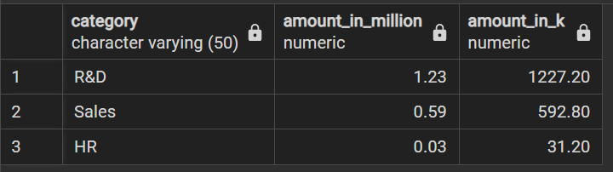

1. Office Travel allowance by Job Role

**For Current Employees**

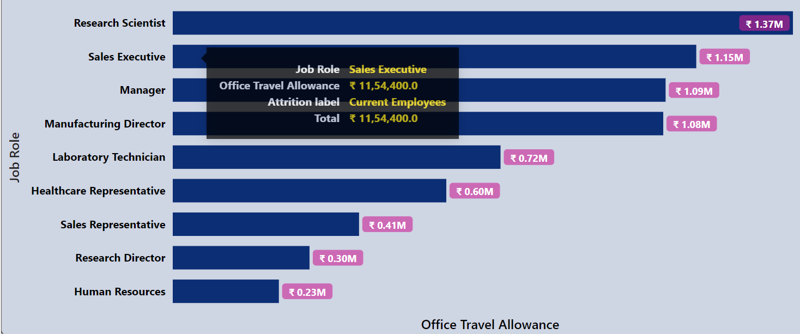

*-- for Current Employees*

*select job_role as category,*

*round(sum(office_travel_allowance_rs)/1000000 ,2) as amount_in_Million,*

*round(sum(office_travel_allowance_rs)/1000 ,2) as amount_in_k*

*from hr*

*where attrition_label = 'Current Employees'*

*group by category*

*order by amount_in_Million desc;*

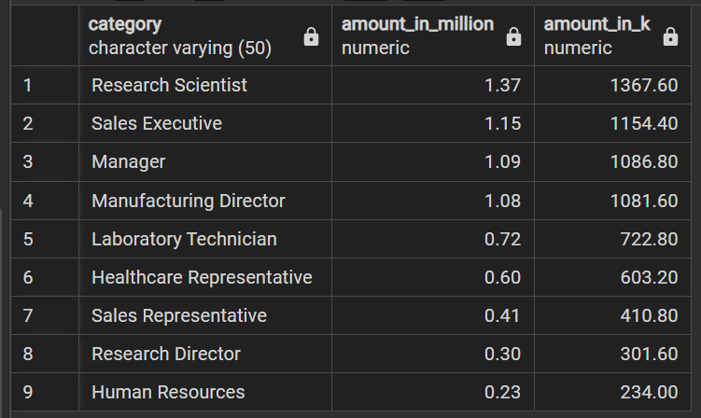

**For Ex-Employees**

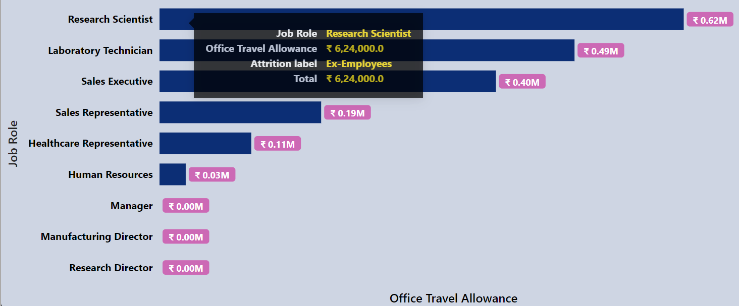

*-- for Ex-Employees*

*select job_role as category,*

*round(sum(office_travel_allowance_rs)/1000000 ,2) as amount_in_Million,*

*round(sum(office_travel_allowance_rs)/1000 ,2) as amount_in_k*

*from hr*

*where attrition_label = 'Ex-Employees'*

*group by category*

*order by amount_in_Million desc;*

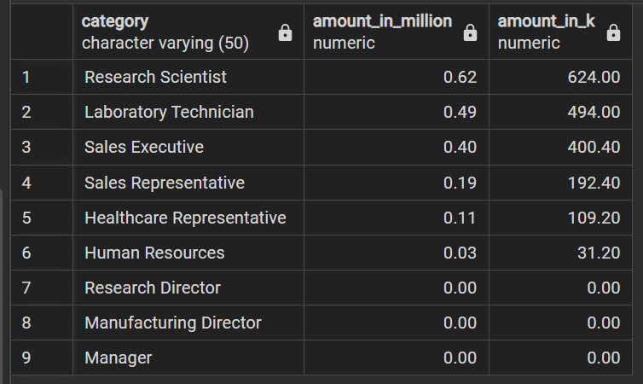

1. Office Travel allowance by Job Level

**For Current Employees**

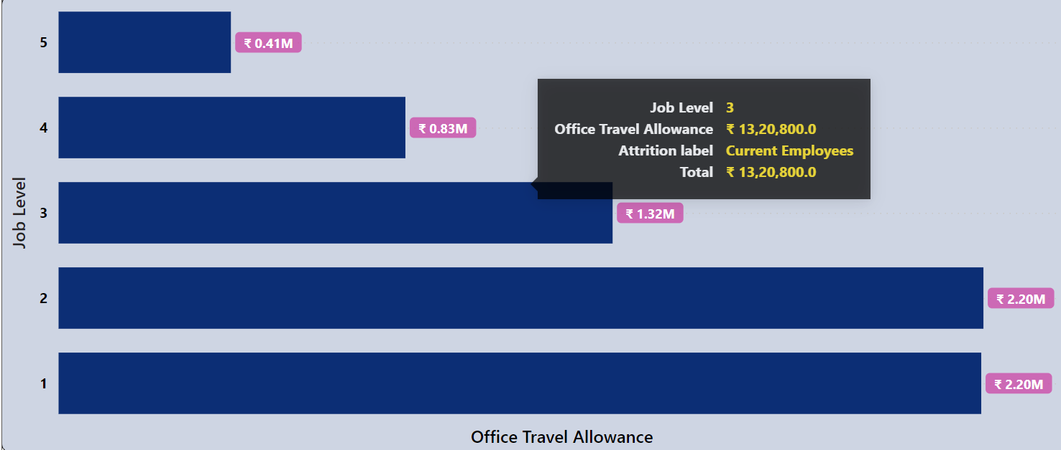

*-- for Current Employees*

*select job_level as category,*

*round(sum(office_travel_allowance_rs)/1000000 ,2) as amount_in_Million,*

*round(sum(office_travel_allowance_rs)/1000 ,2) as amount_in_k*

*from hr*

*where attrition_label = 'Current Employees'*

*group by category*

*order by category desc;*

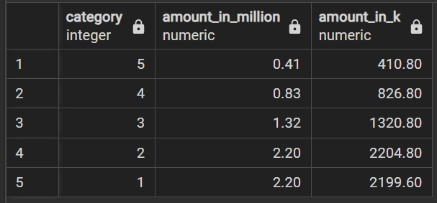

**For Ex-Employees**

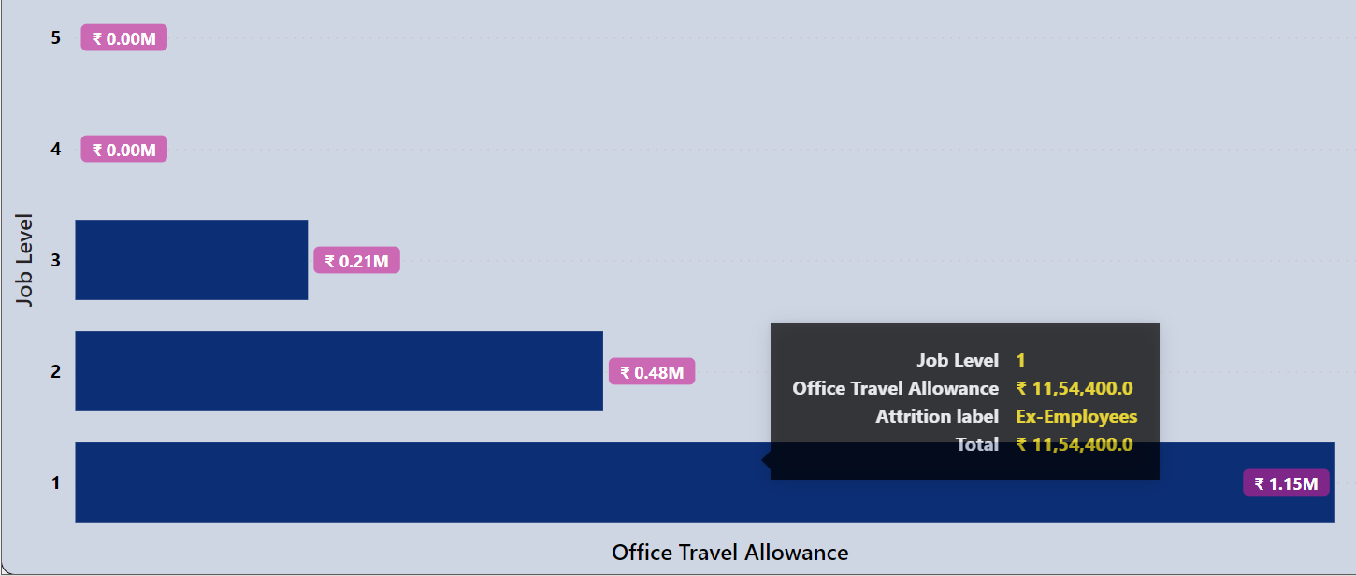

*-- for Ex-Employees*

*select job_level as category,*

*round(sum(office_travel_allowance_rs)/1000000 ,2) as amount_in_Million,*

*round(sum(office_travel_allowance_rs)/1000 ,2) as amount_in_k*

*from hr*

*where attrition_label = 'Ex-Employees'*

*group by category*

*order by category desc;*

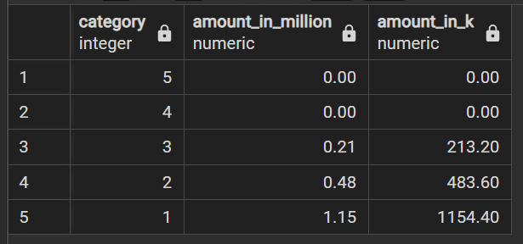

* **Performance Bonus**

1. Performance Bonus by Age Group

**For Current Employees**

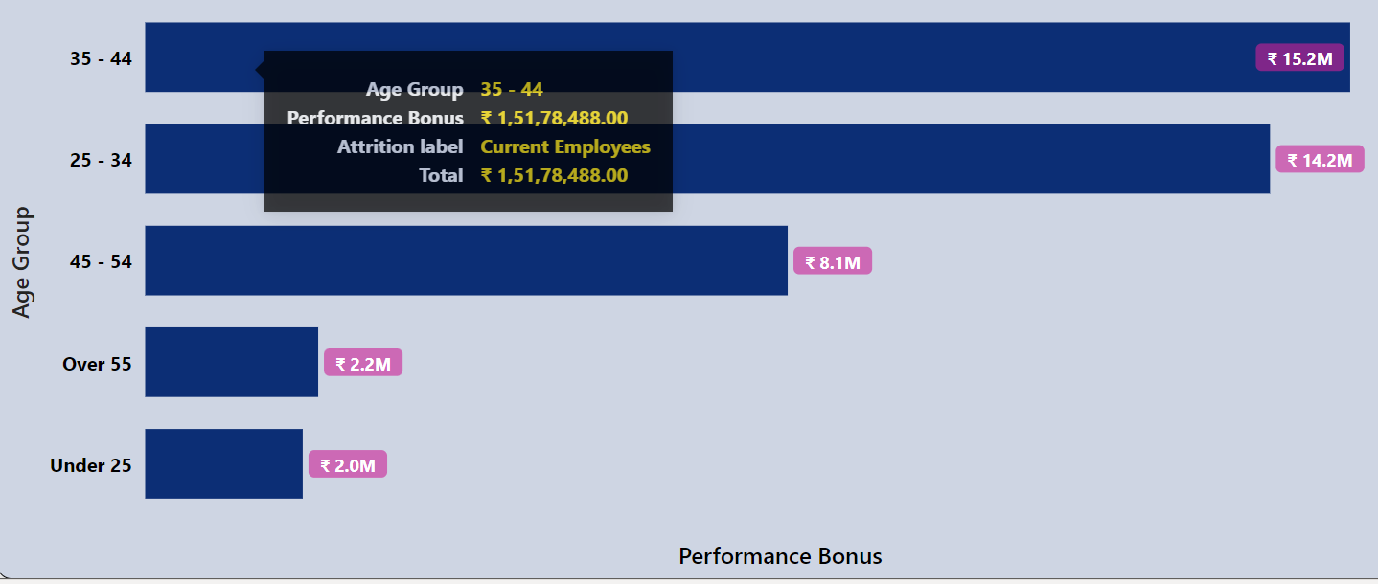

*-- for Current Employees*

*select age_group as category,*

*round(sum(performance_bonus_rs )/1000000 ,2) as amount_in_Million,*

*round(sum(performance_bonus_rs )/1000 ,2) as amount_in_k*

*from hr*

*where attrition_label = 'Current Employees'*

*group by category*

*order by amount_in_Million desc;*

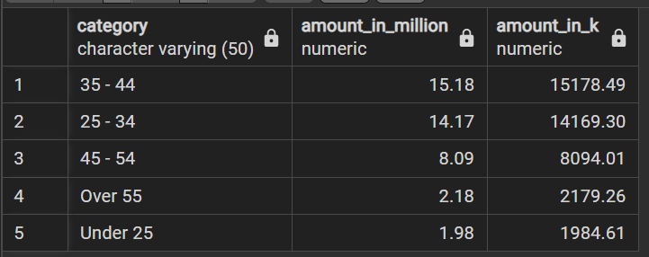

**For Ex-Employees**

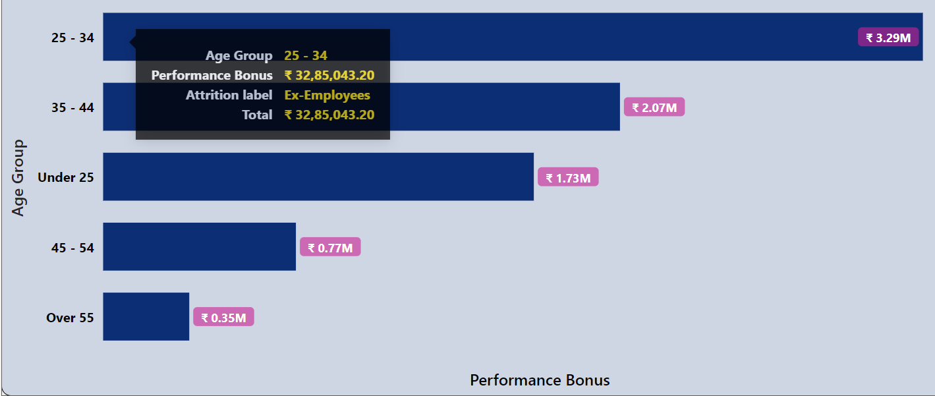

*-- for Ex-Employees*

*select age_group as category,*

*round(sum(performance_bonus_rs )/1000000 ,2) as amount_in_Million,*

*round(sum(performance_bonus_rs )/1000 ,2) as amount_in_k*

*from hr*

*where attrition_label = 'Ex-Employees'*

*group by category*

*order by amount_in_Million desc;*

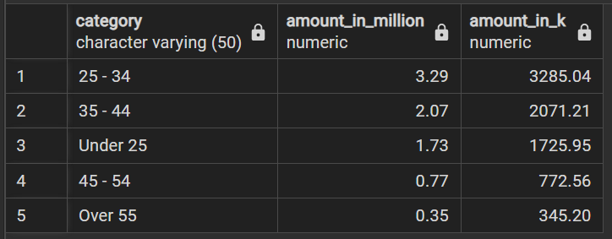

1. Performance Bonus by Gender

**For Current Employees**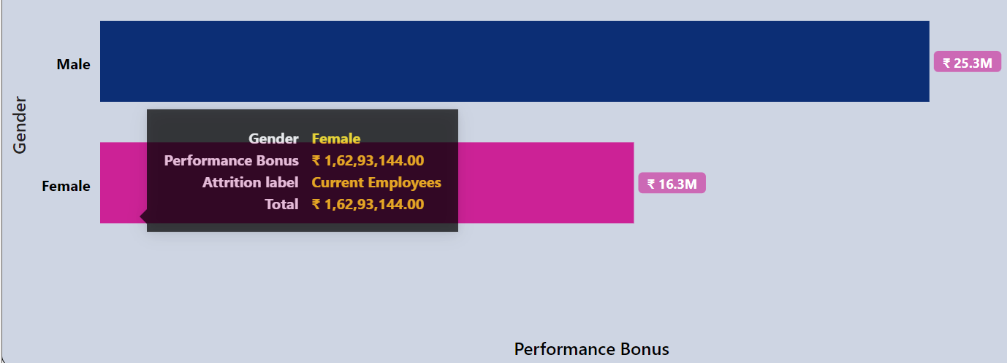

*-- for Current Employees*

*select gender as category,*

*round(sum(performance_bonus_rs )/1000000 ,2) as amount_in_Million,*

*round(sum(performance_bonus_rs )/1000 ,2) as amount_in_k*

*from hr*

*where attrition_label = 'Current Employees'*

*group by category*

*order by amount_in_Million desc;*

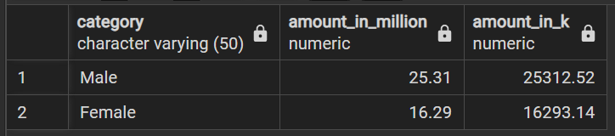

**For Ex-Employees**

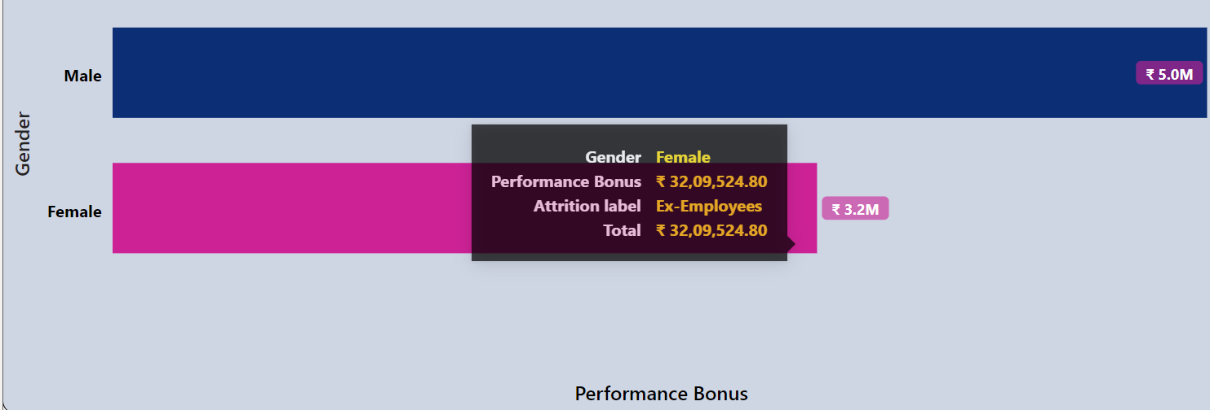

*-- for Ex-Employees*

*select gender as category,*

*round(sum(performance_bonus_rs )/1000000 ,2) as amount_in_Million,*

*round(sum(performance_bonus_rs )/1000 ,2) as amount_in_k*

*from hr*

*where attrition_label = 'Ex-Employees'*

*group by category*

*order by amount_in_Million desc;*

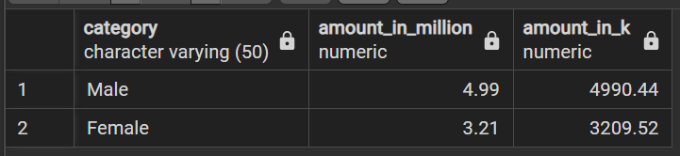

1. Performance Bonus by Department

**For Current Employees**

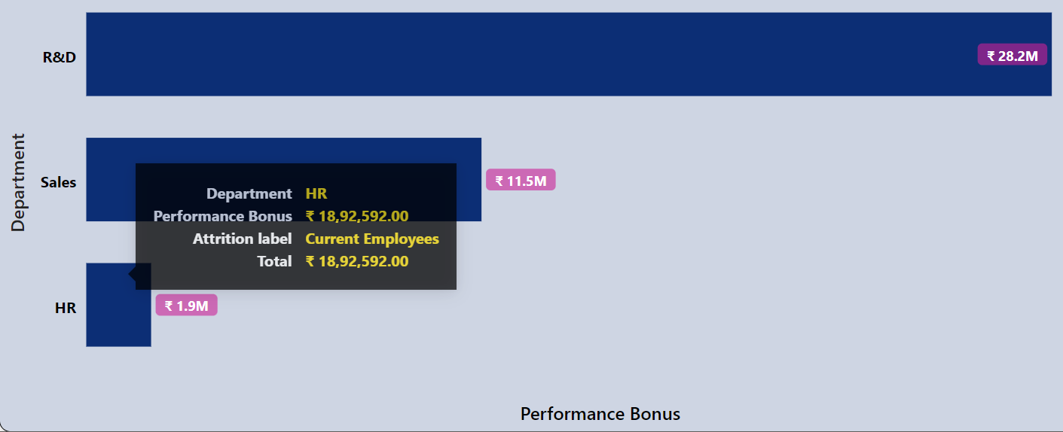

*-- for Current Employees*

*select department as category,*

*round(sum(performance_bonus_rs )/1000000 ,2) as amount_in_Million,*

*round(sum(performance_bonus_rs )/1000 ,2) as amount_in_k*

*from hr*

*where attrition_label = 'Current Employees'*

*group by category*

*order by amount_in_Million desc;*

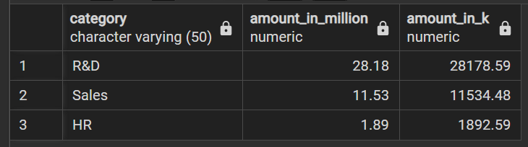

**For Ex-Employees**

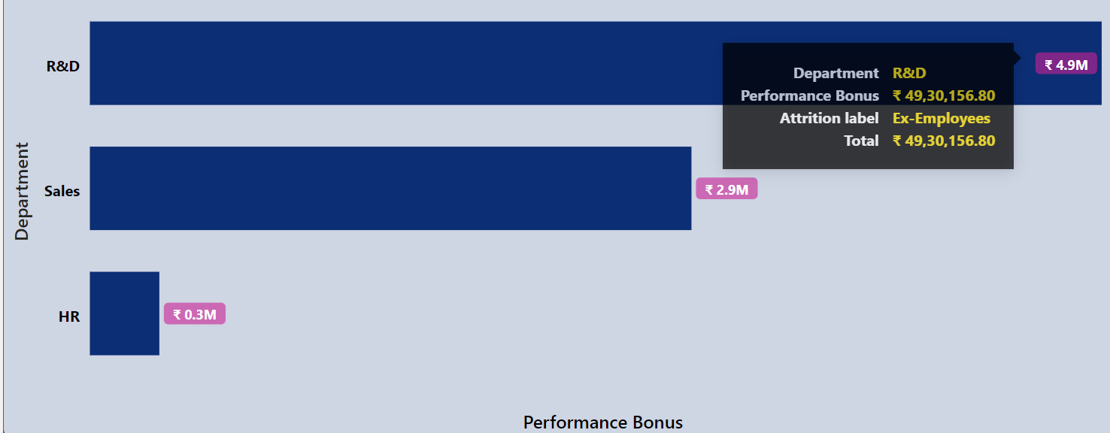

*-- for Ex-Employees*

*select department as category,*

*round(sum(performance_bonus_rs )/1000000 ,2) as amount_in_Million,*

*round(sum(performance_bonus_rs )/1000 ,2) as amount_in_k*

*from hr*

*where attrition_label = 'Ex-Employees'*

*group by category*

*order by amount_in_Million desc;*

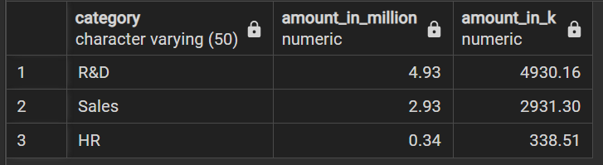

1. Performance Bonus by Job Role

**For Current Employees**

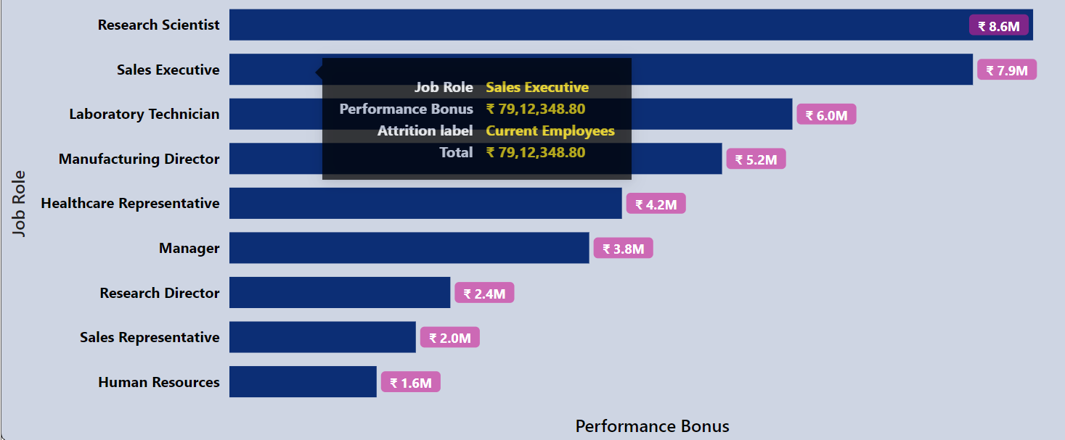

*-- for Current Employees*

*select job_role as category,*

*round(sum(performance_bonus_rs )/1000000 ,2) as amount_in_Million,*

*round(sum(performance_bonus_rs )/1000 ,2) as amount_in_k*

*from hr*

*where attrition_label = 'Current Employees'*

*group by category*

*order by amount_in_Million desc;*

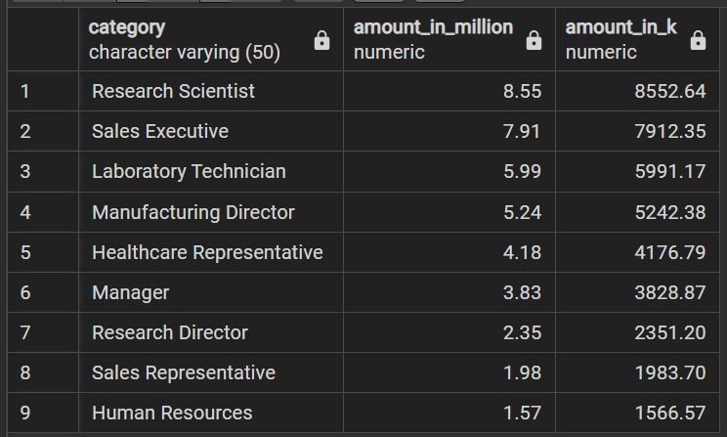

**For Ex-Employees**

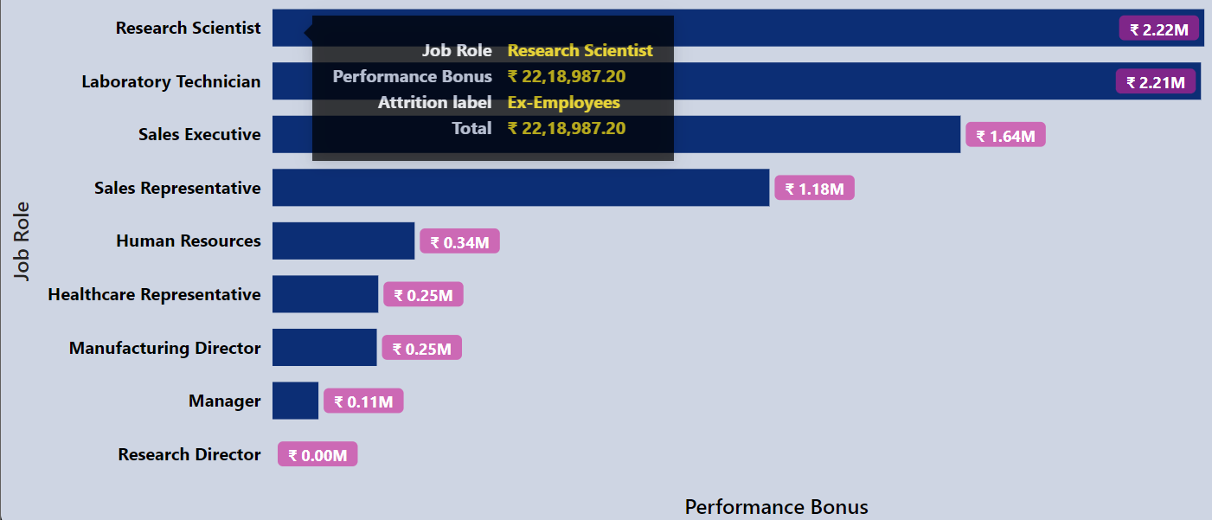

*-- for Ex-Employees*

*select job_role as category,*

*round(sum(performance_bonus_rs )/1000000 ,2) as amount_in_Million,*

*round(sum(performance_bonus_rs )/1000 ,2) as amount_in_k*

*from hr*

*where attrition_label = 'Ex-Employees'*

*group by category*

*order by amount_in_Million desc;*

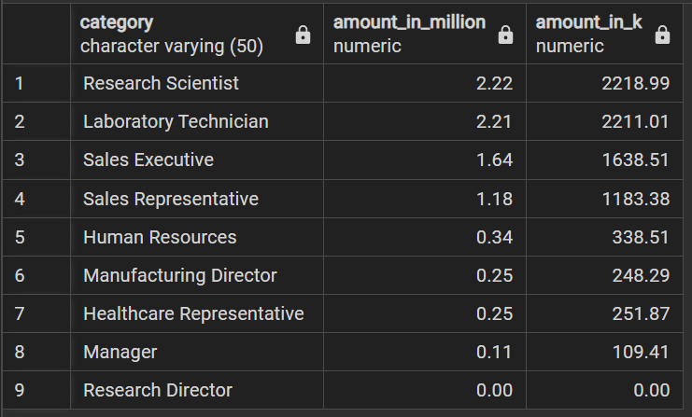

1. Performance Bonus by Job Level

**For Current Employees**

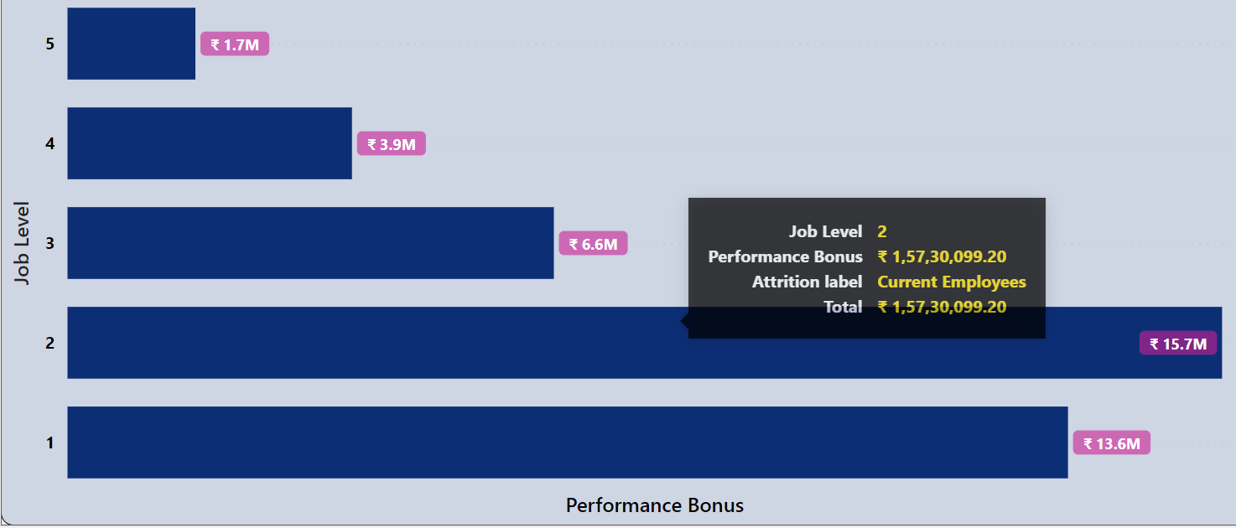

*-- for Current Employees*

*select job_level as category,*

*round(sum(performance_bonus_rs )/1000000 ,2) as amount_in_Million,*

*round(sum(performance_bonus_rs )/1000 ,2) as amount_in_k*

*from hr*

*where attrition_label = 'Current Employees'*

*group by category*

*order by category desc;*

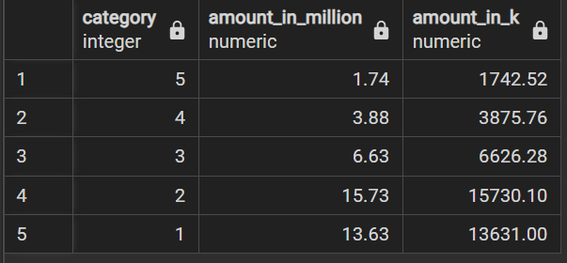

**For Ex-Employees**

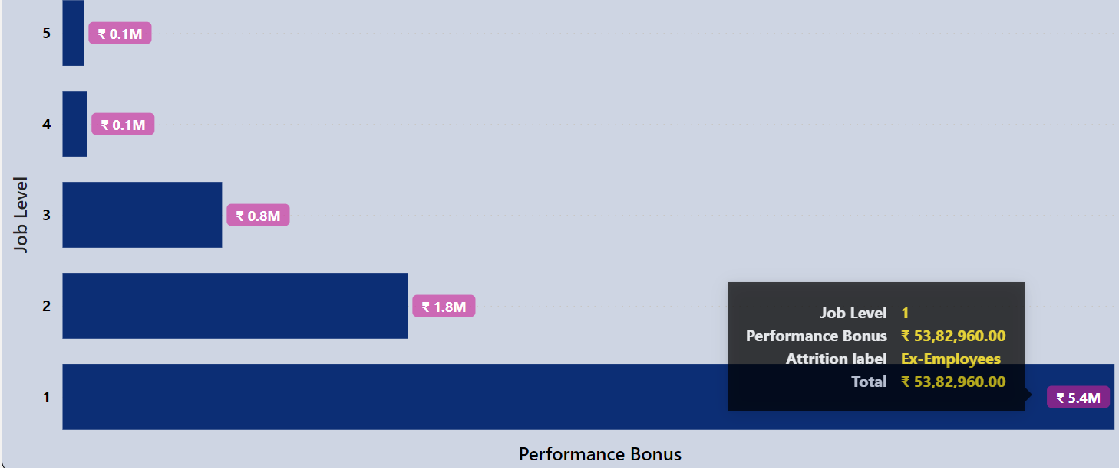

*-- for Ex-Employees*

*select job_level as category,*

*round(sum(performance_bonus_rs )/1000000 ,2) as amount_in_Million,*

*round(sum(performance_bonus_rs )/1000 ,2) as amount_in_k*

*from hr*

*where attrition_label = 'Ex-Employees'*

*group by category*

*order by category desc;*

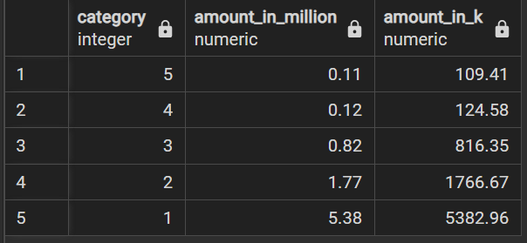

* **Over Time Incentive**

1. Over Time Incentive by Age Group

**For Current Employees**

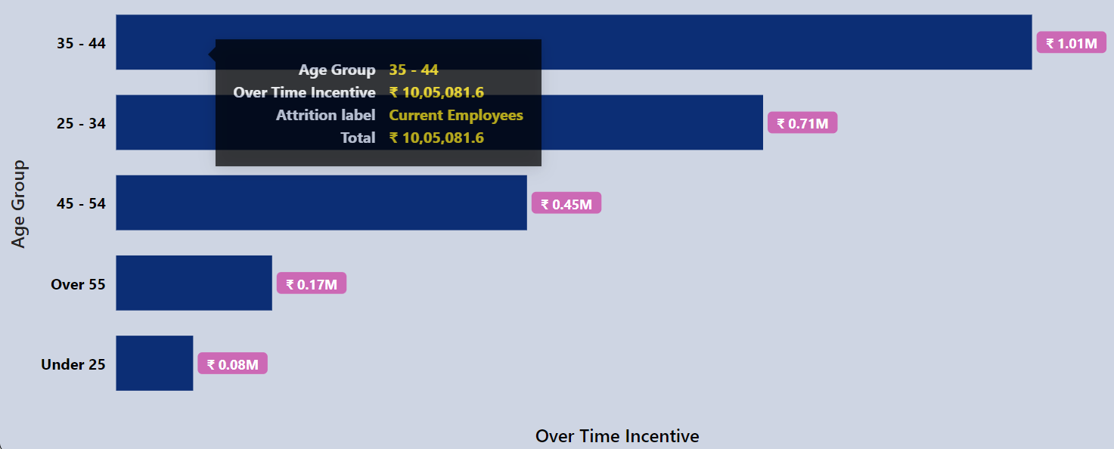

*-- for Current Employees*

*select age_group as category,*

*round(sum(over_time_incentive_rs )/1000000 ,2) as amount_in_Million,*

*round(sum(over_time_incentive_rs )/1000 ,2) as amount_in_k*

*from hr*

*where attrition_label = 'Current Employees'*

*group by category*

*order by amount_in_Million desc;*

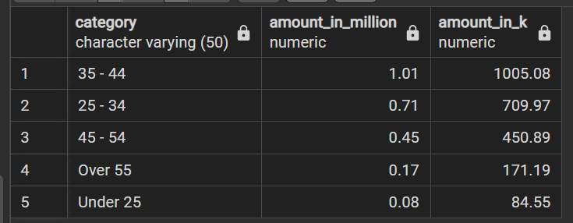

**For Ex-Employees**

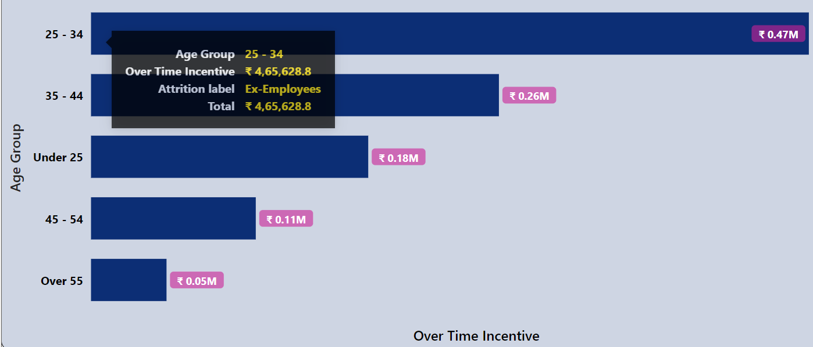

*-- for Ex-Employees*

*select age_group as category,*

*round(sum(over_time_incentive_rs )/1000000 ,2) as amount_in_Million,*

*round(sum(over_time_incentive_rs )/1000 ,2) as amount_in_k*

*from hr*

*where attrition_label = 'Ex-Employees'*

*group by category*

*order by amount_in_Million desc;*

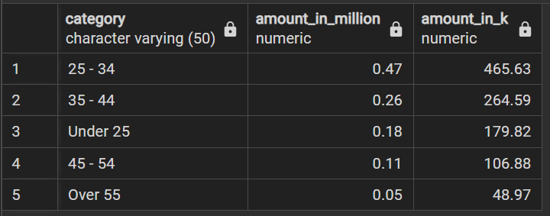

1. Over Time Incentive by Gender

**For Current Employees**

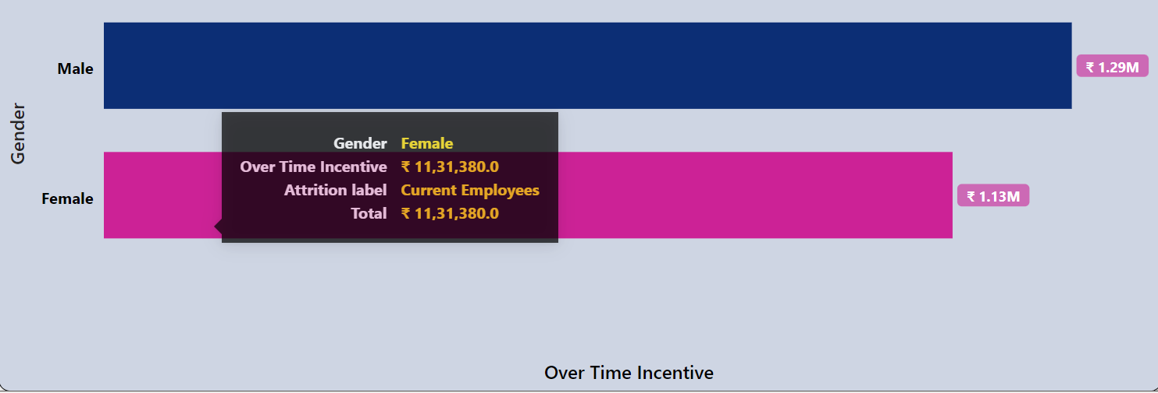

*-- for Current Employees*

*select gender as category,*

*round(sum(over_time_incentive_rs )/1000000 ,2) as amount_in_Million,*

*round(sum(over_time_incentive_rs )/1000 ,2) as amount_in_k*

*from hr*

*where attrition_label = 'Current Employees'*

*group by category*

*order by amount_in_Million desc;*

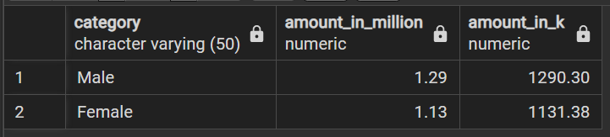

**For Ex-Employees**

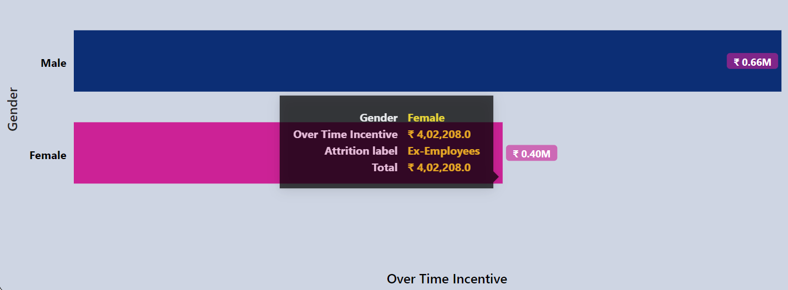

*-- for Ex-Employees*

*select gender as category,*

*round(sum(over_time_incentive_rs )/1000000 ,2) as amount_in_Million,*

*round(sum(over_time_incentive_rs )/1000 ,2) as amount_in_k*

*from hr*

*where attrition_label = 'Ex-Employees'*

*group by category*

*order by amount_in_Million desc;*

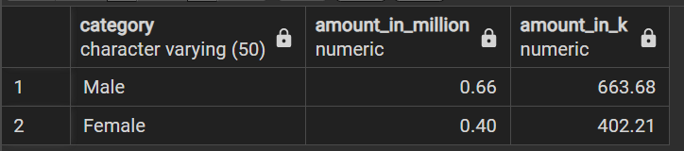

1. Over Time Incentive by Department

**For Current Employees**

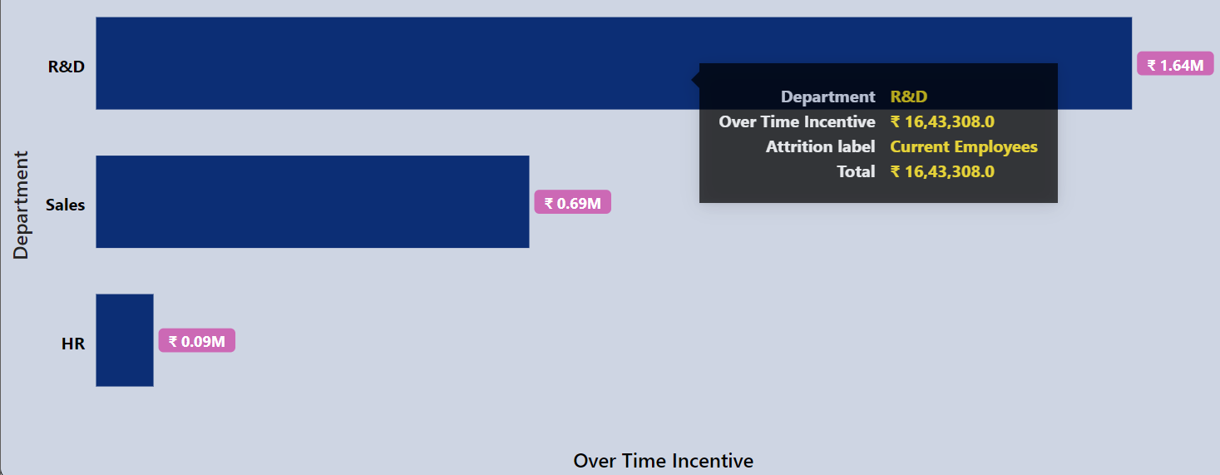

*-- for Current Employees*

*select department as category,*

*round(sum(over_time_incentive_rs )/1000000 ,2) as amount_in_Million,*

*round(sum(over_time_incentive_rs )/1000 ,2) as amount_in_k*

*from hr*

*where attrition_label = 'Current Employees'*

*group by category*

*order by amount_in_Million desc;*

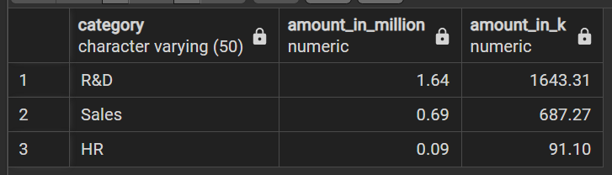

**For Ex-Employees**

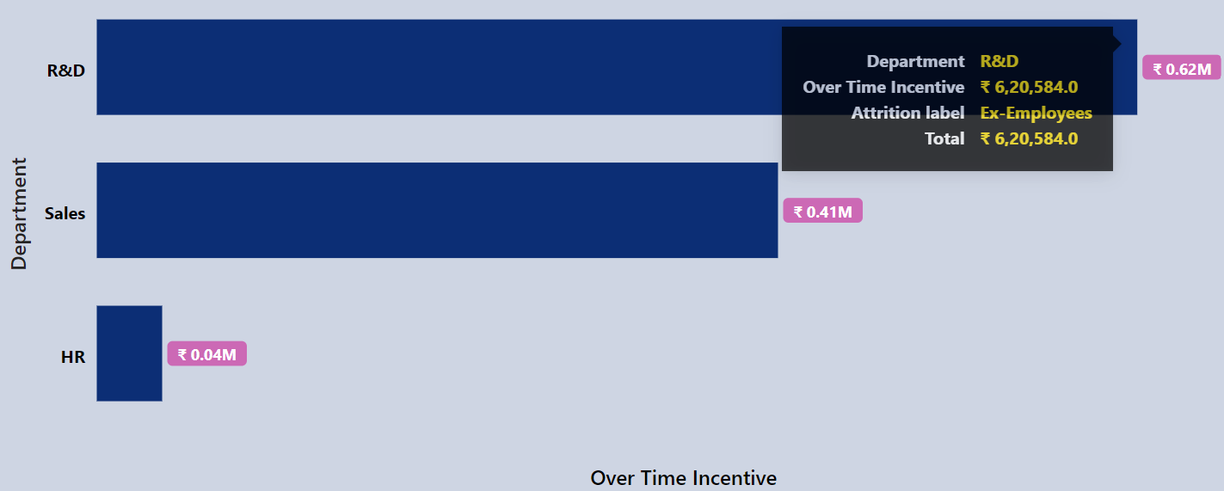

*-- for Ex-Employees*

*select department as category,*

*round(sum(over_time_incentive_rs )/1000000 ,2) as amount_in_Million,*

*round(sum(over_time_incentive_rs )/1000 ,2) as amount_in_k*

*from hr*

*where attrition_label = 'Ex-Employees'*

*group by category*

*order by amount_in_Million desc;*

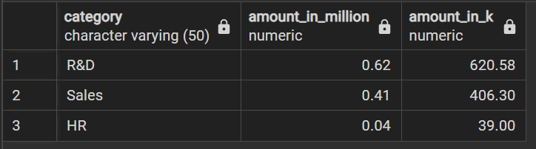

1. Over Time Incentive by Job Role

**For Current Employees**

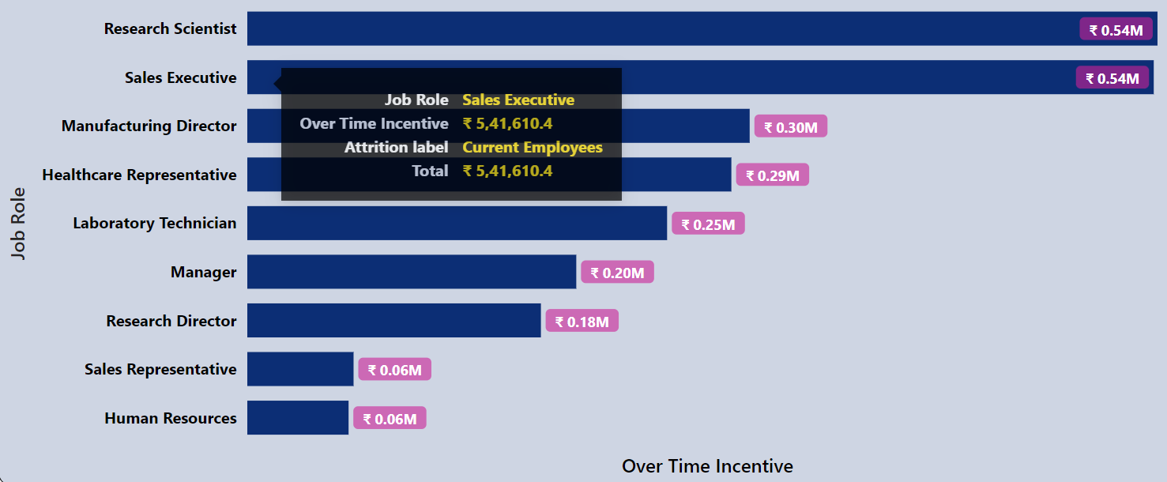

*-- for Current Employees*

*select job_role as category,*

*round(sum(over_time_incentive_rs )/1000000 ,2) as amount_in_Million,*

*round(sum(over_time_incentive_rs )/1000 ,2) as amount_in_k*

*from hr*

*where attrition_label = 'Current Employees'*

*group by category*

*order by amount_in_Million desc;*

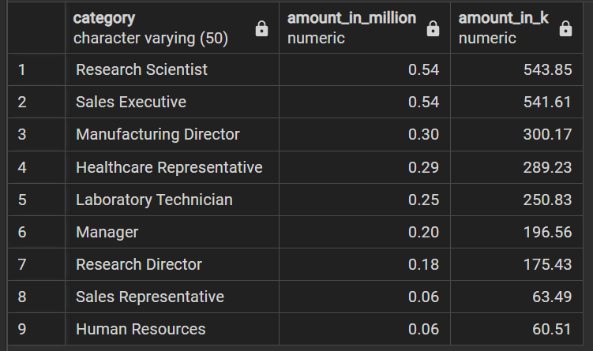

**For Ex-Employees**

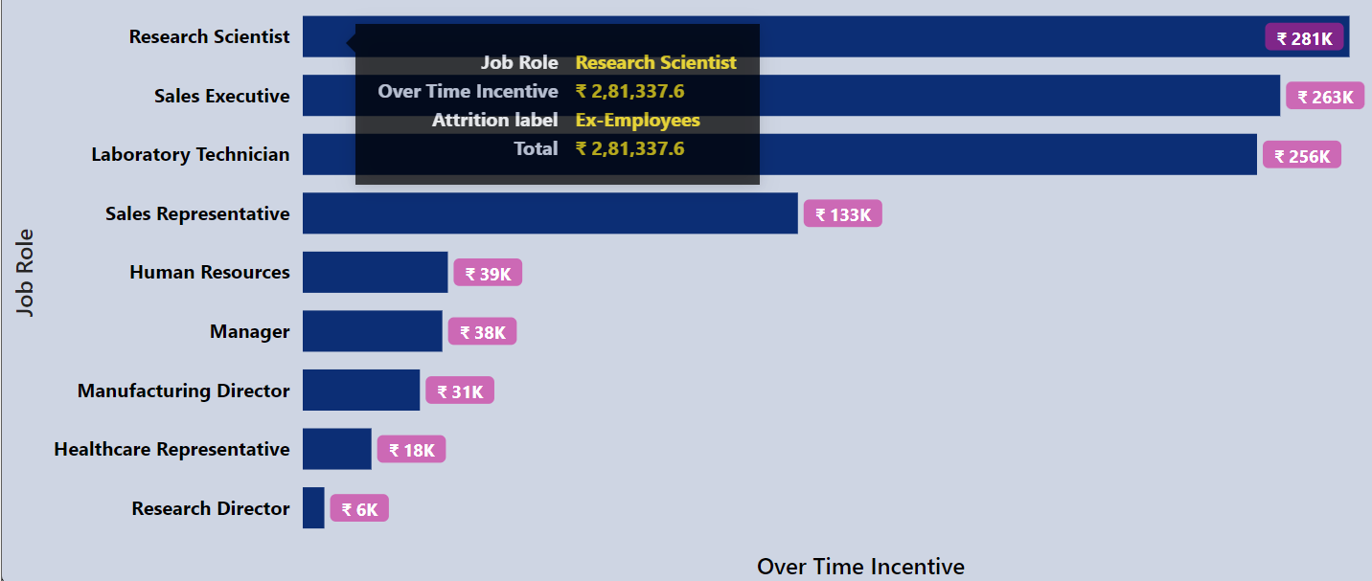

*-- for Ex-Employees*

*select job_role as category,*

*round(sum(over_time_incentive_rs )/1000000 ,2) as amount_in_Million,*

*round(sum(over_time_incentive_rs )/1000 ,2) as amount_in_k*

*from hr*

*where attrition_label = 'Ex-Employees'*

*group by category*

*order by amount_in_Million desc;*

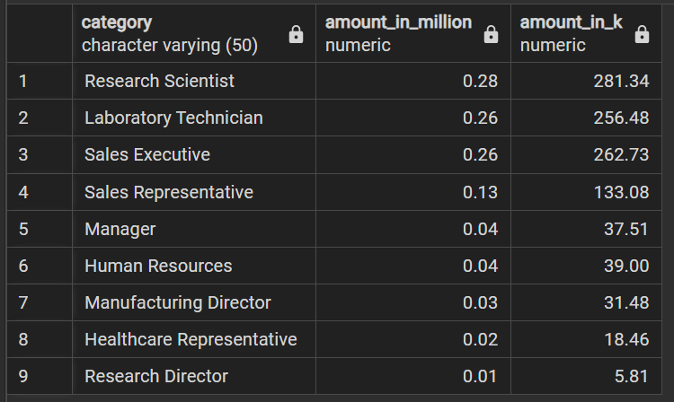

1. Over Time Incentive by Job Level

**For Current Employees**

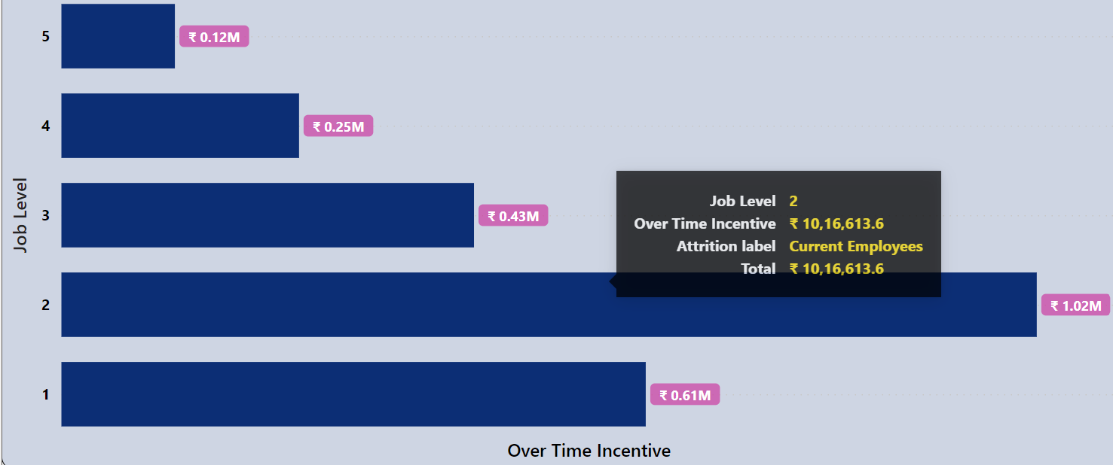

*-- for Current Employees*

*select job_level as category,*

*round(sum(over_time_incentive_rs )/1000000 ,2) as amount_in_Million,*

*round(sum(over_time_incentive_rs )/1000 ,2) as amount_in_k*

*from hr*

*where attrition_label = 'Current Employees'*

*group by category*

*order by category desc;*

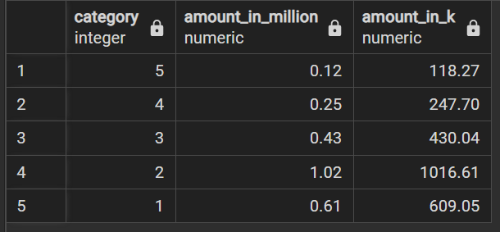

**For Ex-Employees**

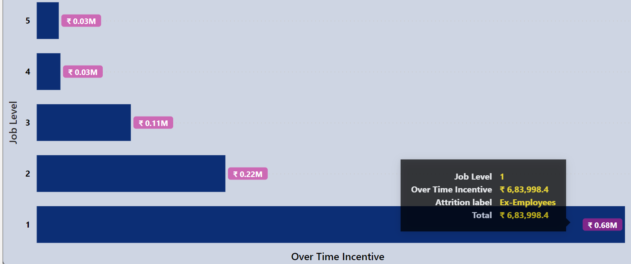

*-- for Ex-Employees*

*select job_level as category,*

*round(sum(over_time_incentive_rs )/1000000 ,2) as amount_in_Million,*

*round(sum(over_time_incentive_rs )/1000 ,2) as amount_in_k*

*from hr*

*where attrition_label = 'Ex-Employees'*

*group by category*

*order by category desc;*

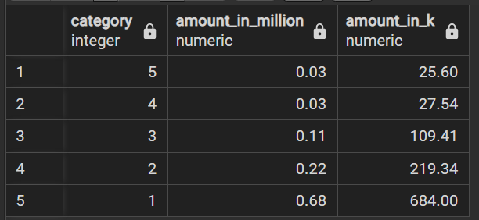

* **Marital allowance**

1. Marital allowance by Age Group

**For Current Employees**

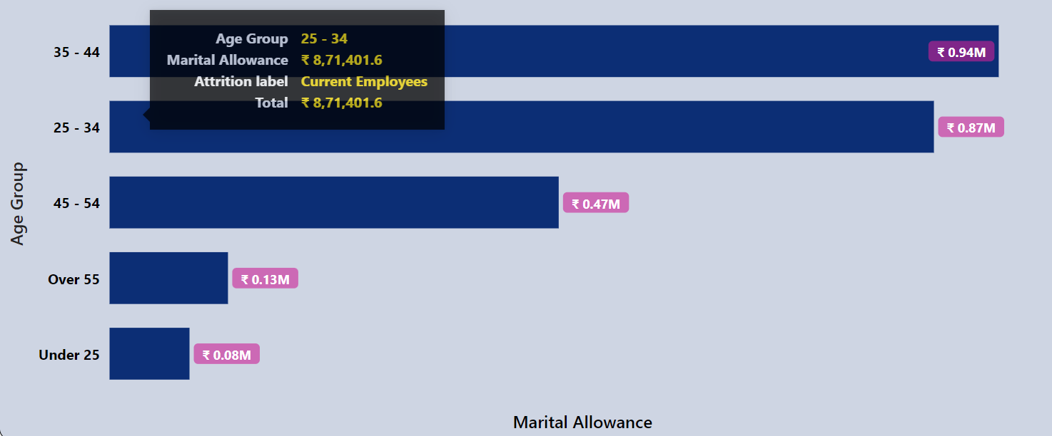

*-- for Current Employees*

*select age_group as category,*

*round(sum(marital_allowance_rs )/1000000 ,2) as amount_in_Million,*

*round(sum(marital_allowance_rs )/1000 ,2) as amount_in_k*

*from hr*

*where attrition_label = 'Current Employees'*

*group by category*

*order by amount_in_Million desc;*

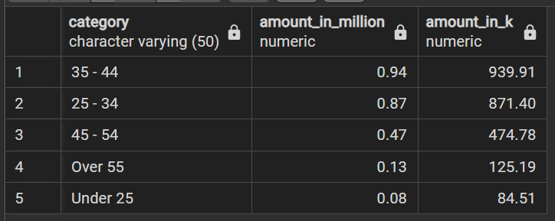

**For Ex-Employees**

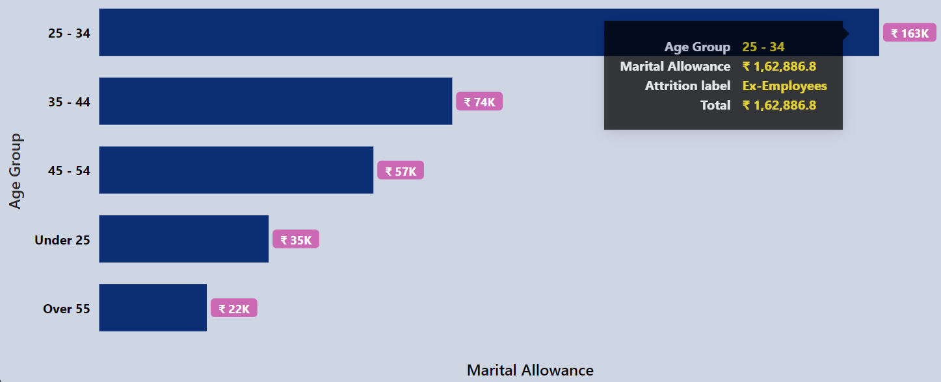

*-- for Ex-Employees*

*select age_group as category,*

*round(sum(marital_allowance_rs )/1000000 ,2) as amount_in_Million,*

*round(sum(marital_allowance_rs )/1000 ,2) as amount_in_k*

*from hr*

*where attrition_label = 'Ex-Employees'*

*group by category*

*order by amount_in_Million desc;*

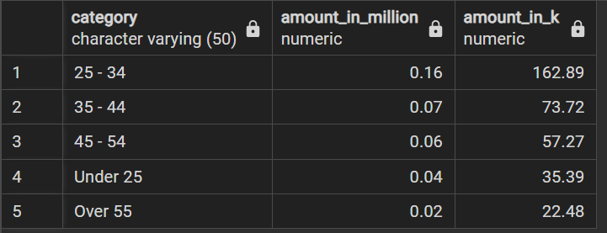

1. Marital allowance by Gender

**For Current Employees**

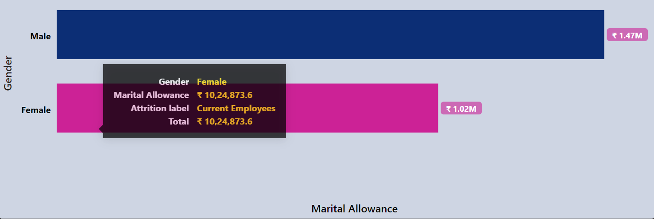

*-- for Current Employees*

*select gender as category,*

*round(sum(marital_allowance_rs )/1000000 ,2) as amount_in_Million,*

*round(sum(marital_allowance_rs )/1000 ,2) as amount_in_k*

*from hr*

*where attrition_label = 'Current Employees'*

*group by category*

*order by amount_in_Million desc;*

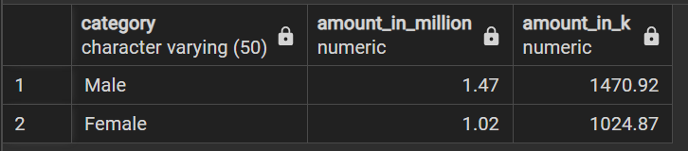

**For Ex-Employees**

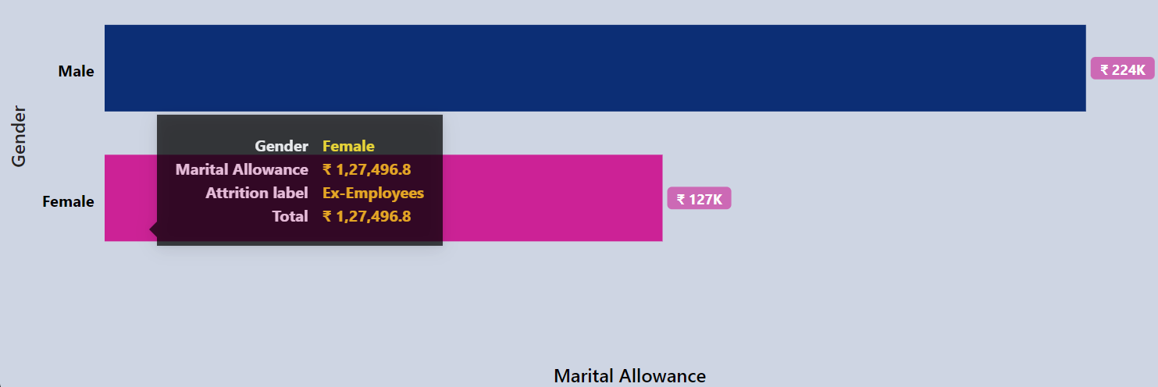

*-- for Ex-Employees*

*select gender as category,*

*round(sum(marital_allowance_rs )/1000000 ,2) as amount_in_Million,*

*round(sum(marital_allowance_rs )/1000 ,2) as amount_in_k*

*from hr*

*where attrition_label = 'Ex-Employees'*

*group by category*

*order by amount_in_Million desc;*

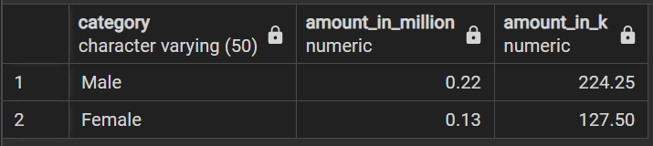

1. Marital allowance by Department

**For Current Employees**

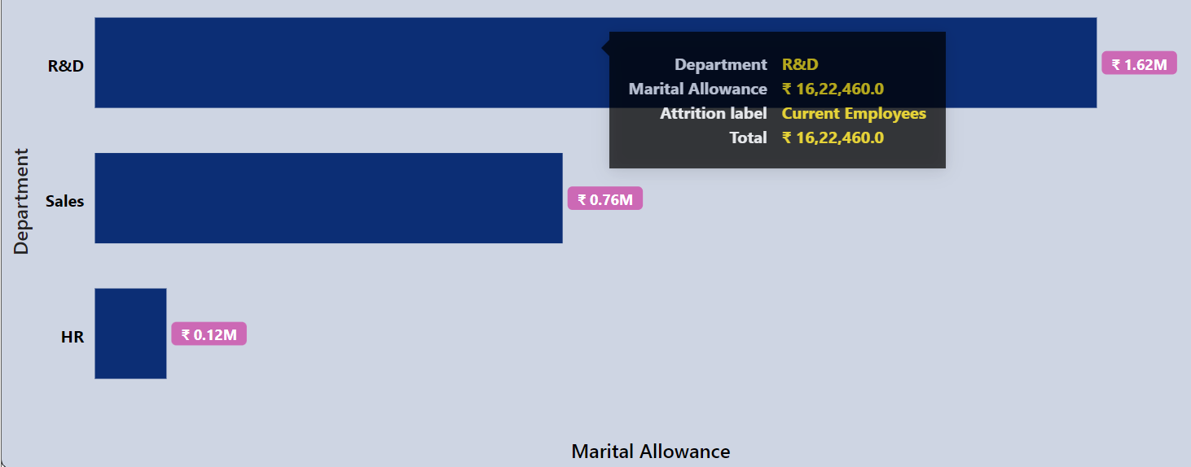

*-- for Current Employees*

*select department as category,*

*round(sum(marital_allowance_rs )/1000000 ,2) as amount_in_Million,*

*round(sum(marital_allowance_rs )/1000 ,2) as amount_in_k*

*from hr*

*where attrition_label = 'Current Employees'*

*group by category*

*order by amount_in_Million desc;*

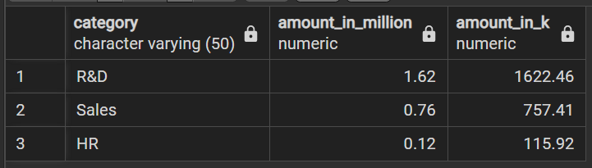

**For Ex-Employees**

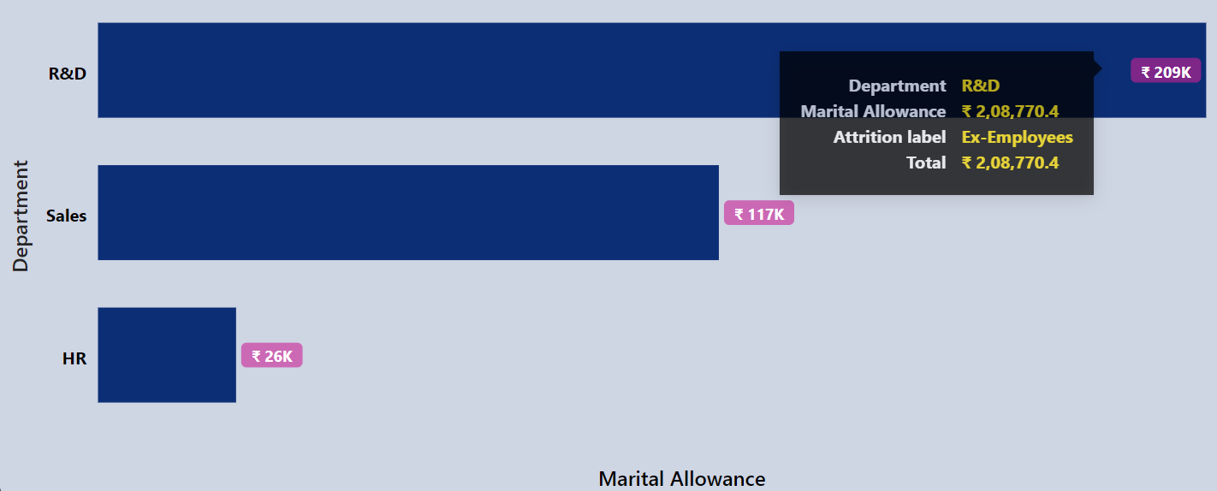

*-- for Ex-Employees*

*select department as category,*

*round(sum(marital_allowance_rs )/1000000 ,2) as amount_in_Million,*

*round(sum(marital_allowance_rs )/1000 ,2) as amount_in_k*

*from hr*

*where attrition_label = 'Ex-Employees'*

*group by category*

*order by amount_in_Million desc;*

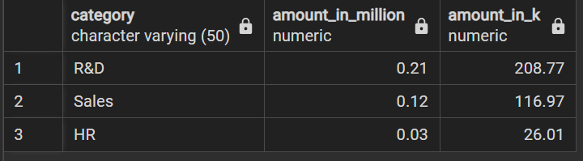

1. Marital allowance by Job Role

**For Current Employees**

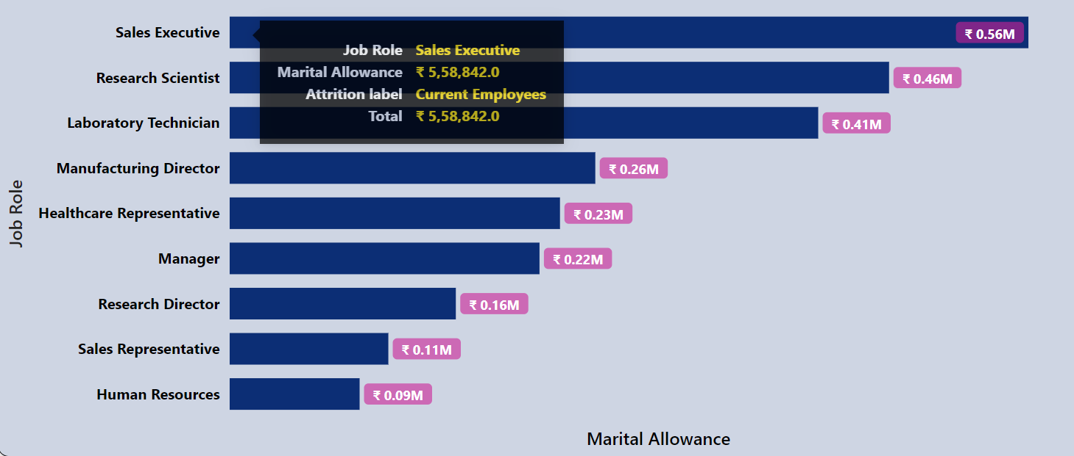

*-- for Current Employees*

*select job_role as category,*

*round(sum(marital_allowance_rs )/1000000 ,2) as amount_in_Million,*

*round(sum(marital_allowance_rs )/1000 ,2) as amount_in_k*

*from hr*

*where attrition_label = 'Current Employees'*

*group by category*

*order by amount_in_Million desc;*

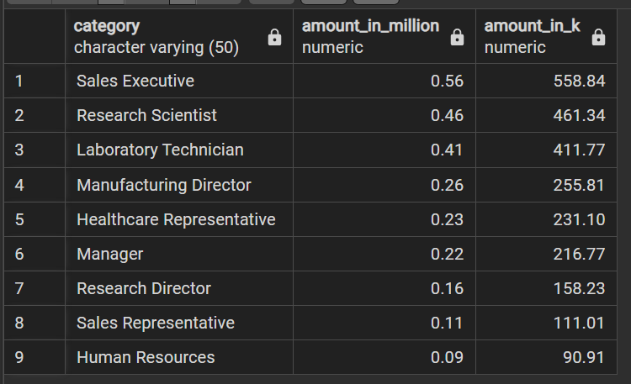

**For Ex-Employees**

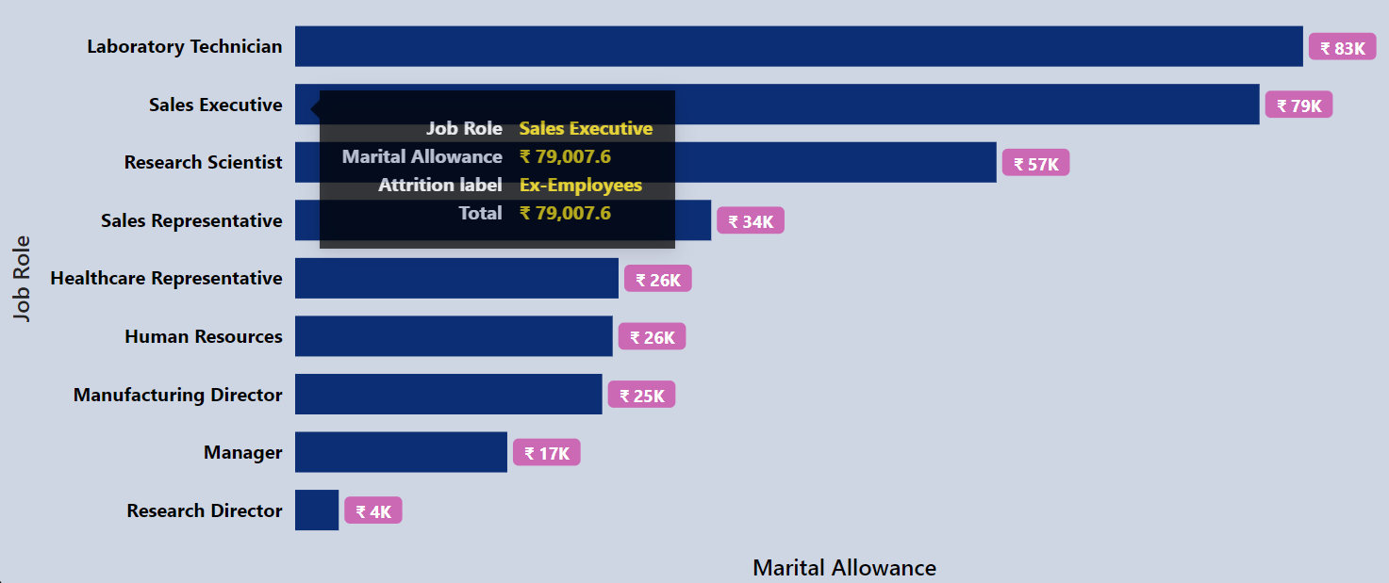

*-- for Ex-Employees*

*select job_role as category,*

*round(sum(marital_allowance_rs )/1000000 ,2) as amount_in_Million,*

*round(sum(marital_allowance_rs )/1000 ,2) as amount_in_k*

*from hr*

*where attrition_label = 'Ex-Employees'*

*group by category*

*order by amount_in_Million desc;*

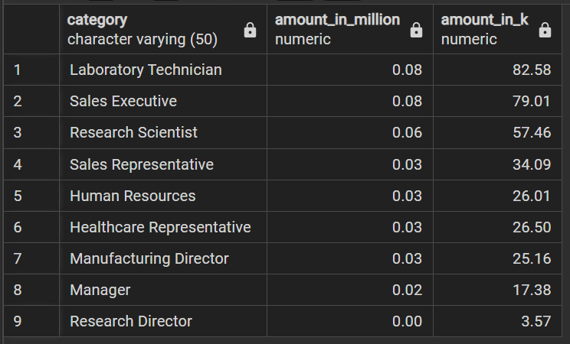

1. Marital allowance by Job Level

**For Current Employees**

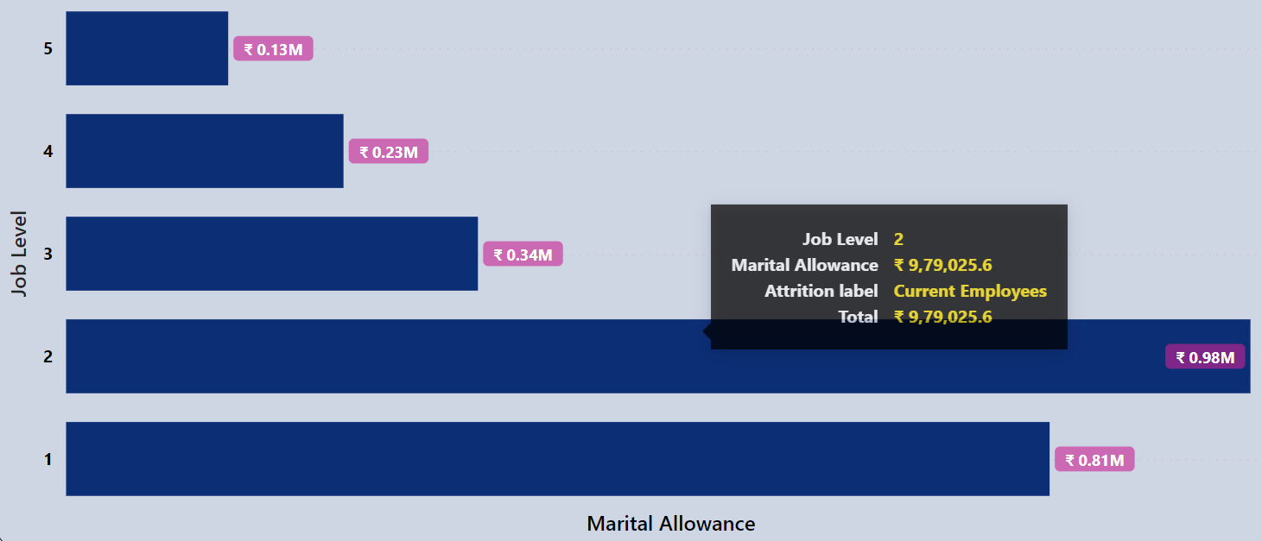

*-- for Current Employees*

*select job_level as category,*

*round(sum(marital_allowance_rs )/1000000 ,2) as amount_in_Million,*

*round(sum(marital_allowance_rs )/1000 ,2) as amount_in_k*

*from hr*

*where attrition_label = 'Current Employees'*

*group by category*

*order by category desc;*

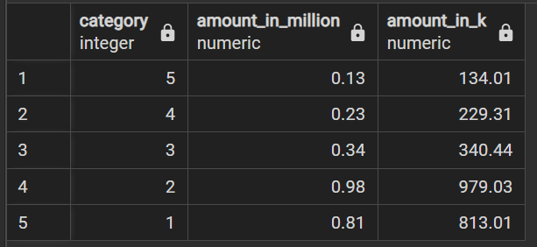

**For Ex-Employees**

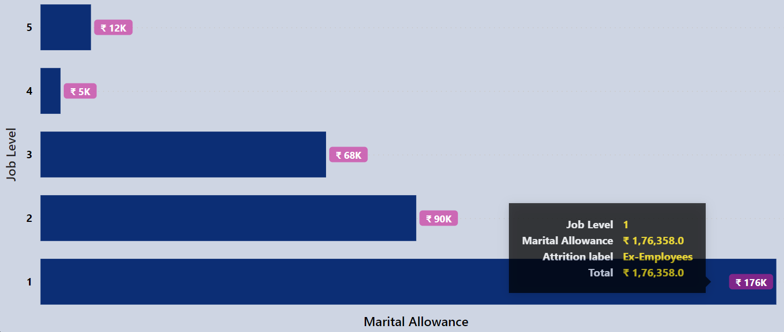

*-- for Ex-Employees*

*select job_level as category,*

*round(sum(marital_allowance_rs )/1000000 ,2) as amount_in_Million,*

*round(sum(marital_allowance_rs )/1000 ,2) as amount_in_k*

*from hr*

*where attrition_label = 'Ex-Employees'*

*group by category*

*order by category desc;*

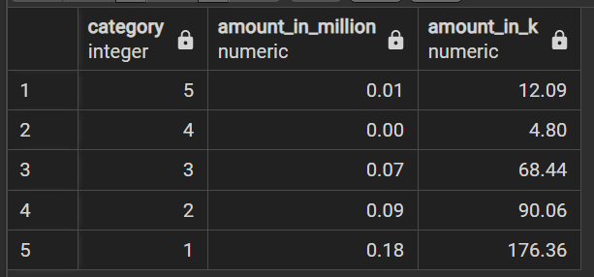

* **Yearly Base Salary Budget**

1. Base Saraly Budget by Age Group

**For Current Employees**

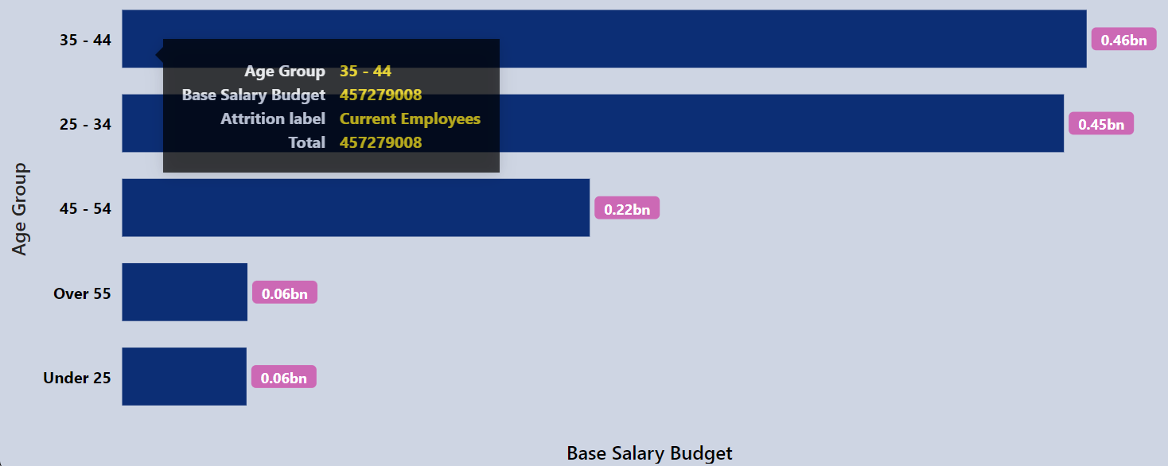

*-- for Current Employees*

*select age_group as category,*

*round(sum(yearly_salary_rs )/1000000000 ,2) as amount_in_Billion,*

*round(sum(yearly_salary_rs )/1000000 ,2) as amount_in_Million,*

*round(sum(yearly_salary_rs )/1000 ,2) as amount_in_k*

*from hr*

*where attrition_label = 'Current Employees'*

*group by category*

*order by amount_in_Million desc;*

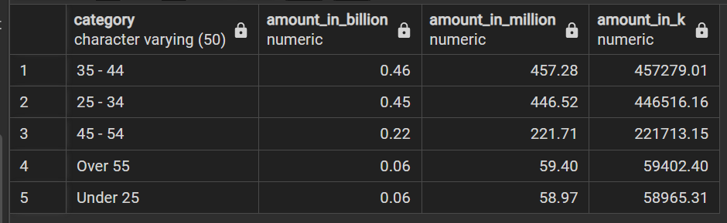

**For Ex-Employees**

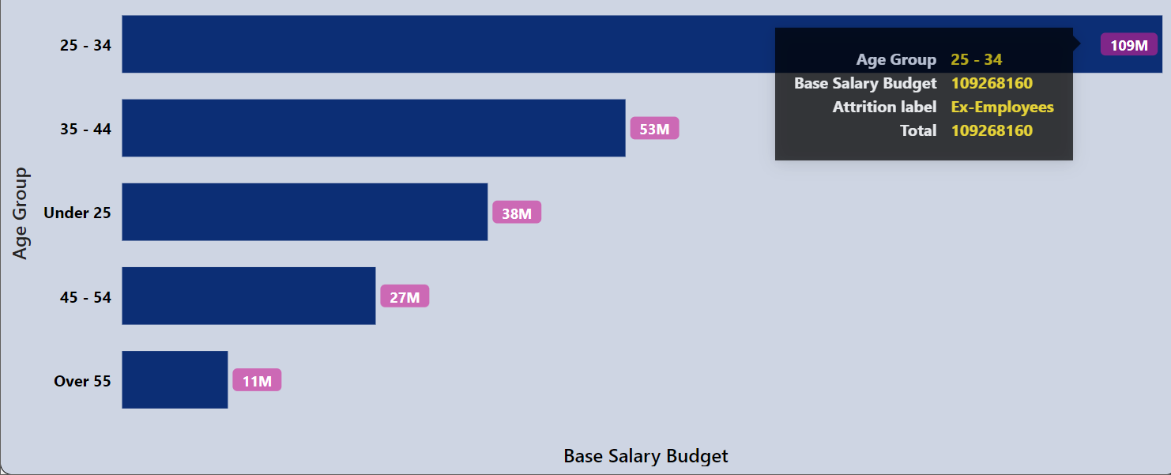

*-- for Ex-Employees*

*select age_group as category,*

*round(sum(yearly_salary_rs )/1000000000 ,2) as amount_in_Billion,*

*round(sum(yearly_salary_rs )/1000000 ,2) as amount_in_Million,*

*round(sum(yearly_salary_rs )/1000 ,2) as amount_in_k*

*from hr*

*where attrition_label = 'Ex-Employees'*

*group by category*

*order by amount_in_Million desc;*

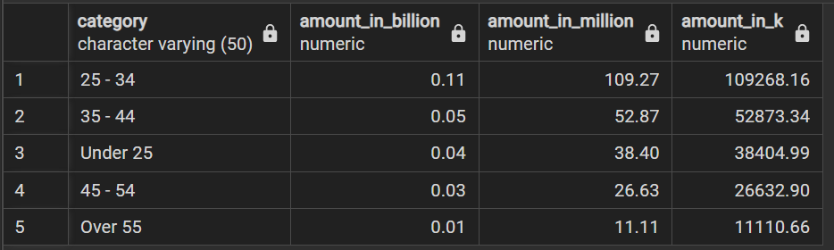

1. Base Saraly Budget by Gender

**For Current Employees**

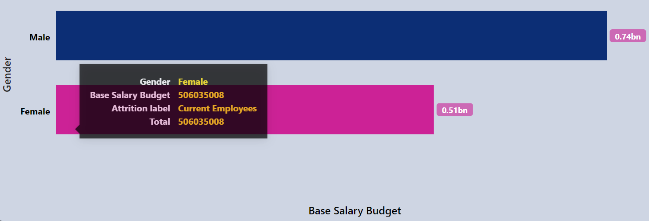

*-- for Current Employees*

*select gender as category,*

*round(sum(yearly_salary_rs )/1000000000 ,2) as amount_in_Billion,*

*round(sum(yearly_salary_rs )/1000000 ,2) as amount_in_Million,*

*round(sum(yearly_salary_rs )/1000 ,2) as amount_in_k*

*from hr*

*where attrition_label = 'Current Employees'*

*group by category*

*order by amount_in_Million desc;*

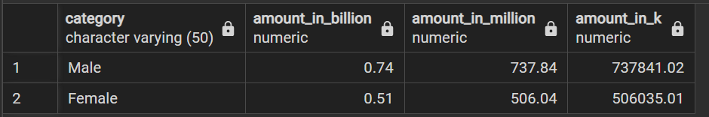

**For Ex-Employees**

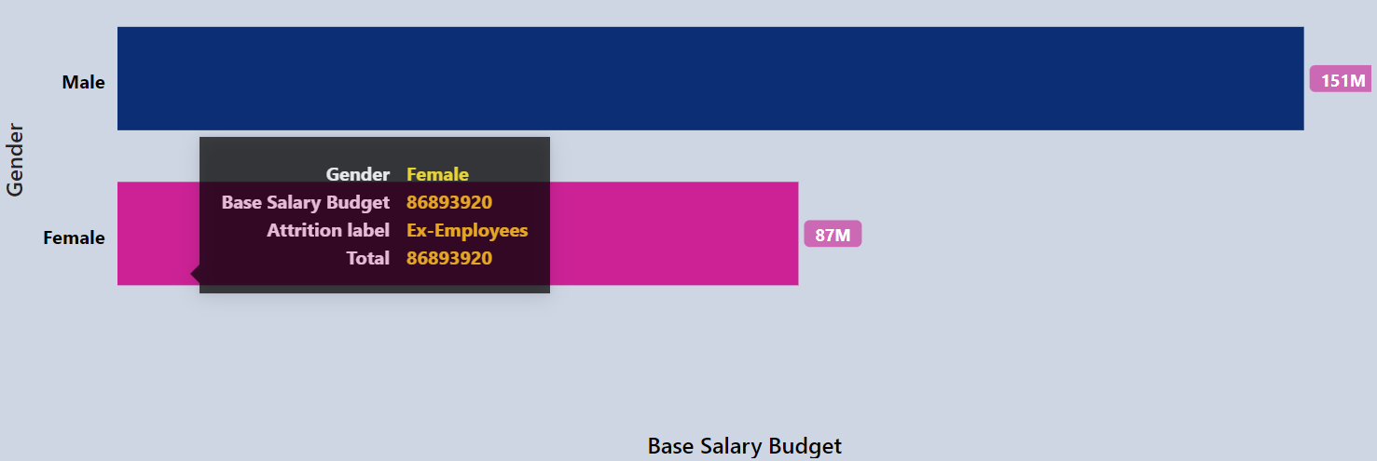

*-- for Ex-Employees*

*select gender as category,*

*round(sum(yearly_salary_rs )/1000000000 ,2) as amount_in_Billion,*

*round(sum(yearly_salary_rs )/1000000 ,2) as amount_in_Million,*

*round(sum(yearly_salary_rs )/1000 ,2) as amount_in_k*

*from hr*

*where attrition_label = 'Ex-Employees'*

*group by category*

*order by amount_in_Million desc;*

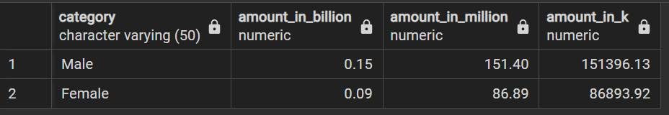

1. Base Saraly Budget by Department

**For Current Employees**

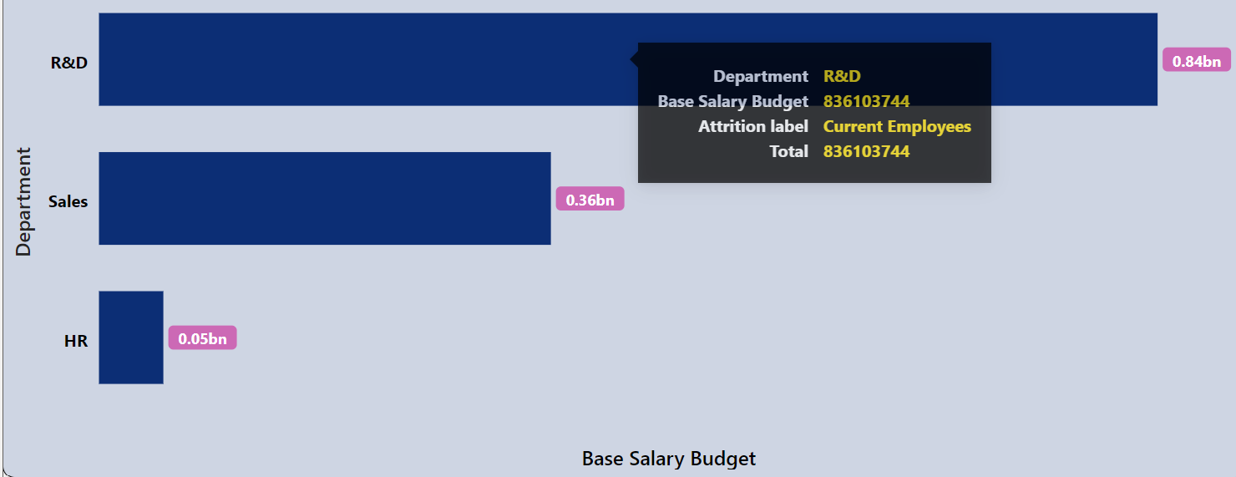

*-- for Current Employees*

*select department as category,*

*round(sum(yearly_salary_rs )/1000000000 ,2) as amount_in_Billion,*

*round(sum(yearly_salary_rs )/1000000 ,2) as amount_in_Million,*

*round(sum(yearly_salary_rs )/1000 ,2) as amount_in_k*

*from hr*

*where attrition_label = 'Current Employees'*

*group by category*

*order by amount_in_Million desc;*

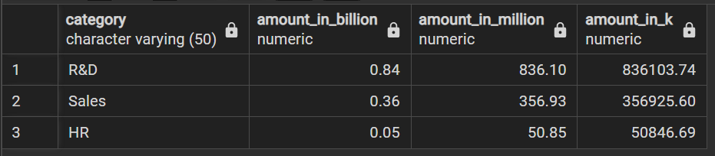

**For Ex-Employees**

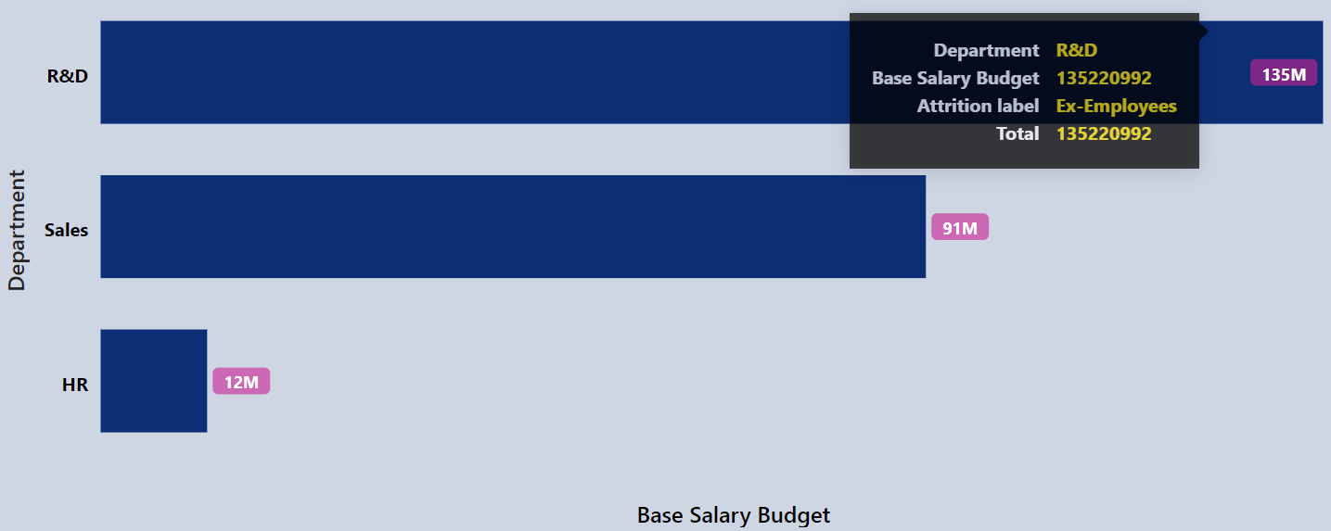

*-- for Ex-Employees*

*select department as category,*

*round(sum(yearly_salary_rs )/1000000000 ,2) as amount_in_Billion,*

*round(sum(yearly_salary_rs )/1000000 ,2) as amount_in_Million,*

*round(sum(yearly_salary_rs )/1000 ,2) as amount_in_k*

*from hr*

*where attrition_label = 'Ex-Employees'*

*group by category*

*order by amount_in_Million desc;*

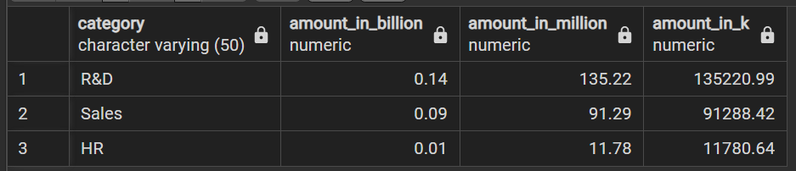

1. Base Saraly Budget by Job Role

**For Current Employees**

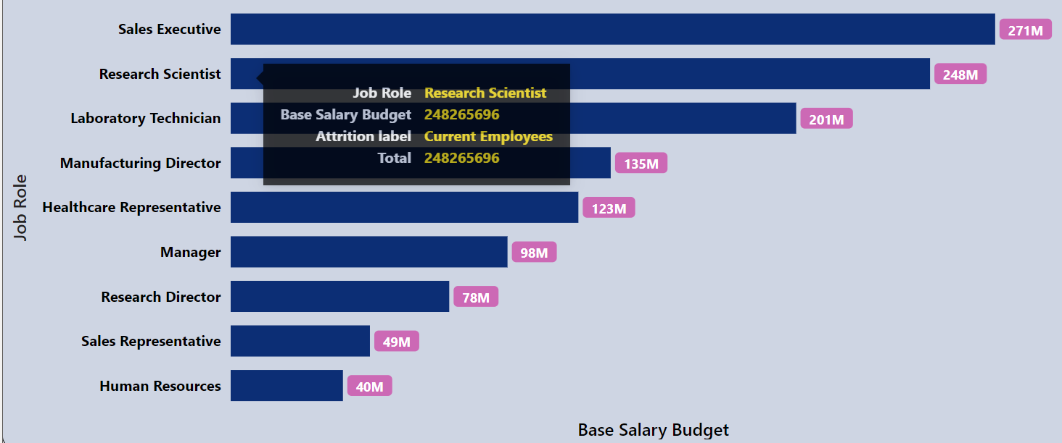

*-- for Current Employees*

*select job_role as category,*

*round(sum(yearly_salary_rs )/1000000000 ,2) as amount_in_Billion,*

*round(sum(yearly_salary_rs )/1000000 ,2) as amount_in_Million,*

*round(sum(yearly_salary_rs )/1000 ,2) as amount_in_k*

*from hr*

*where attrition_label = 'Current Employees'*

*group by category*

*order by amount_in_Million desc;*

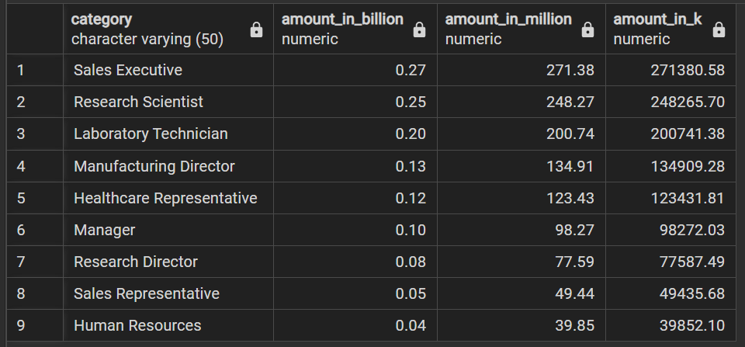

**For Ex-Employees**

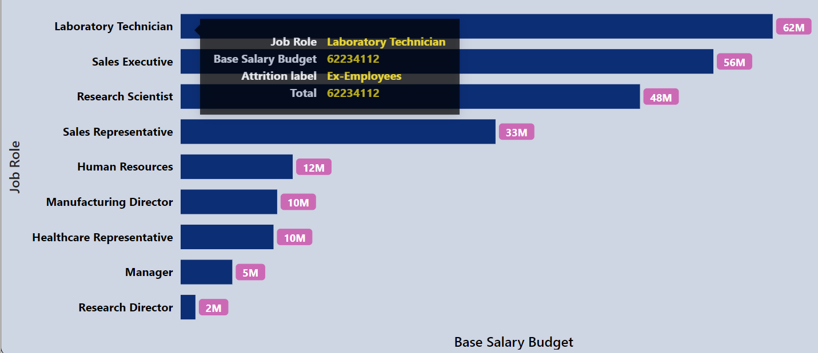

*-- for Ex-Employees*

*select job_role as category,*

*round(sum(yearly_salary_rs )/1000000000 ,2) as amount_in_Billion,*

*round(sum(yearly_salary_rs )/1000000 ,2) as amount_in_Million,*

*round(sum(yearly_salary_rs )/1000 ,2) as amount_in_k*

*from hr*

*where attrition_label = 'Ex-Employees'*

*group by category*

*order by amount_in_Million desc;*

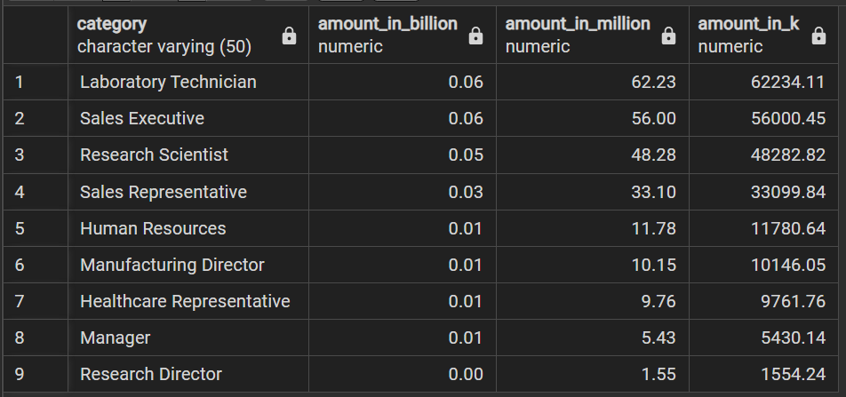

1. Base Saraly Budget by Job Level

**For Current Employees**

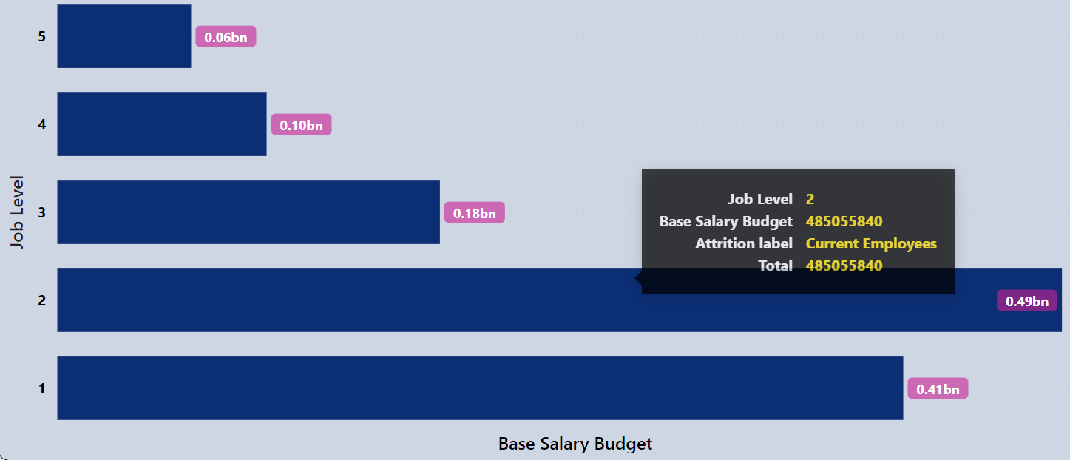

*-- for Current Employees*

*select job_level as category,*

*round(sum(yearly_salary_rs )/1000000000 ,2) as amount_in_Billion,*

*round(sum(yearly_salary_rs )/1000000 ,2) as amount_in_Million,*

*round(sum(yearly_salary_rs )/1000 ,2) as amount_in_k*

*from hr*

*where attrition_label = 'Current Employees'*

*group by category*

*order by category desc;*

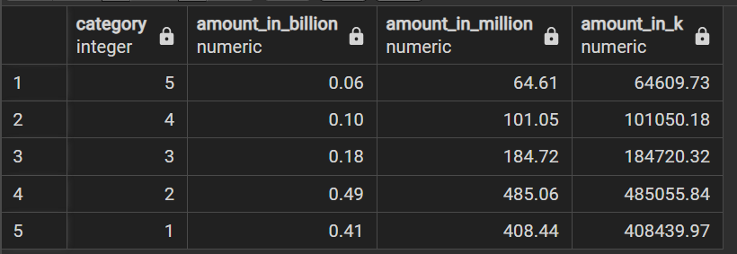

**For Ex-Employees**

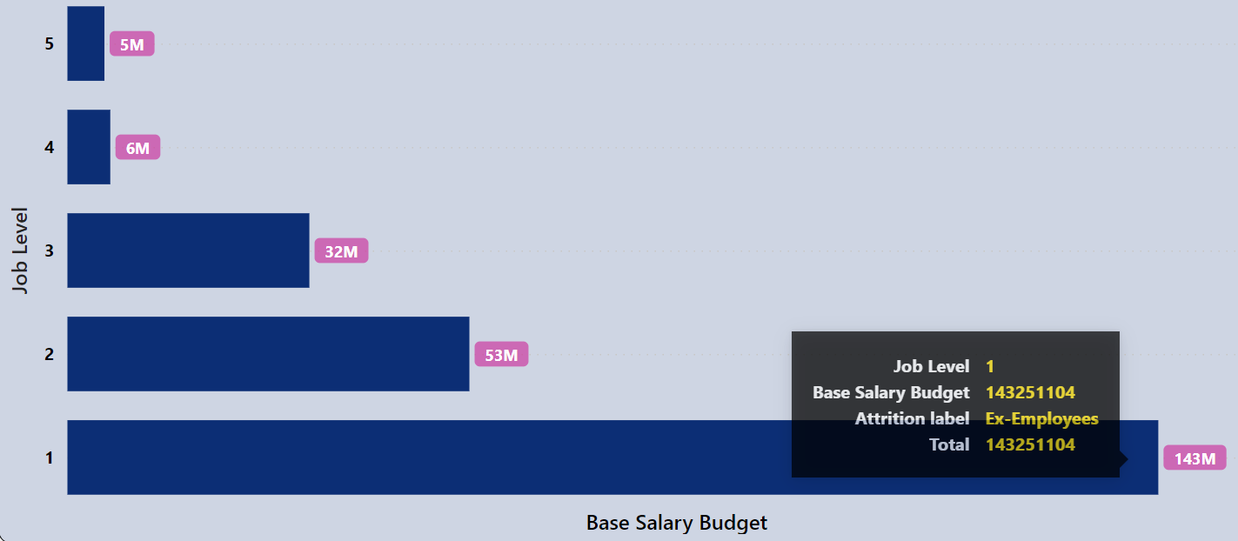

*-- for Ex-Employees*

*select job_level as category,*

*round(sum(yearly_salary_rs )/1000000000 ,2) as amount_in_Billion,*

*round(sum(yearly_salary_rs )/1000000 ,2) as amount_in_Million,*

*round(sum(yearly_salary_rs )/1000 ,2) as amount_in_k*

*from hr*

*where attrition_label = 'Ex-Employees'*

*group by category*

*order by category desc;*

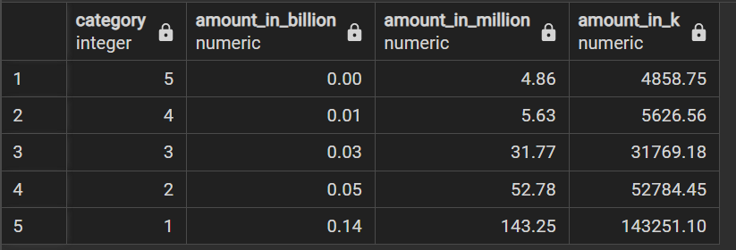

**For Dashboard Page- ‘Employees’ Performance’**

This dashboard page helps to analyse number of employees by different performance parameters of employees.

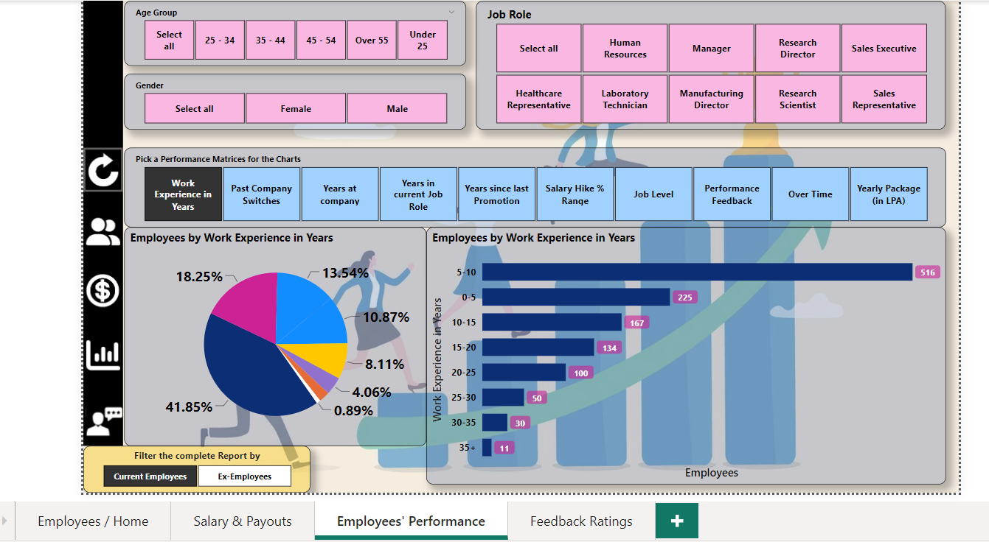

* **Employees by years of Work Experience**

**For Current Employees**

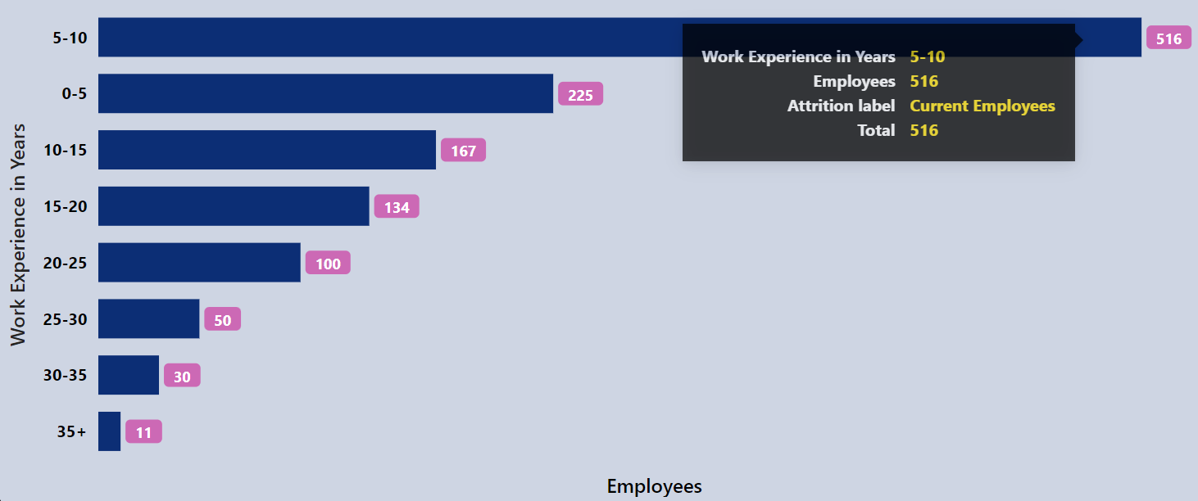

*-- For Current Employees*

*select range_work_x as performance_parameter,*

*count(*) as employees_count*

*from hr*

*where attrition_label = 'Current Employees'*

*group by performance_parameter*

*order by employees_count desc;*

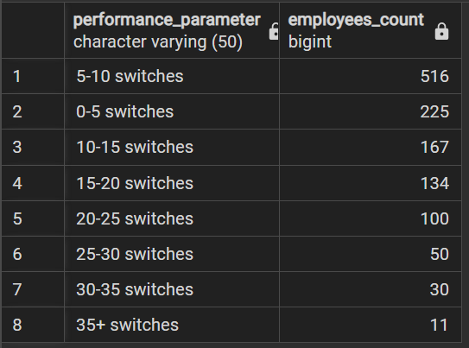

**For Ex-Employees**

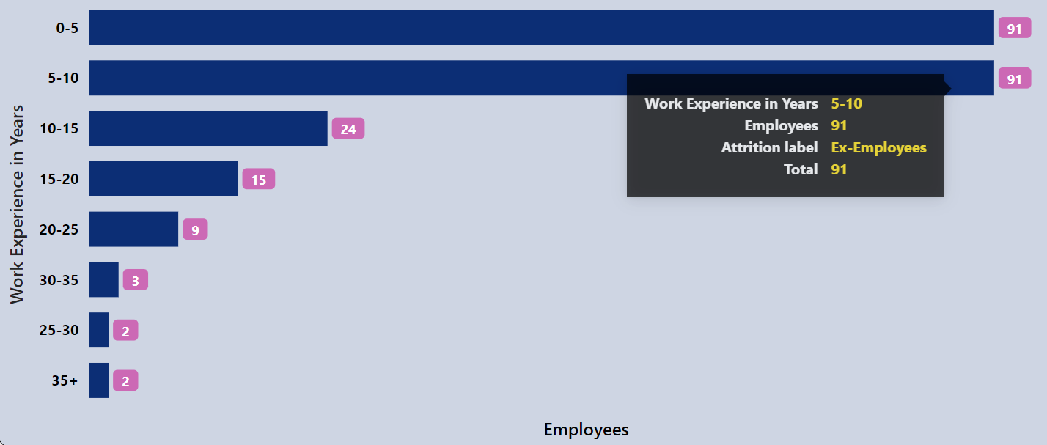

*-- For Ex-Employees*

*select range_work_x as performance_parameter,*

*count(*) as employees_count*

*from hr*

*where attrition_label = 'Ex-Employees'*

*group by performance_parameter*

*order by employees_count desc;*

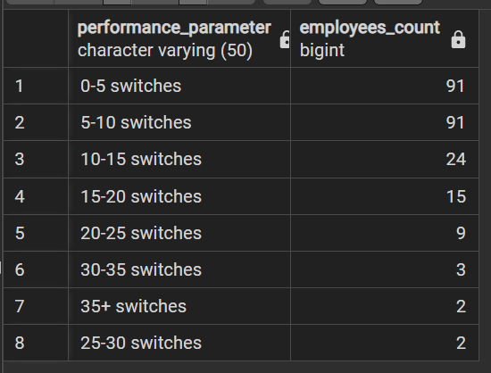

* **Employees by Past Company Switches**

**For Current Employees**

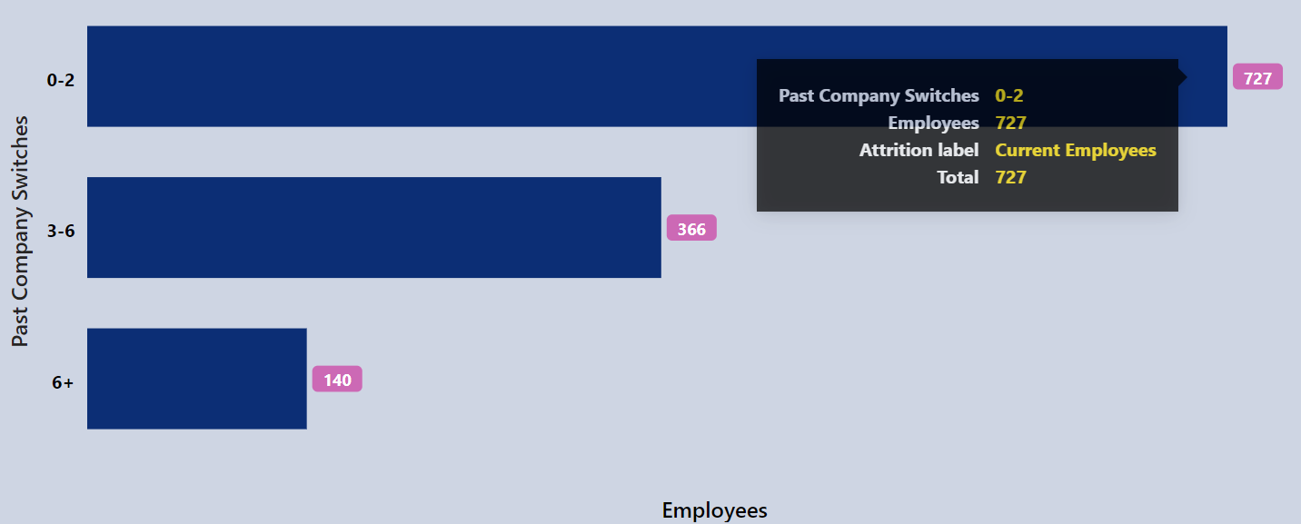

*-- For Current Employees*

*select range_company_switches as performance_parameter,*

*count(*) as employees_count*

*from hr*

*where attrition_label = 'Current Employees'*

*group by performance_parameter*

*order by employees_count desc;*

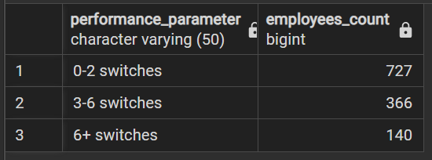

**For Ex-Employees**

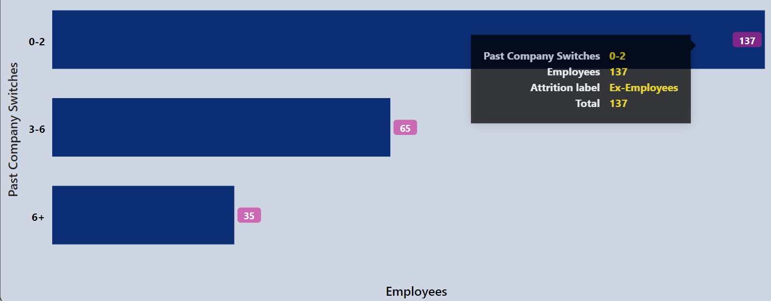

*-- For Ex-Employees*

*select range_company_switches as performance_parameter,*

*count(*) as employees_count*

*from hr*

*where attrition_label = 'Ex-Employees'*

*group by performance_parameter*

*order by employees_count desc;*

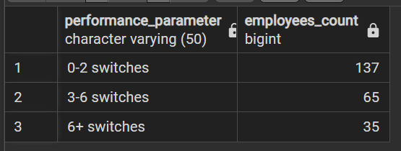

* **Employees by Working years at Company**

**For Current Employees**

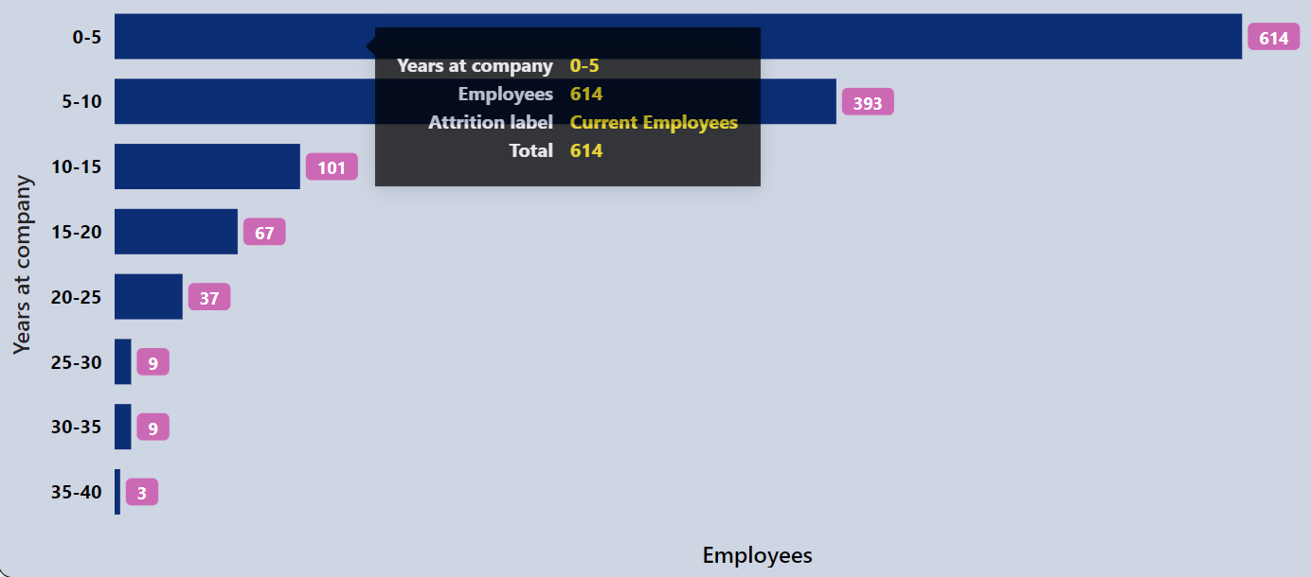

*-- For Current Employees*

*select range_years_at_company as performance_parameter,*

*count(*) as employees_count*

*from hr*

*where attrition_label = 'Current Employees'*

*group by performance_parameter*

*order by employees_count desc;*

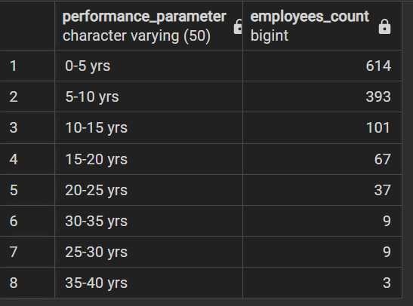

**For Ex-Employees**

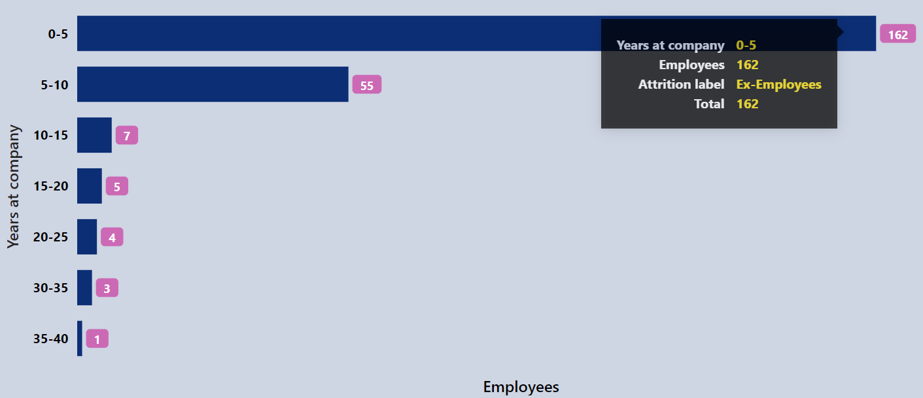

*-- For Ex-Employees*

*select range_years_at_company as performance_parameter,*

*count(*) as employees_count*

*from hr*

*where attrition_label = 'Ex-Employees'*

*group by performance_parameter*

*order by employees_count desc;*

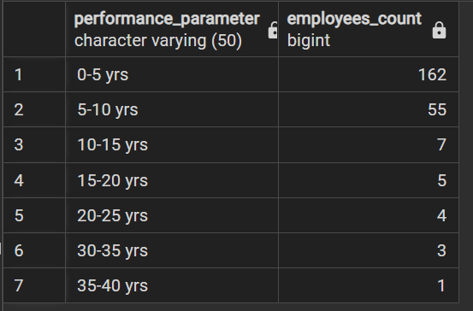

* **Employees by years in Current Job Role**

**For Current Employees**

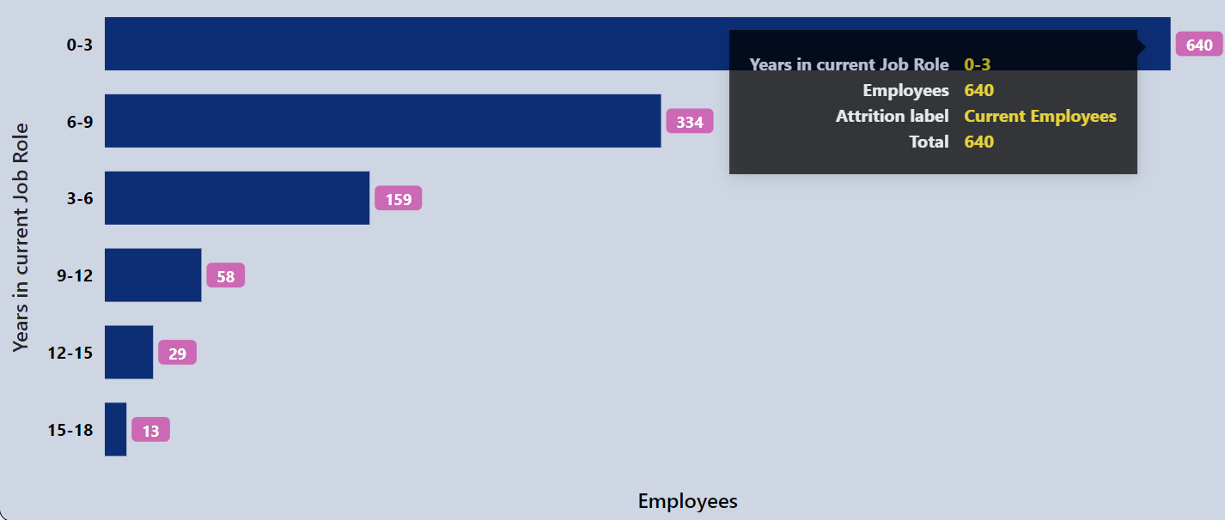

*-- For Current Employees*

*select range_years_in_curr_role as performance_parameter,*

*count(*) as employees_count*

*from hr*

*where attrition_label = 'Current Employees'*

*group by performance_parameter*

*order by employees_count desc;*

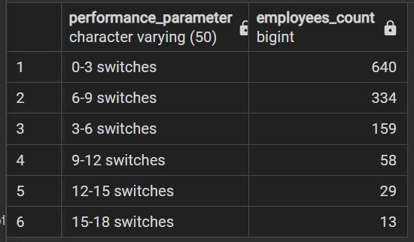

**For Ex-Employees**

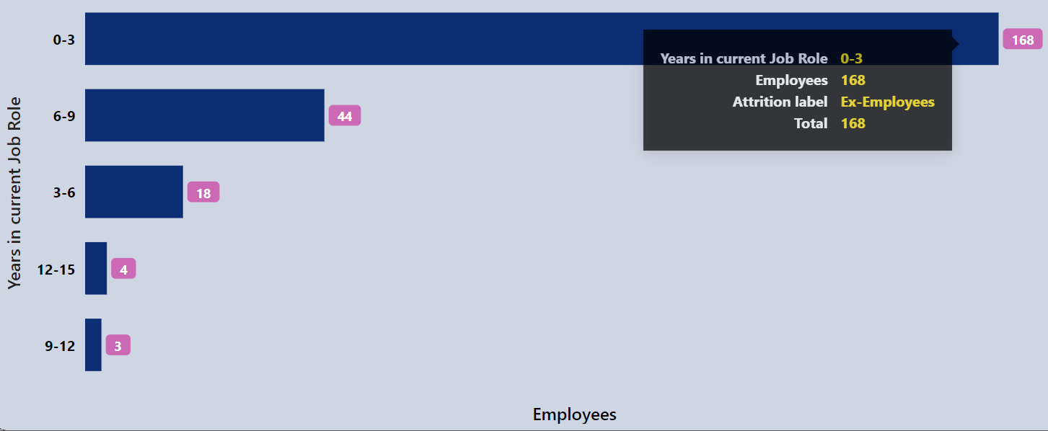

*-- For Ex-Employees*

*select range_years_in_curr_role as performance_parameter,*

*count(*) as employees_count*

*from hr*

*where attrition_label = 'Ex-Employees'*

*group by performance_parameter*

*order by employees_count desc;*

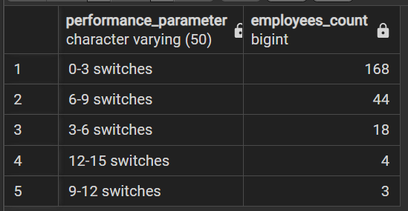

* **Employees by years since last Promotion**

**For Current Employees**

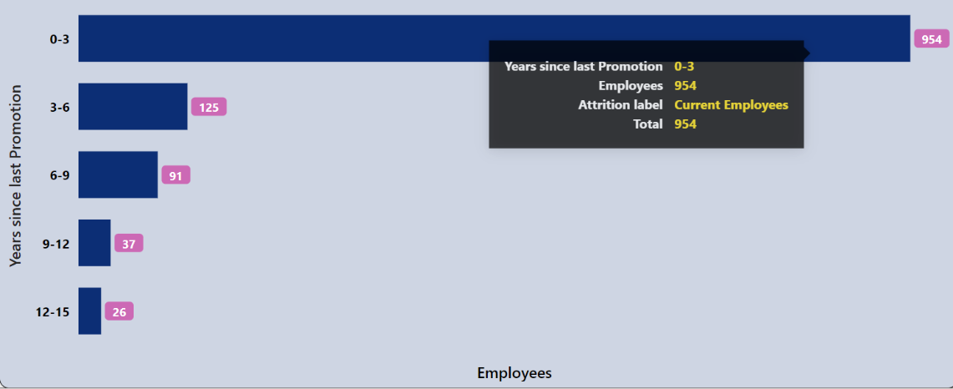

*-- For Current Employees*

*select range_years_since_last_promotion as performance_parameter,*

*count(*) as employees_count*

*from hr*

*where attrition_label = 'Current Employees'*

*group by performance_parameter*

*order by employees_count desc;*

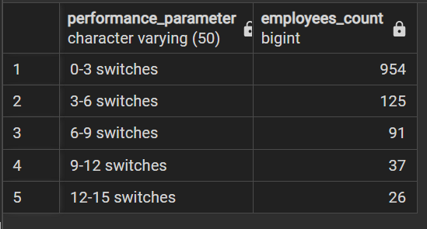

**For Ex-Employees**

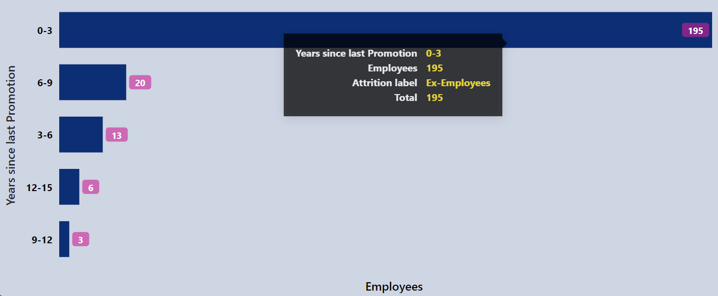

*-- For Ex-Employees*

*select range_years_since_last_promotion as performance_parameter,*

*count(*) as employees_count*

*from hr*

*where attrition_label = 'Ex-Employees'*

*group by performance_parameter*

*order by employees_count desc;*

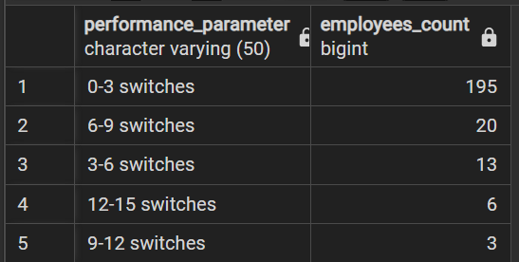

* **Employees by Salary Hike %**

**For Current Employees**

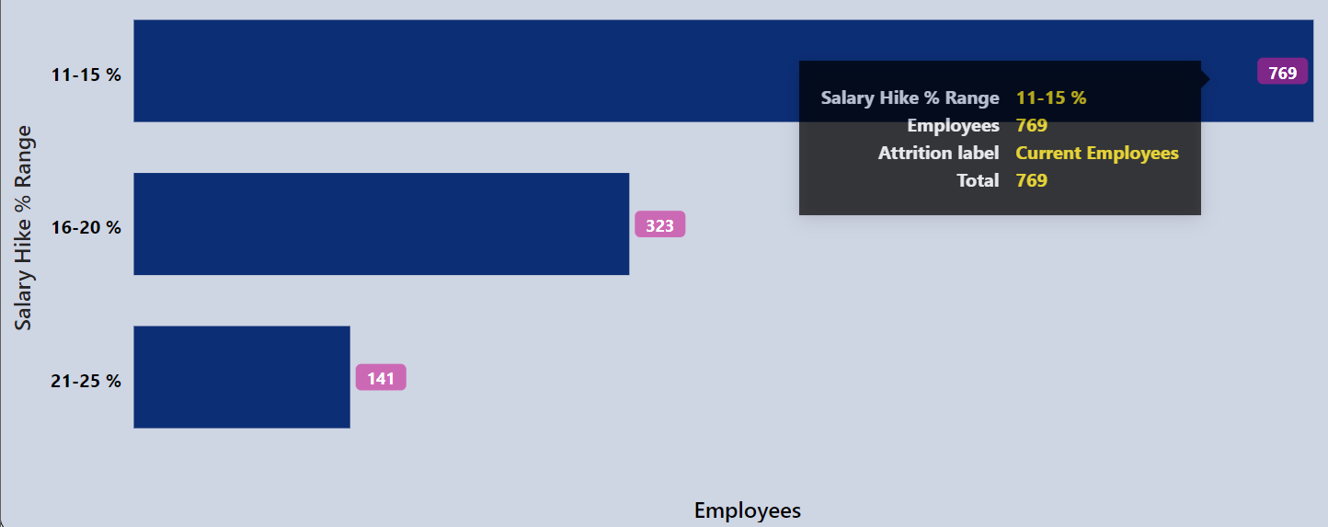

*-- For Current Employees*

*select range_salary_hike as performance_parameter,*

*count(*) as employees_count*

*from hr*

*where attrition_label = 'Current Employees'*

*group by performance_parameter*

*order by employees_count desc;*

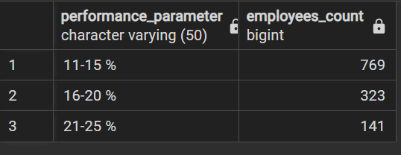

**For Ex-Employees**

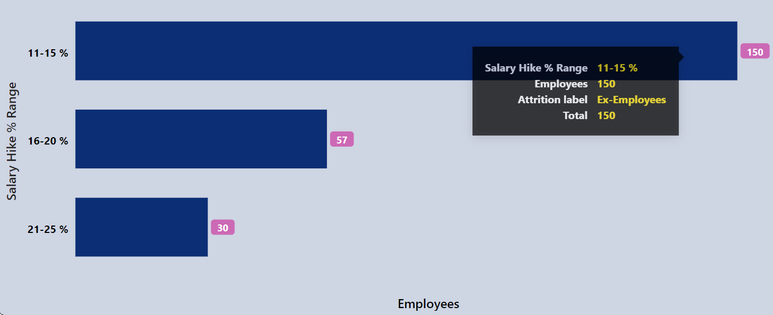

*-- For Ex-Employees*

*select range_salary_hike as performance_parameter,*

*count(*) as employees_count*

*from hr*

*where attrition_label = 'Ex-Employees'*

*group by performance_parameter*

*order by employees_count desc;*

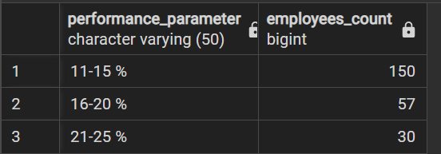

* **Employees by Job Level**

**For Current Employees**

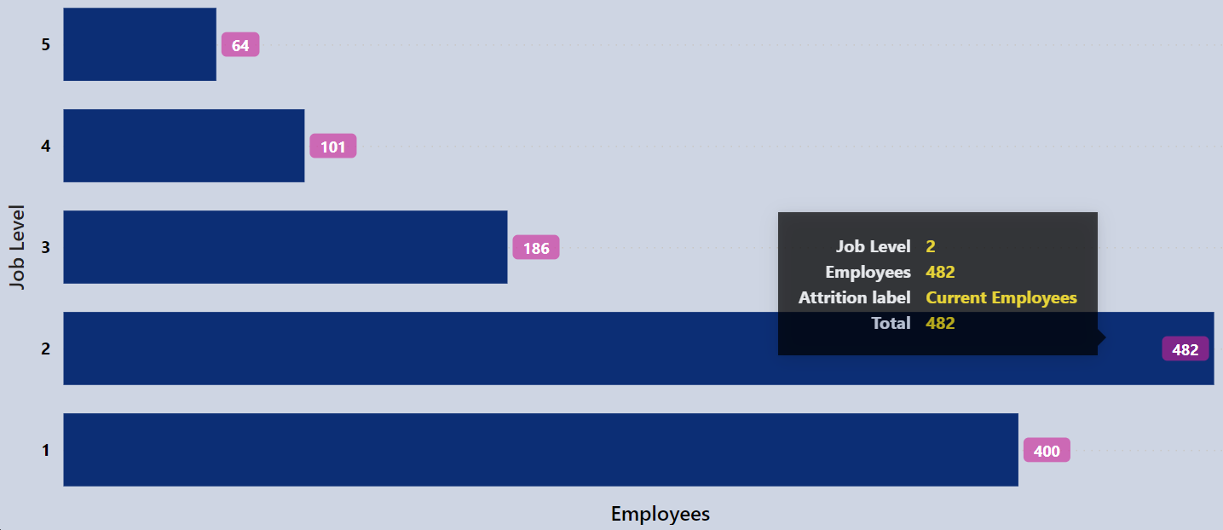

*-- For Current Employees*

*select job_level as performance_parameter,*

*count(*) as employees_count*

*from hr*

*where attrition_label = 'Current Employees'*

*group by performance_parameter*

*order by performance_parameter desc;*

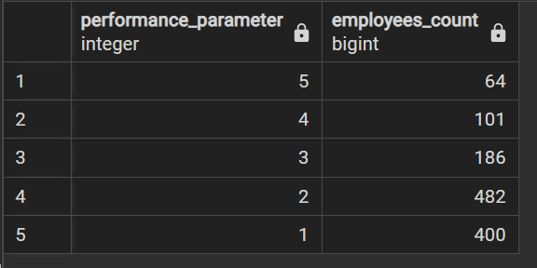

**For Ex-Employees**

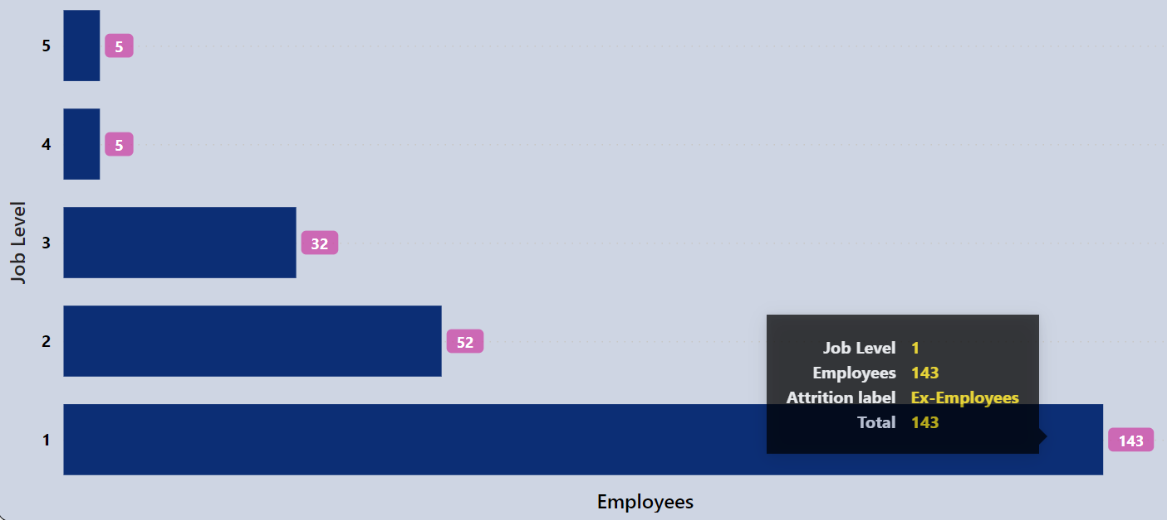

*-- For Ex-Employees*

*select job_level as performance_parameter,*

*count(*) as employees_count*

*from hr*

*where attrition_label = 'Ex-Employees'*

*group by performance_parameter*

*order by performance_parameter desc;*

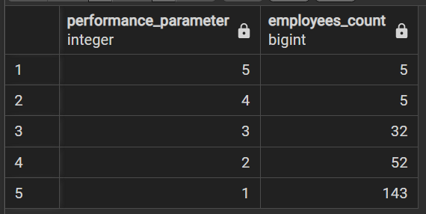

* **Employees by Performance Feedback**

**For Current Employees**

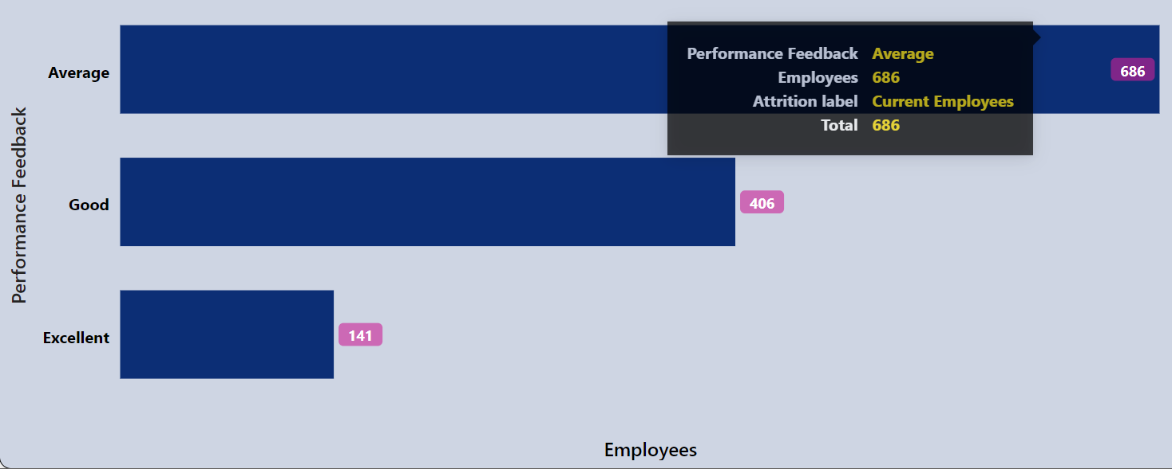

*-- For Current Employees*

*select performance as performance_parameter,*

*count(*) as employees_count*

*from hr*

*where attrition_label = 'Current Employees'*

*group by performance_parameter*

*order by employees_count desc;*

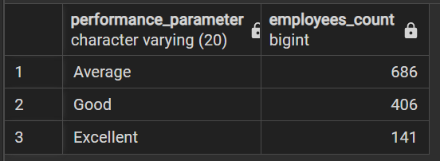

**For Ex-Employees**

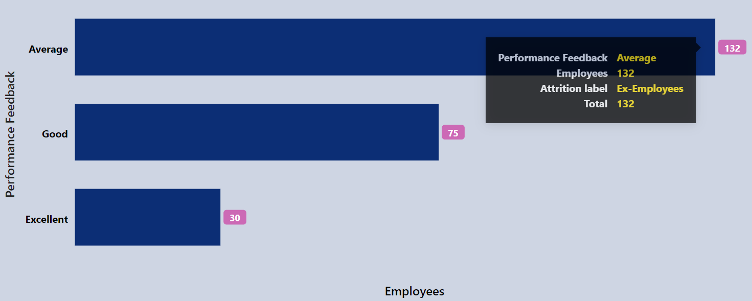

*-- For Ex-Employees*

*select performance as performance_parameter,*

*count(*) as employees_count*

*from hr*

*where attrition_label = 'Ex-Employees'*

*group by performance_parameter*

*order by employees_count desc;*

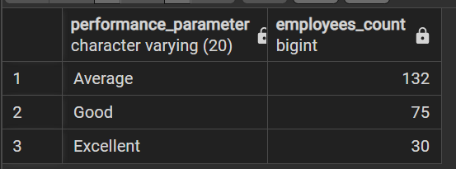

* **Employees by Over Time**

**For Current Employees**

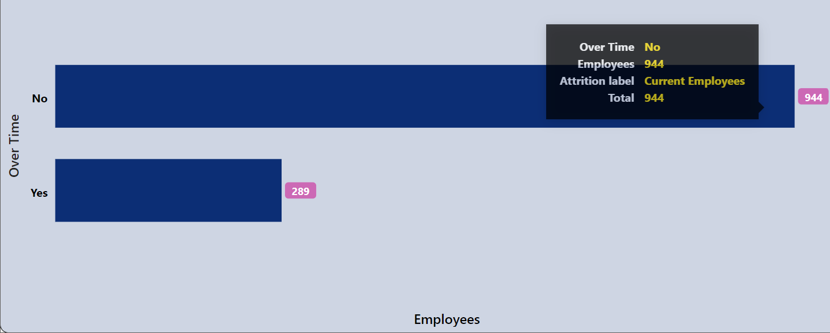

*-- For Current Employees*

*select over_time as performance_parameter,*

*count(*) as employees_count*

*from hr*

*where attrition_label = 'Current Employees'*

*group by performance_parameter*

*order by employees_count desc;*

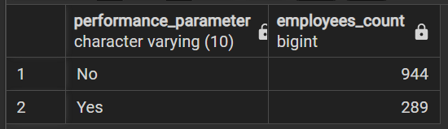

**For Ex-Employees**

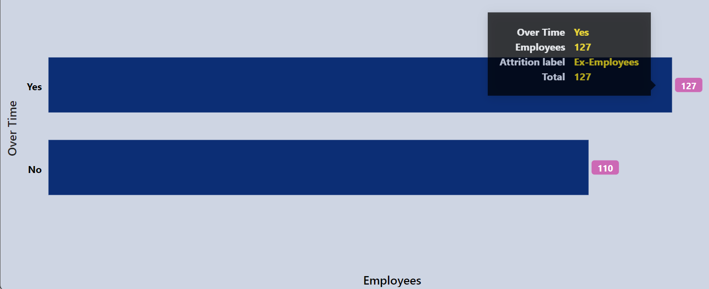

*-- For Ex-Employees*

*select over_time as performance_parameter,*

*count(*) as employees_count*

*from hr*

*where attrition_label = 'Ex-Employees'*

*group by performance_parameter*

*order by employees_count desc;*

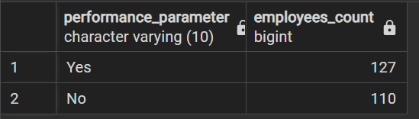

* **Employees by Salary Package (in LPA)**

**For Current Employees**

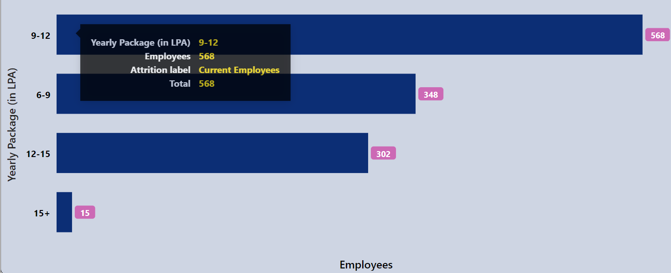

*-- For Current Employees*

*select range_yearly_package as performance_parameter,*

*count(*) as employees_count*

*from hr*

*where attrition_label = 'Current Employees'*

*group by performance_parameter*

*order by employees_count desc;*

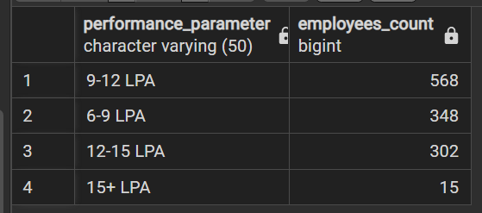

**For Ex-Employees**

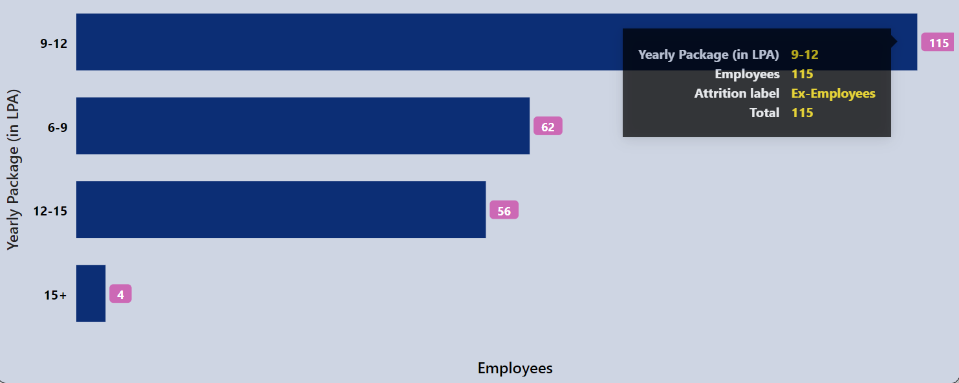

*-- For Ex-Employees*

*select range_yearly_package as performance_parameter,*

*count(*) as employees_count*

*from hr*

*where attrition_label = 'Ex-Employees'*

*group by performance_parameter*

*order by employees_count desc;*

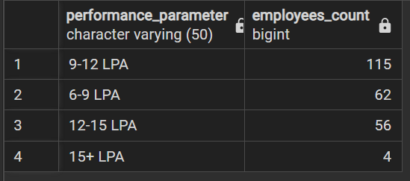

**For Dashboard Page- ‘Feedback Ratings’**

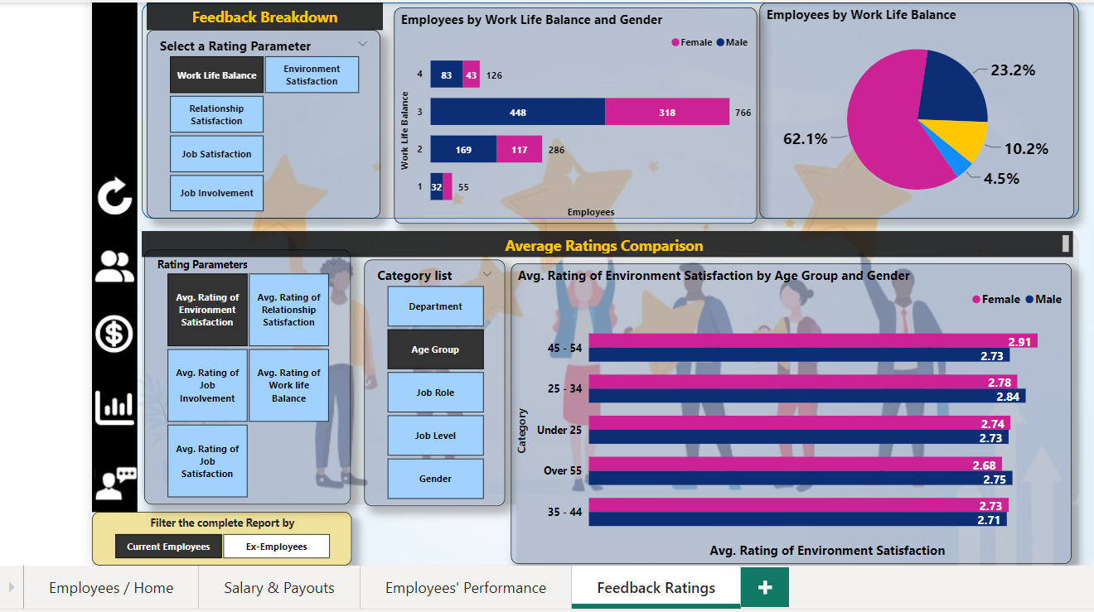

Feedback Ratings Breakdown

This Visualization chart help us to analyse number of employees by each rating scale value for every Feedback rating parameter (like work life balance).

**Note**: To validate every chart in the segment ‘Feedback Ratings Breakdown’, we have executed three queries for three different values on a chart.

Query 1 – validating total employee count.

Query 2– validating total Male employee count.

Query 3 – validating total Female employee count.

* **Employees by Work life Balance**

**For Current Employees**

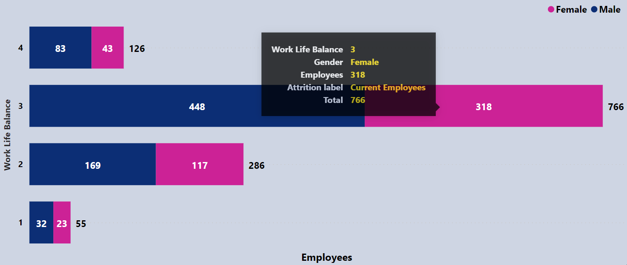

-- wlb curr total

select work_life_balance_rating as rating_values,

count(*) as totol_count

from hr

where attrition_label = 'Current Employees'

group by rating_values

order by rating_values desc;

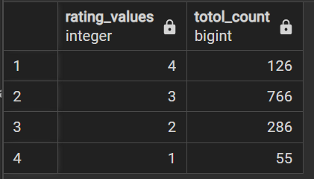

-- wlb curr male

select work_life_balance_rating as rating_values,

count(*) as male_count

from hr

where attrition_label = 'Current Employees' and gender = 'Male'

group by rating_values

order by rating_values desc;

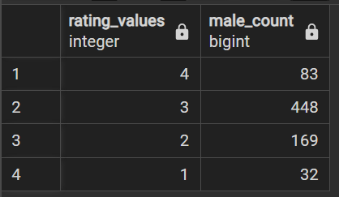

-- wlb curr female

select work_life_balance_rating as rating_values,

count(*) as female_count

from hr

where attrition_label = 'Current Employees' and gender = 'Female'

group by rating_values

order by rating_values desc;

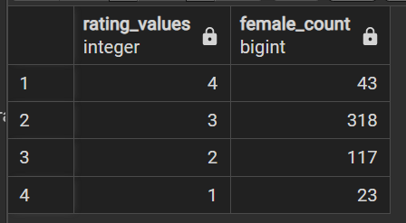

**For Ex-Employees**

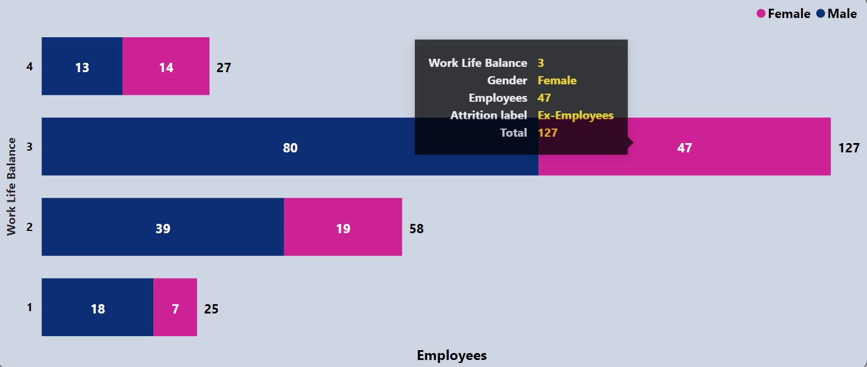

-- wlb x total

select work_life_balance_rating as rating_values,

count(*) as totol_count

from hr

where attrition_label = 'Ex-Employees'

group by rating_values

order by rating_values desc;

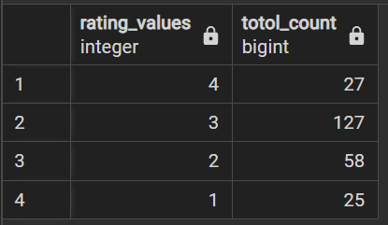

-- wlb x male

select work_life_balance_rating as rating_values,

count(*) as male_count

from hr

where attrition_label = 'Ex-Employees' and gender = 'Male'

group by rating_values

order by rating_values desc;

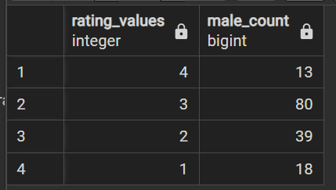

-- wlb x female

select work_life_balance_rating as rating_values,

count(*) as female_count

from hr

where attrition_label = 'Ex-Employees' and gender = 'Female'

group by rating_values

order by rating_values desc;

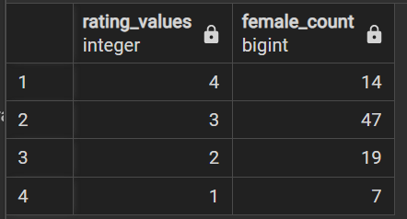

* **Employees by Relationship Satisfaction**

**For Current Employees**

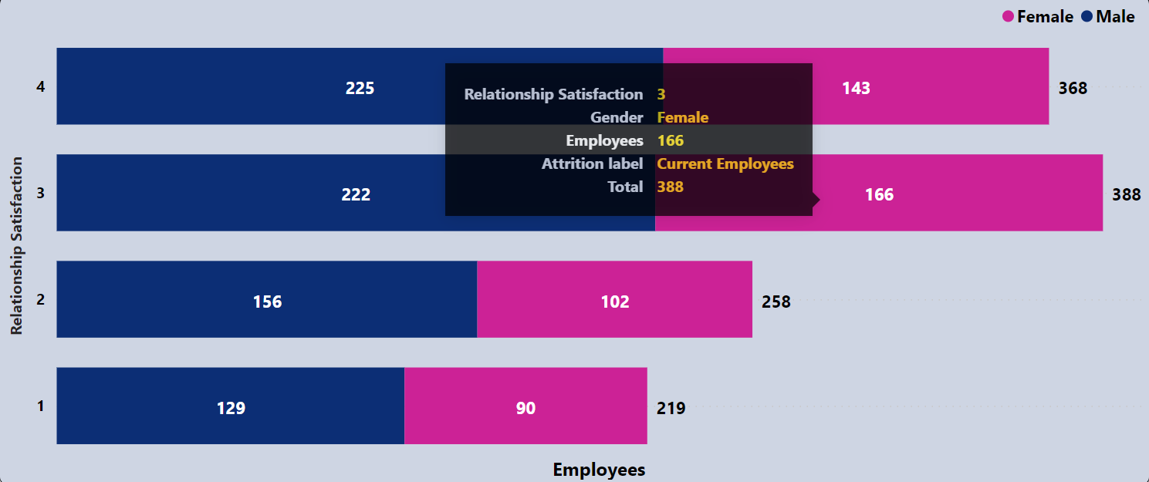

-- rs curr total

select relationship_satisfaction_rating as rating_values,

count(*) as totol_count

from hr

where attrition_label = 'Current Employees'

group by rating_values

order by rating_values desc;

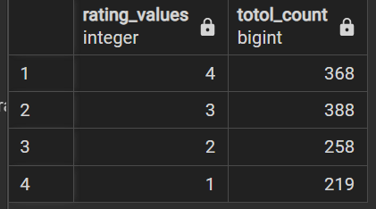

-- rs curr male

select relationship_satisfaction_rating as rating_values,

count(*) as male_count

from hr

where attrition_label = 'Current Employees' and gender = 'Male'

group by rating_values

order by rating_values desc;

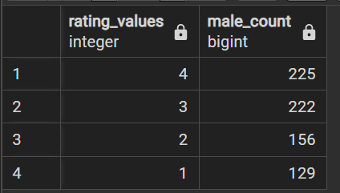

-- rs curr female

select relationship_satisfaction_rating as rating_values,

count(*) as female_count

from hr

where attrition_label = 'Current Employees' and gender = 'Female'

group by rating_values

order by rating_values desc;

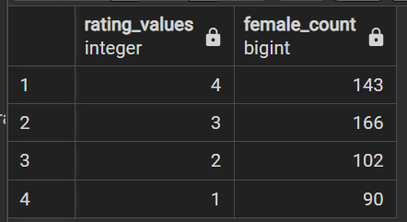

**For Ex-Employees**

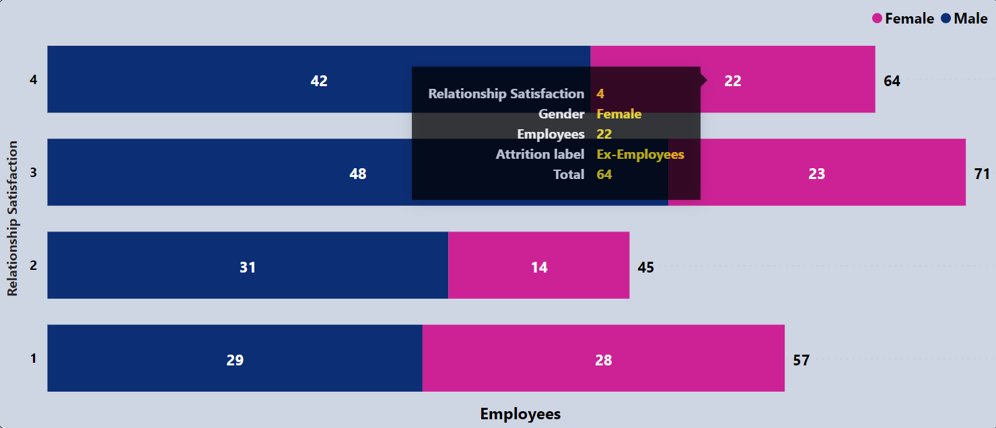

-- rs x total

select relationship_satisfaction_rating as rating_values,

count(*) as totol_count

from hr

where attrition_label = 'Ex-Employees'

group by rating_values

order by rating_values desc;

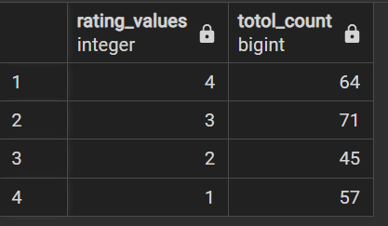

-- rs x male

select relationship_satisfaction_rating as rating_values,

count(*) as male_count

from hr

where attrition_label = 'Ex-Employees' and gender = 'Male'

group by rating_values

order by rating_values desc;

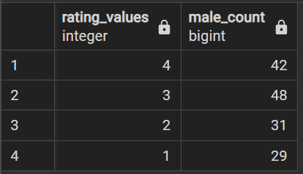

-- rs x female

select relationship_satisfaction_rating as rating_values,

count(*) as female_count

from hr

where attrition_label = 'Ex-Employees' and gender = 'Female'

group by rating_values

order by rating_values desc;

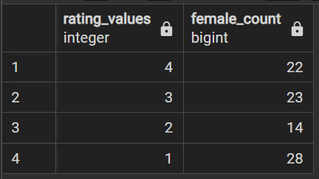

* **Employees by Job Satisfaction**

**For Current Employees**

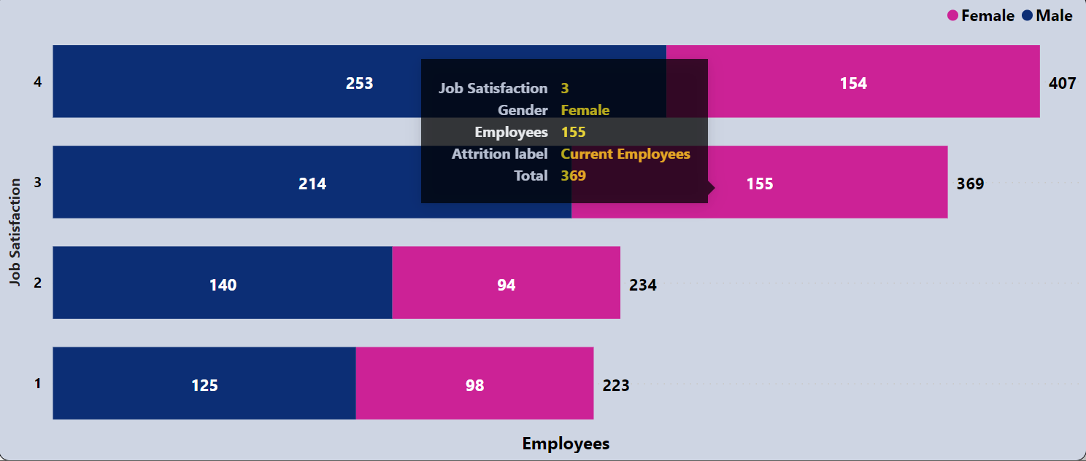

-- js curr total

select job_satisfaction_rating as rating_values,

count(*) as totol_count

from hr

where attrition_label = 'Current Employees'

group by rating_values

order by rating_values desc;

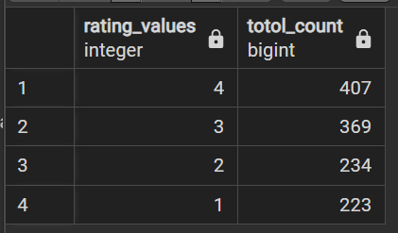

-- js curr male

select job_satisfaction_rating as rating_values,

count(*) as male_count

from hr

where attrition_label = 'Current Employees' and gender = 'Male'

group by rating_values

order by rating_values desc;

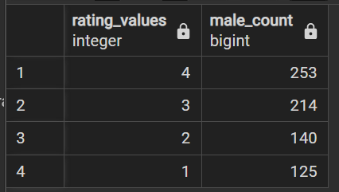

-- js curr female

select job_satisfaction_rating as rating_values,

count(*) as female_count

from hr

where attrition_label = 'Current Employees' and gender = 'Female'

group by rating_values

order by rating_values desc;

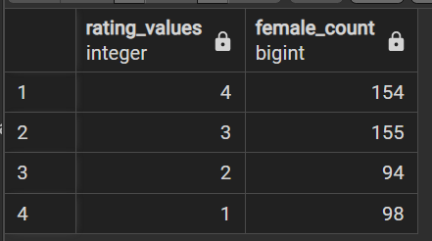

**For Ex-Employees**

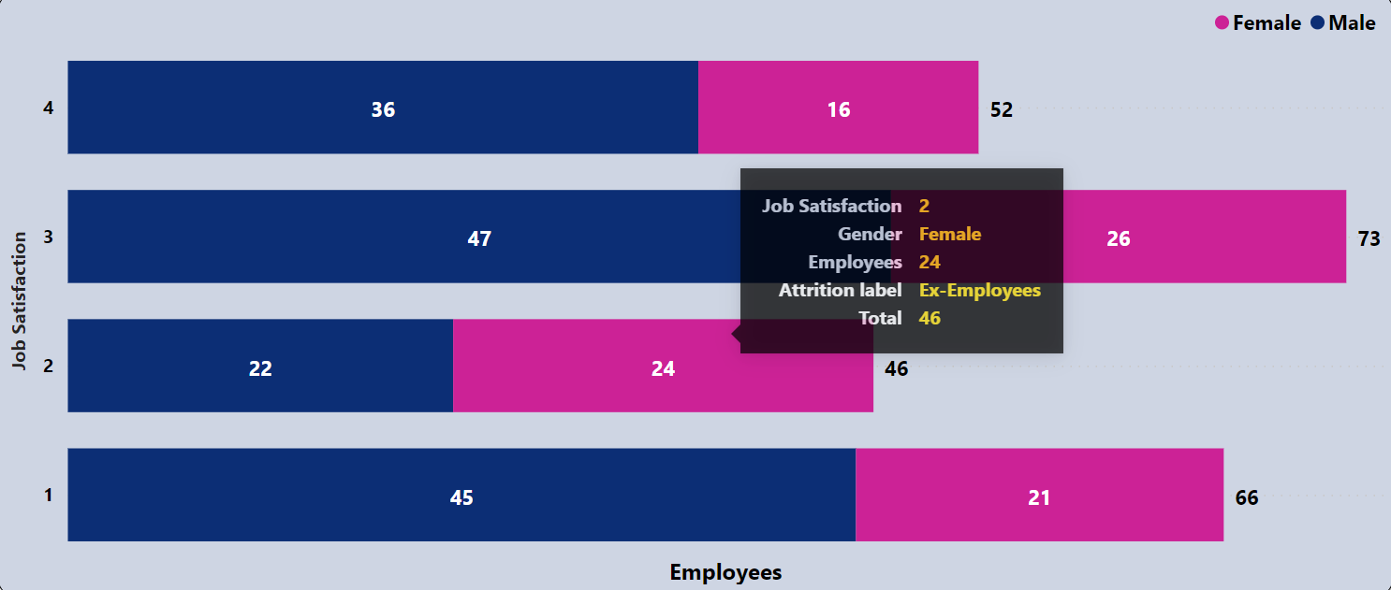

-- js x total

select job_satisfaction_rating as rating_values,

count(*) as totol_count

from hr

where attrition_label = 'Ex-Employees'

group by rating_values

order by rating_values desc;

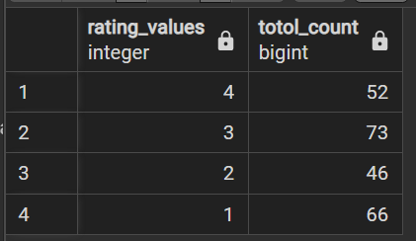

-- js x male

select job_satisfaction_rating as rating_values,

count(*) as male_count

from hr

where attrition_label = 'Ex-Employees' and gender = 'Male'

group by rating_values

order by rating_values desc;

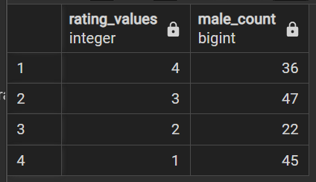

-- js x female

select job_satisfaction_rating as rating_values,

count(*) as female_count

from hr

where attrition_label = 'Ex-Employees' and gender = 'Female'

group by rating_values

order by rating_values desc;

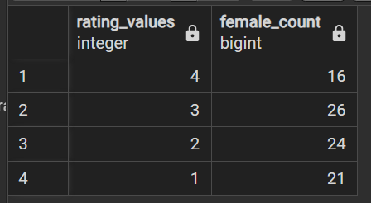

* **Employees by Job involvement**

**For Current Employees**

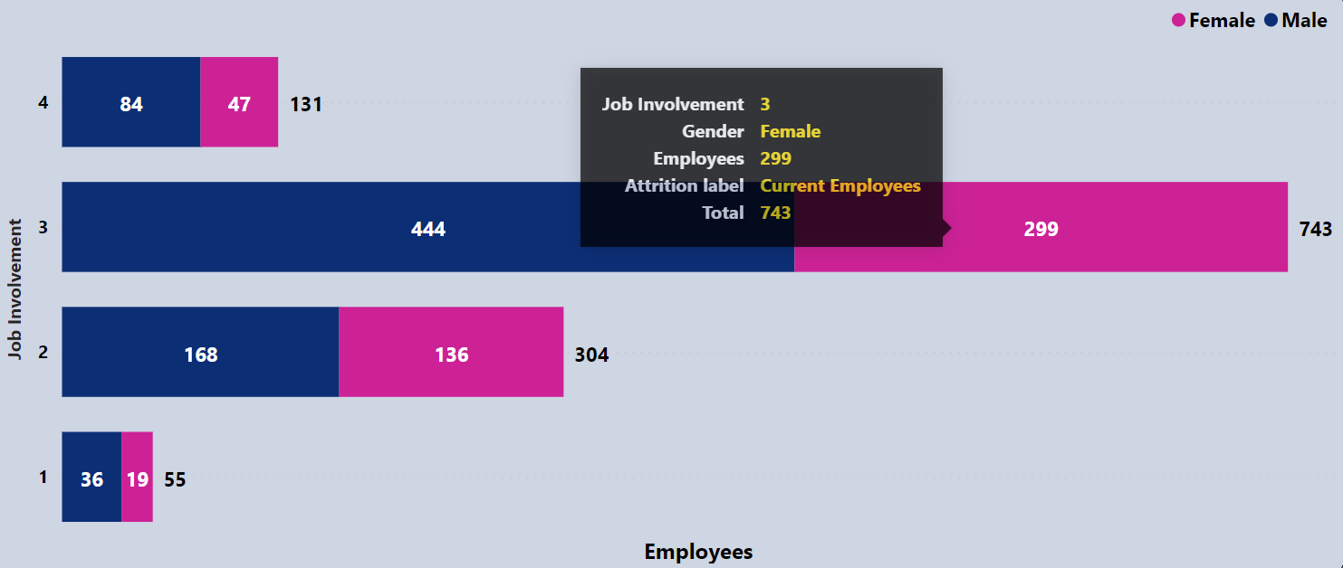

-- ji curr total

select job_involvement_rating as rating_values,

count(*) as totol_count

from hr

where attrition_label = 'Current Employees'

group by rating_values

order by rating_values desc;

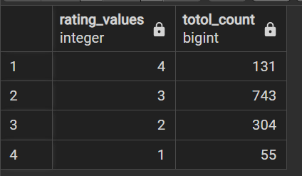

-- ji curr male

select job_involvement_rating as rating_values,

count(*) as male_count

from hr

where attrition_label = 'Current Employees' and gender = 'Male'

group by rating_values

order by rating_values desc;

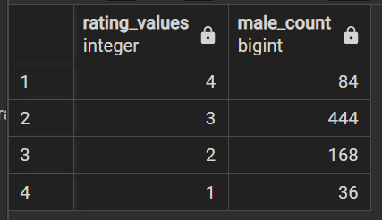

-- ji curr female

select job_involvement_rating as rating_values,

count(*) as female_count

from hr

where attrition_label = 'Current Employees' and gender = 'Female'

group by rating_values

order by rating_values desc;

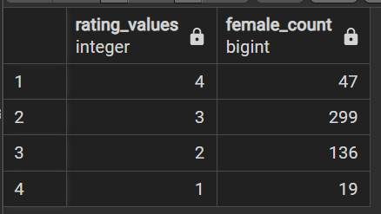

**For Ex-Employees**

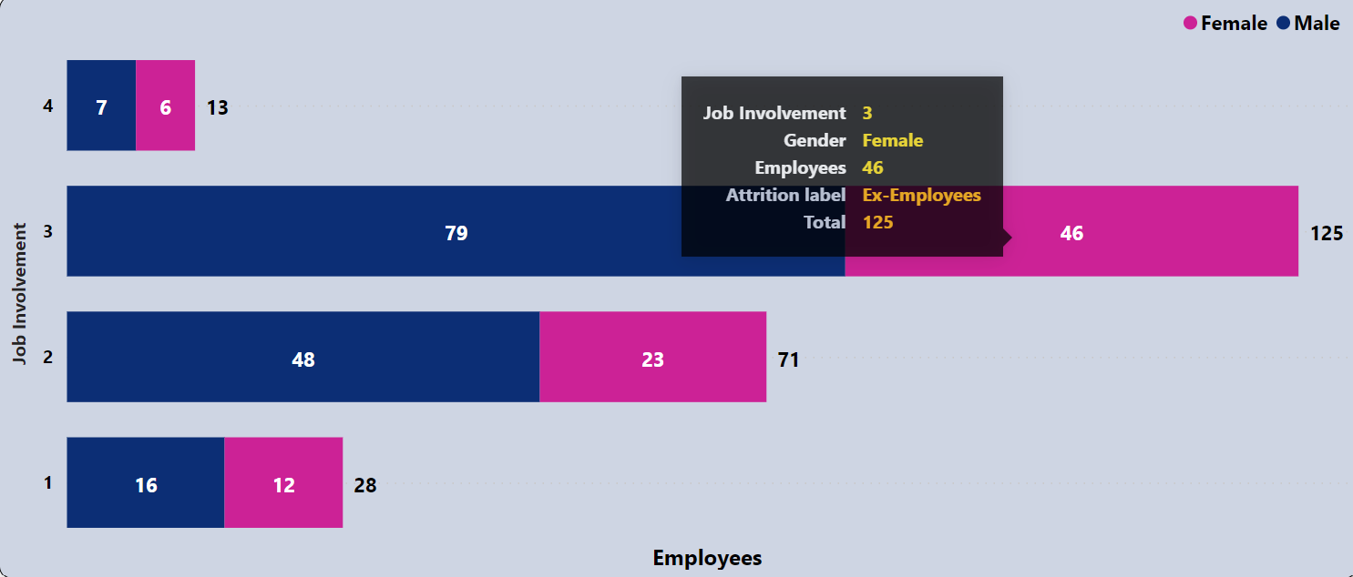

-- ji x total

select job_involvement_rating as rating_values,

count(*) as totol_count

from hr

where attrition_label = 'Ex-Employees'

group by rating_values

order by rating_values desc;

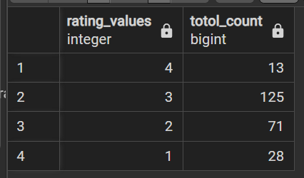

-- ji x male

select job_involvement_rating as rating_values,

count(*) as male_count

from hr

where attrition_label = 'Ex-Employees' and gender = 'Male'

group by rating_values

order by rating_values desc;

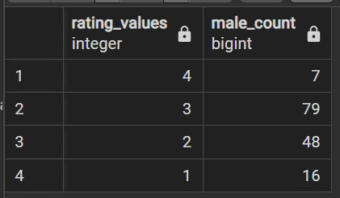

-- ji x female

select job_involvement_rating as rating_values,

count(*) as female_count

from hr

where attrition_label = 'Ex-Employees' and gender = 'Female'

group by rating_values

order by rating_values desc;

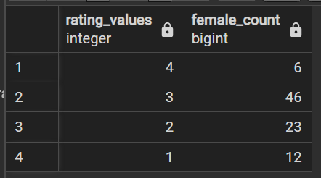

* **Employees by Environment Satisfaction**

**For Current Employees**

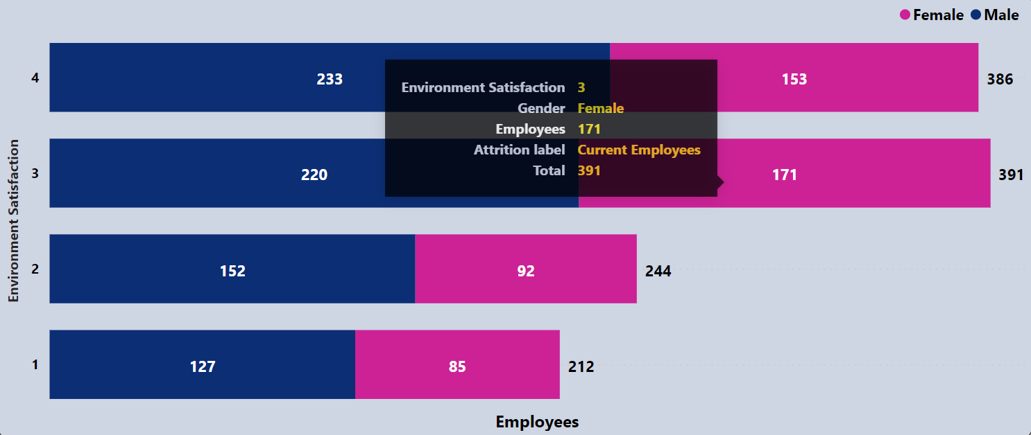

-- es curr total

select environment_satisfaction_rating as rating_values,

count(*) as totol_count

from hr

where attrition_label = 'Current Employees'

group by rating_values

order by rating_values desc;

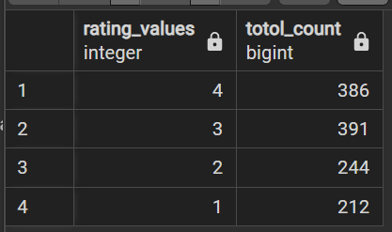

-- es curr male

select environment_satisfaction_rating as rating_values,

count(*) as male_count

from hr

where attrition_label = 'Current Employees' and gender = 'Male'

group by rating_values

order by rating_values desc;

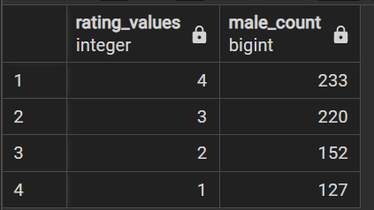

-- es curr female

select environment_satisfaction_rating as rating_values,

count(*) as female_count

from hr

where attrition_label = 'Current Employees' and gender = 'Female'

group by rating_values

order by rating_values desc;

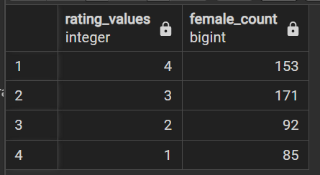

**For Ex-Employees**

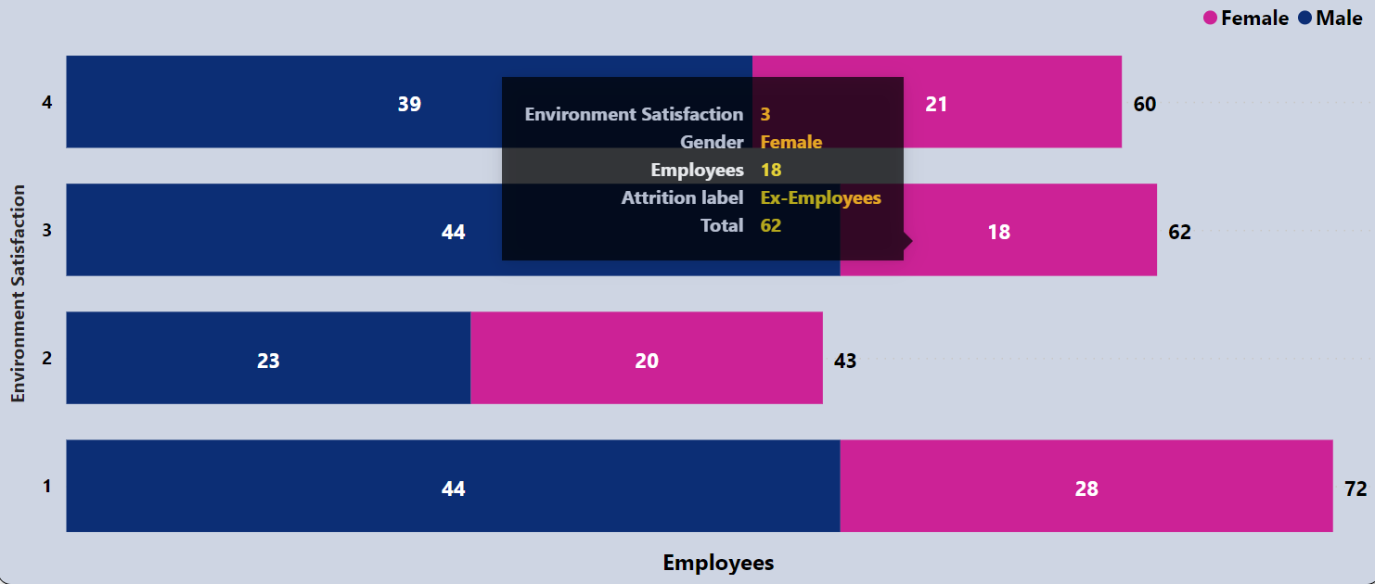

-- es x total

select environment_satisfaction_rating as rating_values,

count(*) as totol_count

from hr

where attrition_label = 'Ex-Employees'

group by rating_values

order by rating_values desc;

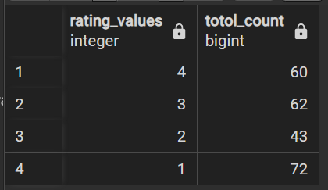

-- es x male

select environment_satisfaction_rating as rating_values,

count(*) as male_count

from hr

where attrition_label = 'Ex-Employees' and gender = 'Male'

group by rating_values

order by rating_values desc;

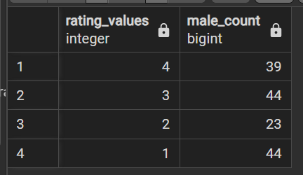

-- es x female

select environment_satisfaction_rating as rating_values,

count(*) as female_count

from hr

where attrition_label = 'Ex-Employees' and gender = 'Female'

group by rating_values

order by rating_values desc;

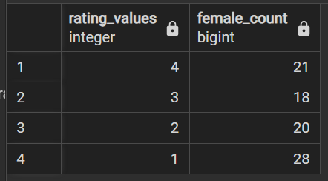

Average Rating Comparison

**Note**: For this segment, we’ve validated the output values of the dashboard only for the filter- “**Current Employees**”. Because, once we are done with the validation of this visualization for either filter, it will ensure that output values will also be accurate for another filter view.

1. **Work life Balance**

* **Average Rating of Work life Balance by Department**

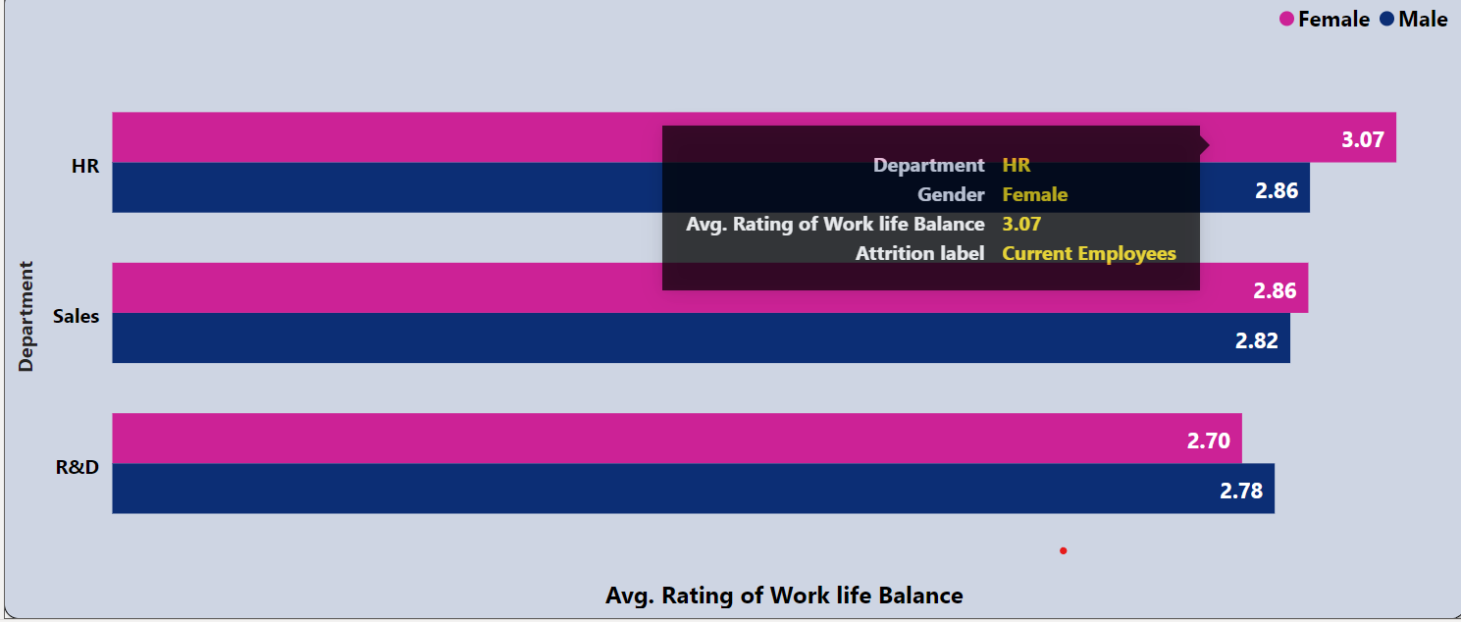

*with*

*hr as (*

*select e.*, s.*, r.* from*

*employees as e join salary as s on e.employee_id=s.emp_id*

*join ratings as r on e.employee_id=r.e_id*

*),*

*male as(*

*select department as category, round(avg(work_life_balance_rating), 2) as male_avg_rating*

*from hr*

*where gender = 'Male' and attrition_label = 'Current Employees'*

*group by category*

*),*

*female as(*

*select department as category, round(avg(work_life_balance_rating), 2) as female_avg_rating*

*from hr*

*where gender = 'Female' and attrition_label = 'Current Employees'*

*group by category*

*)*

*select female.*, male.male_avg_rating,*

*round( (female.female_avg_rating + male.male_avg_rating)/2, 2) as total_avg_rating*

*from male join female on male.category = female.category*

*order by total_avg_rating desc;*

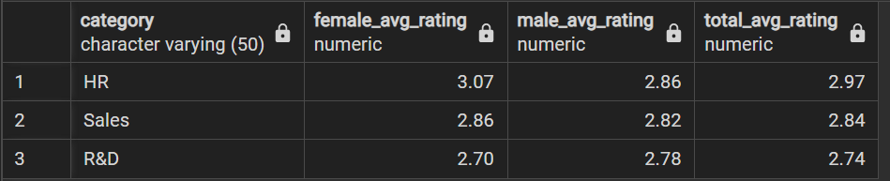

* **Average Rating of Work life Balance by Age Group**

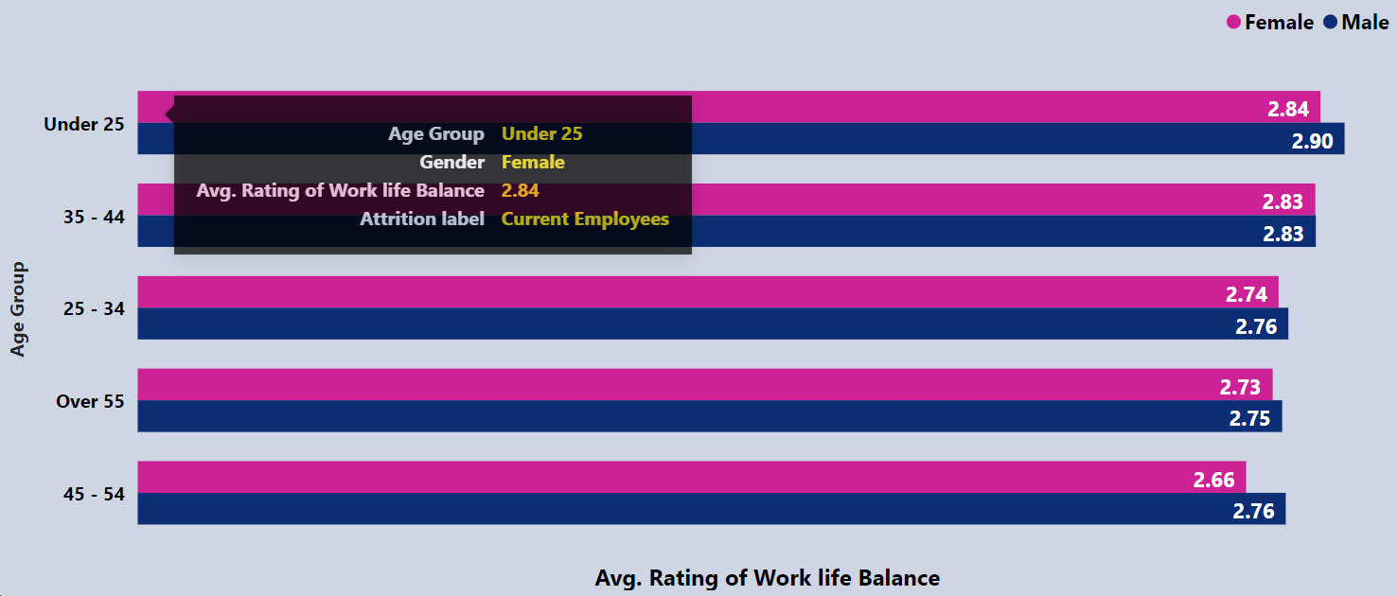

*with*

*hr as (*

*select e.*, s.*, r.* from*

*employees as e join salary as s on e.employee_id=s.emp_id*

*join ratings as r on e.employee_id=r.e_id*

*),*

*male as(*

*select age_group as category, round(avg(work_life_balance_rating), 2) as male_avg_rating*

*from hr*

*where gender = 'Male' and attrition_label = 'Current Employees'*

*group by category*

*),*

*female as(*

*select age_group as category, round(avg(work_life_balance_rating), 2) as female_avg_rating*

*from hr*

*where gender = 'Female' and attrition_label = 'Current Employees'*

*group by category*

*)*

*select female.*, male.male_avg_rating,*

*round( (female.female_avg_rating + male.male_avg_rating)/2, 2) as total_avg_rating*

*from male join female on male.category = female.category*

*order by total_avg_rating desc;*

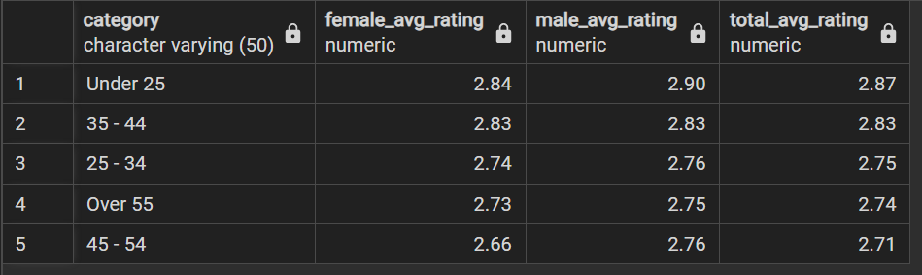

* **Average Rating of Work life Balance by Job Level**

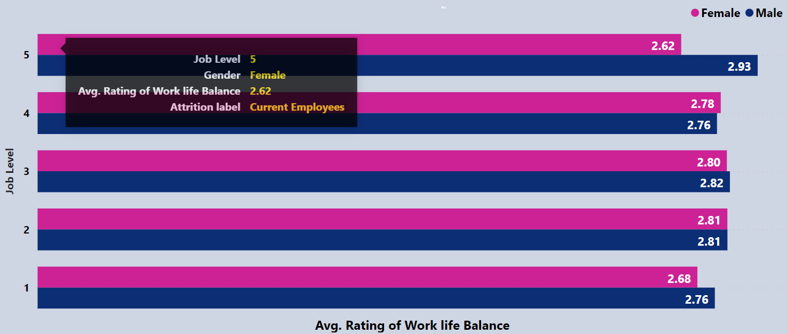

*with*

*hr as (*

*select e.*, s.*, r.* from*

*employees as e join salary as s on e.employee_id=s.emp_id*

*join ratings as r on e.employee_id=r.e_id*

*),*

*male as(*

*select job_level as category, round(avg(work_life_balance_rating), 2) as male_avg_rating*

*from hr*

*where gender = 'Male' and attrition_label = 'Current Employees'*

*group by category*

*),*

*female as(*

*select job_level as category, round(avg(work_life_balance_rating), 2) as female_avg_rating*

*from hr*

*where gender = 'Female' and attrition_label = 'Current Employees'*

*group by category*

*)*

*select female.*, male.male_avg_rating,*

*round( (female.female_avg_rating + male.male_avg_rating)/2, 2) as total_avg_rating*

*from male join female on male.category = female.category*

*order by female.category desc;*

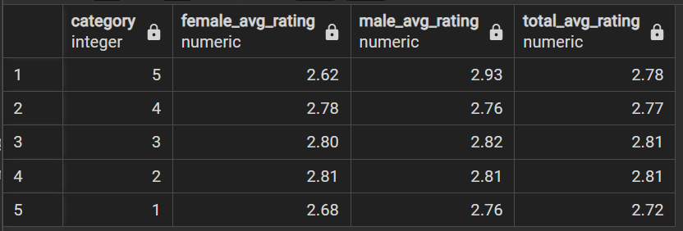

* **Average Rating of Work life Balance by Job Role**

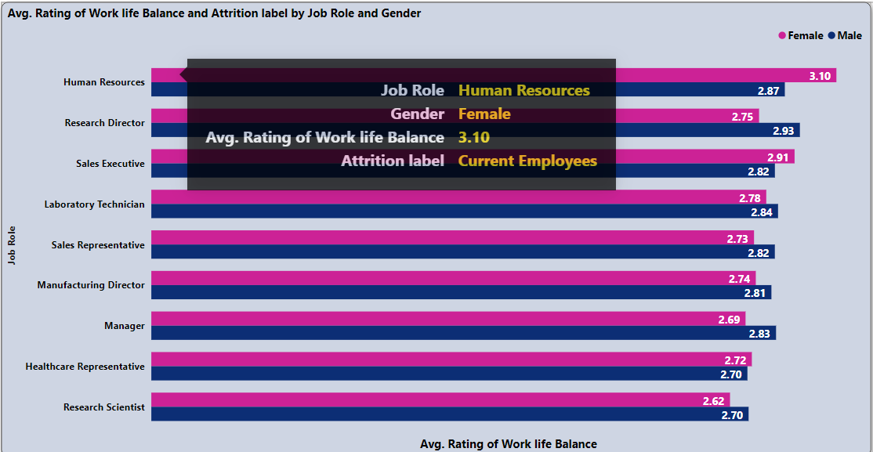

*with*

*hr as (*

*select e.*, s.*, r.* from*

*employees as e join salary as s on e.employee_id=s.emp_id*

*join ratings as r on e.employee_id=r.e_id*

*),*

*male as(*

*select job_role as category, round(avg(work_life_balance_rating), 2) as male_avg_rating*

*from hr*

*where gender = 'Male' and attrition_label = 'Current Employees'*

*group by category*

*),*

*female as(*

*select job_role as category, round(avg(work_life_balance_rating), 2) as female_avg_rating*

*from hr*

*where gender = 'Female' and attrition_label = 'Current Employees'*

*group by category*

*)*

*select female.*, male.male_avg_rating,*

*round( (female.female_avg_rating + male.male_avg_rating)/2, 2) as total_avg_rating*

*from male join female on male.category = female.category*

*order by total_avg_rating desc;*

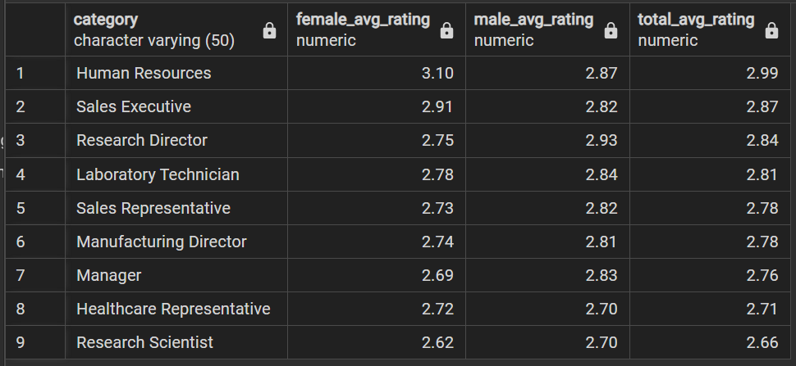

* **Average Rating of Work life Balance by Gender**

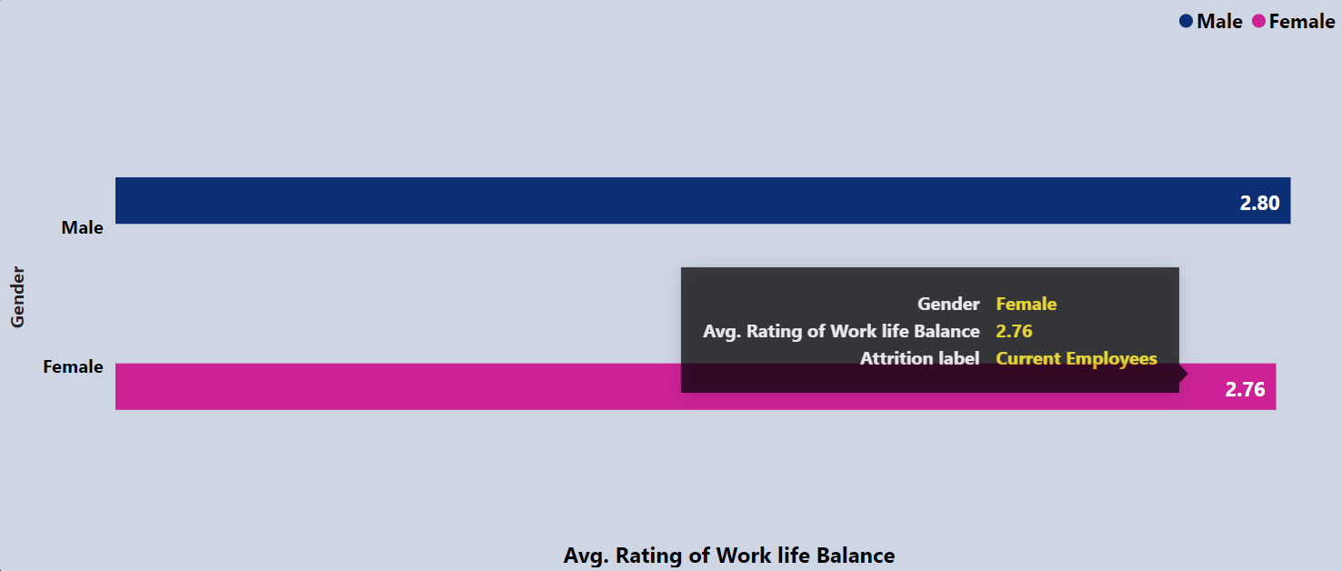

*with*

*hr as (*

*select e.*, s.*, r.* from*

*employees as e join salary as s on e.employee_id=s.emp_id*

*join ratings as r on e.employee_id=r.e_id*

*)*

*select gender as category, round(avg(work_life_balance_rating), 2 ) as avg_rating*

*from hr*

*where attrition_label ='Current Employees'*

*group by category*

*order by avg_rating desc;*

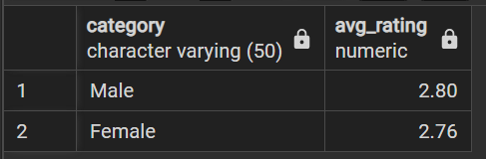

1. **Relationship Satisfaction**

* **Average Rating of Relationship Satisfaction by Department**

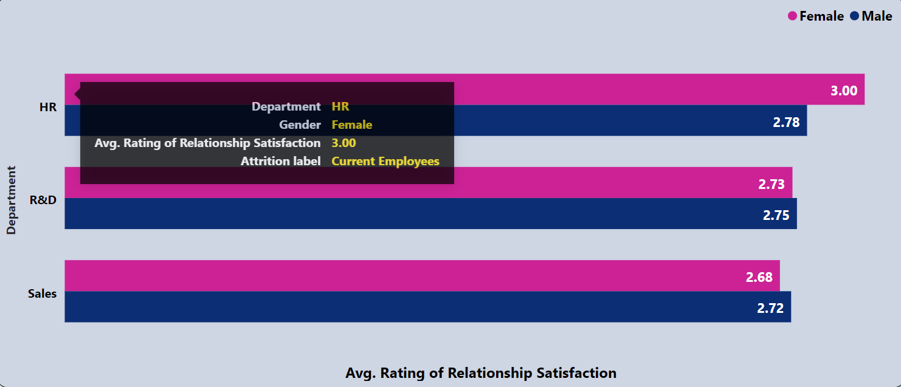

*with*

*hr as (*

*select e.*, s.*, r.* from*

*employees as e join salary as s on e.employee_id=s.emp_id*

*join ratings as r on e.employee_id=r.e_id*

*),*

*male as(*

*select department as category, round(avg(relationship_satisfaction_rating), 2) as male_avg_rating*

*from hr*

*where gender = 'Male' and attrition_label = 'Current Employees'*

*group by category*

*),*

*female as(*

*select department as category, round(avg(relationship_satisfaction_rating), 2) as female_avg_rating*

*from hr*

*where gender = 'Female' and attrition_label = 'Current Employees'*

*group by category*

*)*

*select female.*, male.male_avg_rating,*

*round( (female.female_avg_rating + male.male_avg_rating)/2, 2) as total_avg_rating*

*from male join female on male.category = female.category*

*order by total_avg_rating desc;*

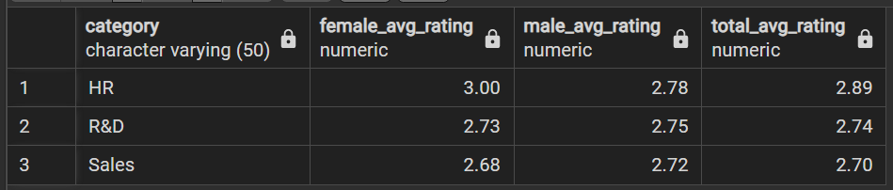

* **Average Rating of Relationship Satisfaction by Age Group**

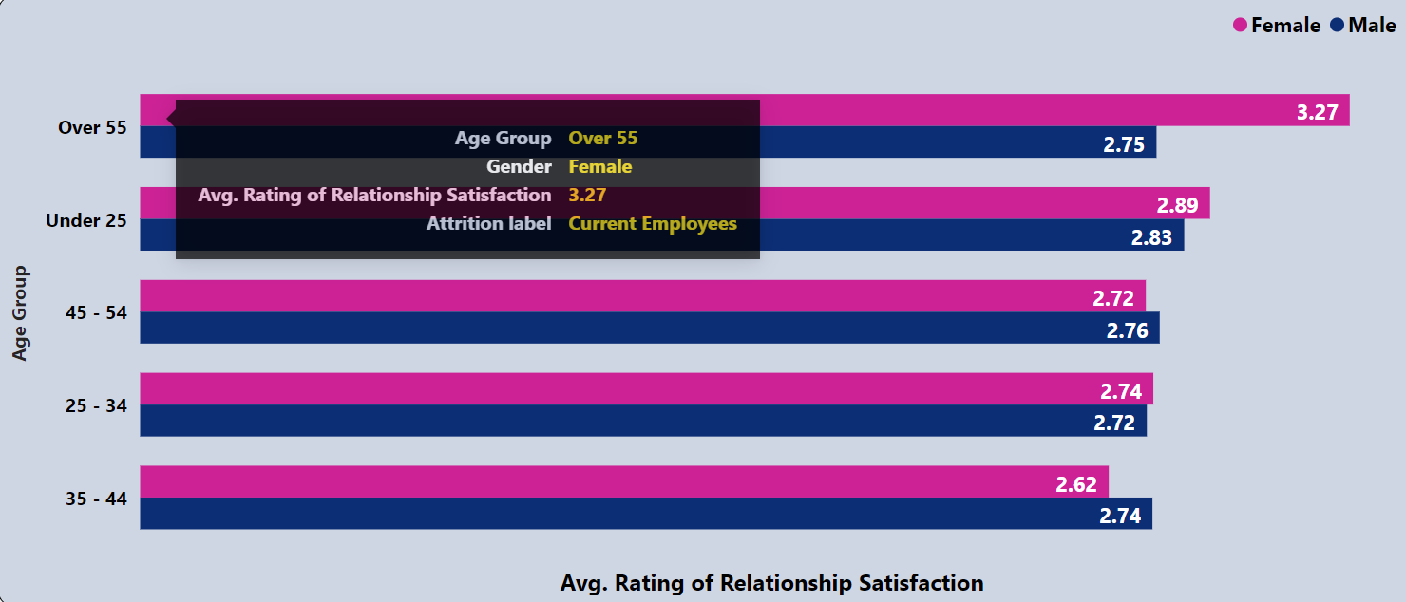

*with*

*hr as (*

*select e.*, s.*, r.* from*

*employees as e join salary as s on e.employee_id=s.emp_id*

*join ratings as r on e.employee_id=r.e_id*

*),*

*male as(*

*select age_group as category, round(avg(relationship_satisfaction_rating), 2) as male_avg_rating*

*from hr*

*where gender = 'Male' and attrition_label = 'Current Employees'*

*group by category*

*),*

*female as(*

*select age_group as category, round(avg(relationship_satisfaction_rating), 2) as female_avg_rating*

*from hr*

*where gender = 'Female' and attrition_label = 'Current Employees'*

*group by category*

*)*

*select female.*, male.male_avg_rating,*

*round( (female.female_avg_rating + male.male_avg_rating)/2, 2) as total_avg_rating*

*from male join female on male.category = female.category*

*order by total_avg_rating desc;*

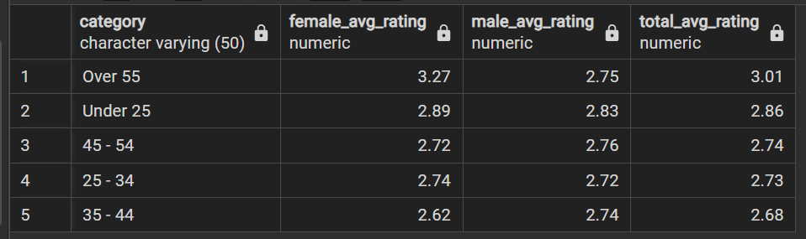

* **Average Rating of Relationship Satisfaction by Job Level**

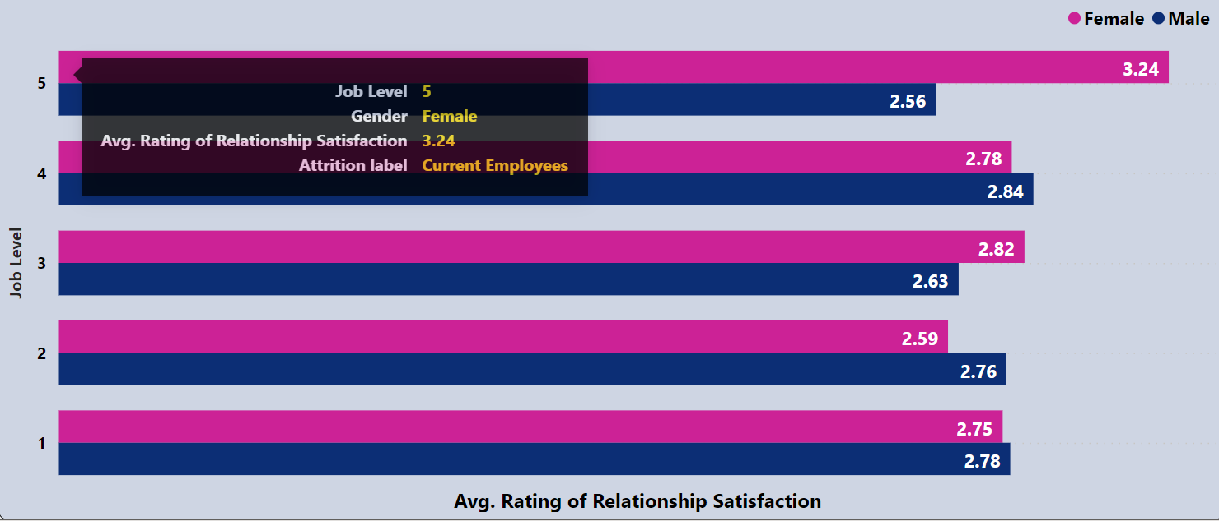

*with*

*hr as (*

*select e.*, s.*, r.* from*

*employees as e join salary as s on e.employee_id=s.emp_id*

*join ratings as r on e.employee_id=r.e_id*

*),*

*male as(*

*select job_level as category, round(avg(relationship_satisfaction_rating), 2) as male_avg_rating*

*from hr*

*where gender = 'Male' and attrition_label = 'Current Employees'*

*group by category*

*),*

*female as(*

*select job_level as category, round(avg(relationship_satisfaction_rating), 2) as female_avg_rating*

*from hr*

*where gender = 'Female' and attrition_label = 'Current Employees'*

*group by category*

*)*

*select female.*, male.male_avg_rating,*

*round( (female.female_avg_rating + male.male_avg_rating)/2, 2) as total_avg_rating*

*from male join female on male.category = female.category*

*order by female.category desc;*

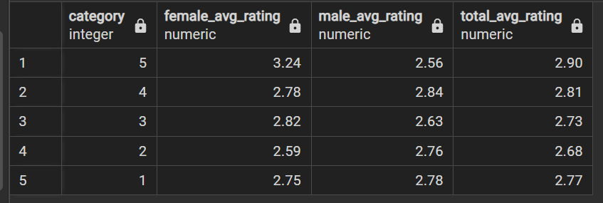

* **Average Rating of Relationship Satisfaction by Job Role**

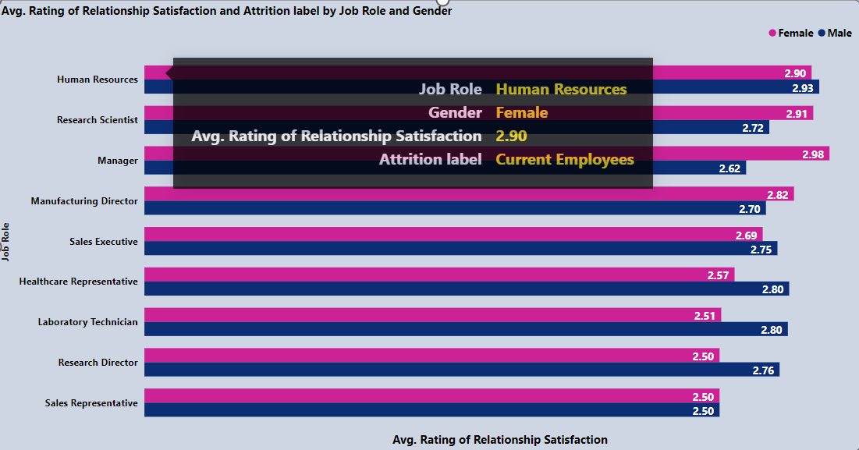

*with*

*hr as (*

*select e.*, s.*, r.* from*

*employees as e join salary as s on e.employee_id=s.emp_id*

*join ratings as r on e.employee_id=r.e_id*

*),*

*male as(*

*select job_role as category, round(avg(relationship_satisfaction_rating), 2) as male_avg_rating*

*from hr*

*where gender = 'Male' and attrition_label = 'Current Employees'*

*group by category*

*),*

*female as(*

*select job_role as category, round(avg(relationship_satisfaction_rating), 2) as female_avg_rating*

*from hr*

*where gender = 'Female' and attrition_label = 'Current Employees'*

*group by category*

*)*

*select female.*, male.male_avg_rating,*

*round( (female.female_avg_rating + male.male_avg_rating)/2, 2) as total_avg_rating*

*from male join female on male.category = female.category*

*order by total_avg_rating desc;*

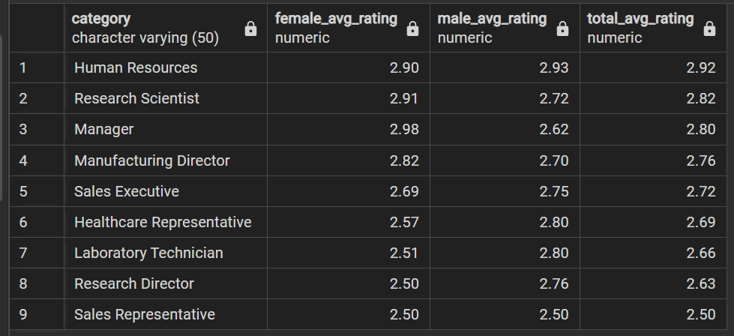

* **Average Rating of Relationship Satisfaction by Gender**

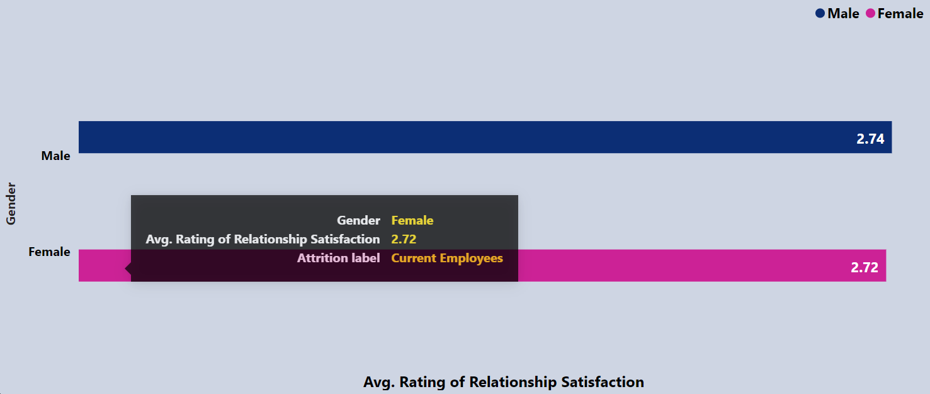

*with*

*hr as (*

*select e.*, s.*, r.* from*

*employees as e join salary as s on e.employee_id=s.emp_id*

*join ratings as r on e.employee_id=r.e_id*

*)*

*select gender as category, round(avg(relationship_satisfaction_rating), 2 ) as avg_rating*

*from hr*

*where attrition_label ='Current Employees'*

*group by category*

*order by avg_rating desc;*

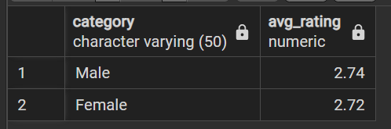

1. **Average Rating of Job Involvement**

* **Average Rating of Job Involvement by Department**

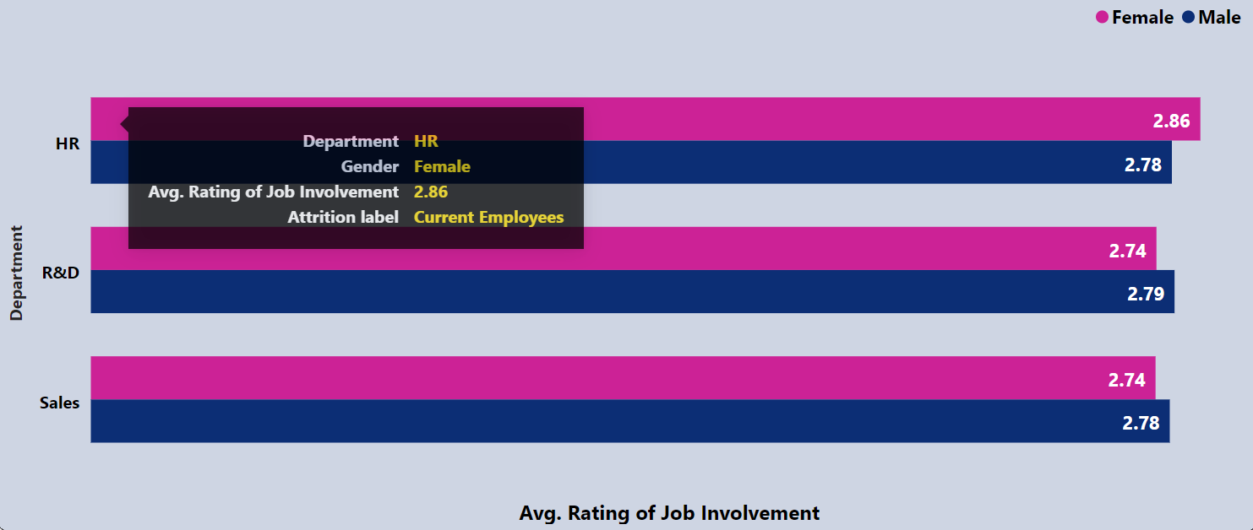

*with*

*hr as (*

*select e.*, s.*, r.* from*

*employees as e join salary as s on e.employee_id=s.emp_id*

*join ratings as r on e.employee_id=r.e_id*

*),*

*male as(*

*select department as category, round(avg(job_involvement_rating), 2) as male_avg_rating*

*from hr*

*where gender = 'Male' and attrition_label = 'Current Employees'*

*group by category*

*),*

*female as(*

*select department as category, round(avg(job_involvement_rating), 2) as female_avg_rating*

*from hr*

*where gender = 'Female' and attrition_label = 'Current Employees'*

*group by category*

*)*

*select female.*, male.male_avg_rating,*

*round( (female.female_avg_rating + male.male_avg_rating)/2, 2) as total_avg_rating*

*from male join female on male.category = female.category*

*order by total_avg_rating desc;*

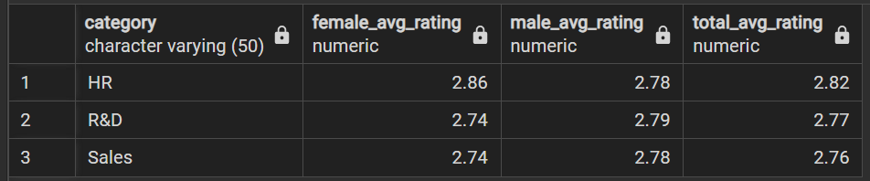

* **Average Rating of Job Involvement by Age Group**

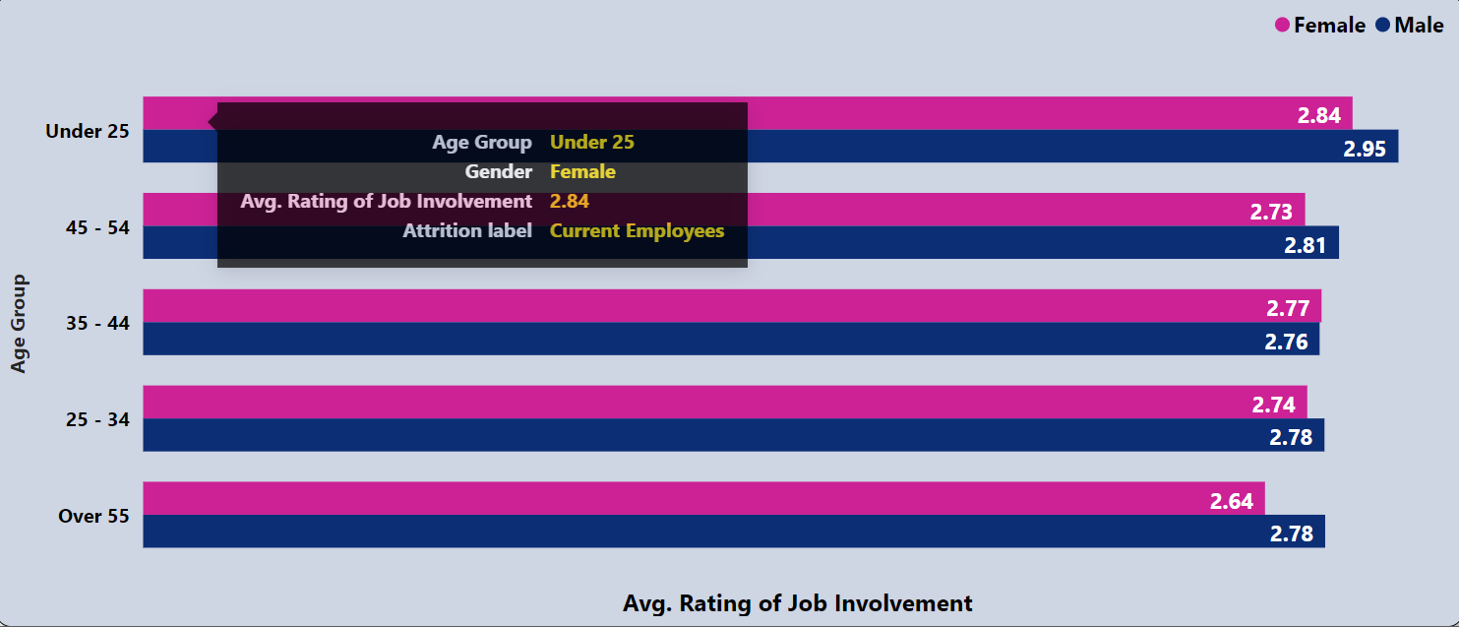

*with*

*hr as (*

*select e.*, s.*, r.* from*

*employees as e join salary as s on e.employee_id=s.emp_id*

*join ratings as r on e.employee_id=r.e_id*

*),*

*male as(*

*select age_group as category, round(avg(job_involvement_rating), 2) as male_avg_rating*

*from hr*

*where gender = 'Male' and attrition_label = 'Current Employees'*

*group by category*

*),*

*female as(*

*select age_group as category, round(avg(job_involvement_rating), 2) as female_avg_rating*

*from hr*

*where gender = 'Female' and attrition_label = 'Current Employees'*

*group by category*

*)*

*select female.*, male.male_avg_rating,*

*round( (female.female_avg_rating + male.male_avg_rating)/2, 2) as total_avg_rating*

*from male join female on male.category = female.category*

*order by total_avg_rating desc;*

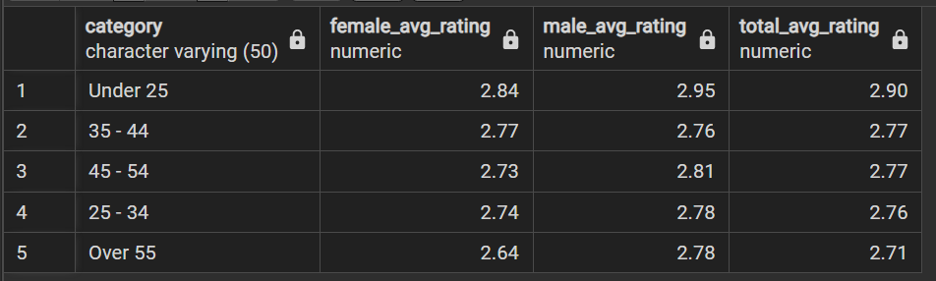

* **Average Rating of Job Involvement by Job Level**

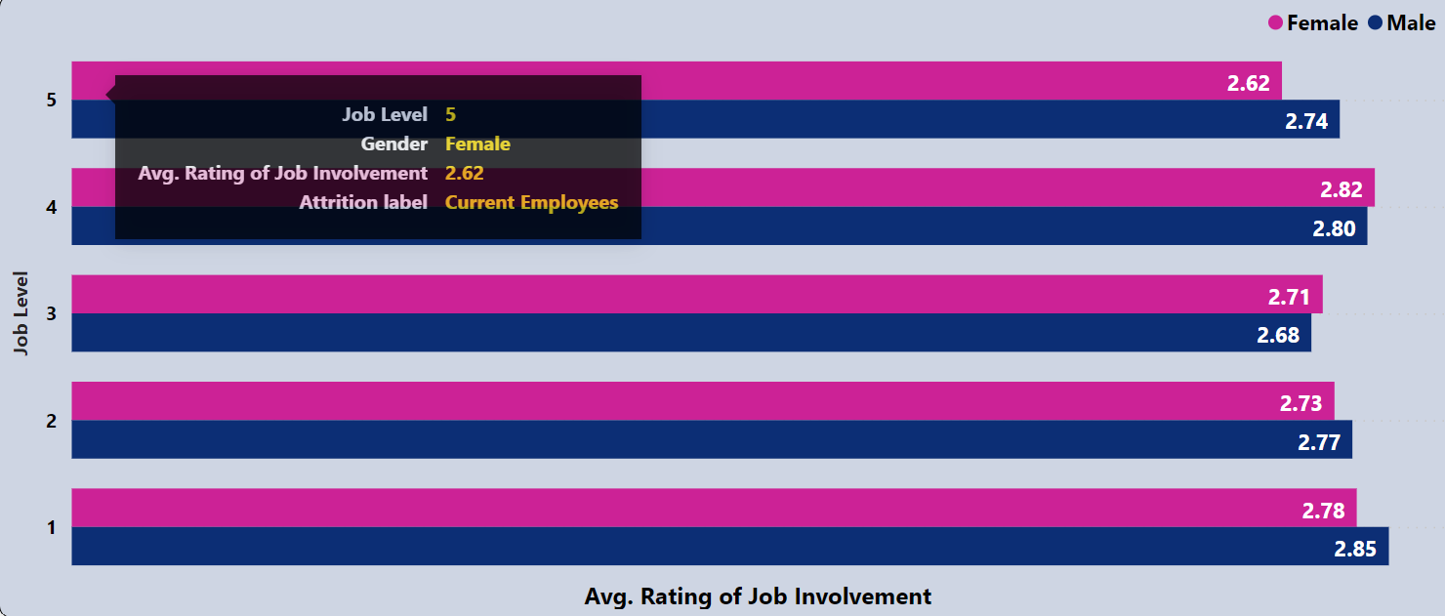

*with*

*hr as (*

*select e.*, s.*, r.* from*

*employees as e join salary as s on e.employee_id=s.emp_id*

*join ratings as r on e.employee_id=r.e_id*

*),*

*male as(*

*select job_level as category, round(avg(job_involvement_rating), 2) as male_avg_rating*

*from hr*

*where gender = 'Male' and attrition_label = 'Current Employees'*

*group by category*

*),*

*female as(*

*select job_level as category, round(avg(job_involvement_rating), 2) as female_avg_rating*

*from hr*

*where gender = 'Female' and attrition_label = 'Current Employees'*

*group by category*

*)*

*select female.*, male.male_avg_rating,*

*round( (female.female_avg_rating + male.male_avg_rating)/2, 2) as total_avg_rating*

*from male join female on male.category = female.category*

*order by female.category desc;*

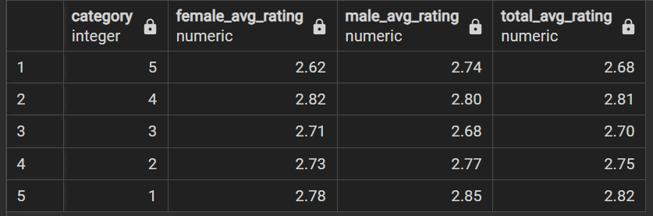

* **Average Rating of Job Involvement by Job Role**

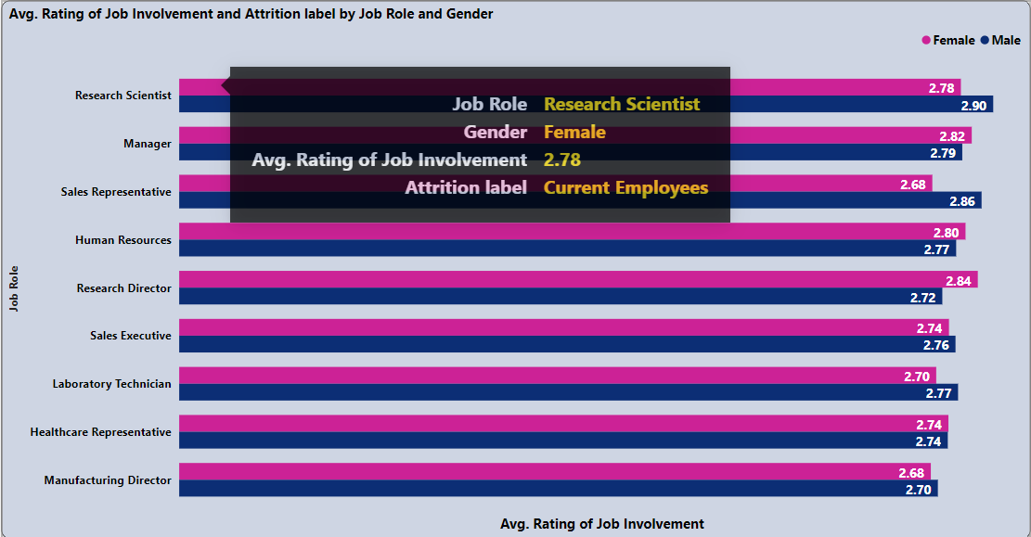

*with*

*hr as (*

*select e.*, s.*, r.* from*

*employees as e join salary as s on e.employee_id=s.emp_id*

*join ratings as r on e.employee_id=r.e_id*

*),*

*male as(*

*select job_role as category, round(avg(job_involvement_rating), 2) as male_avg_rating*

*from hr*

*where gender = 'Male' and attrition_label = 'Current Employees'*

*group by category*

*),*

*female as(*

*select job_role as category, round(avg(job_involvement_rating), 2) as female_avg_rating*

*from hr*

*where gender = 'Female' and attrition_label = 'Current Employees'*

*group by category*

*)*

*select female.*, male.male_avg_rating,*

*round( (female.female_avg_rating + male.male_avg_rating)/2, 2) as total_avg_rating*

*from male join female on male.category = female.category*

*order by total_avg_rating desc;*

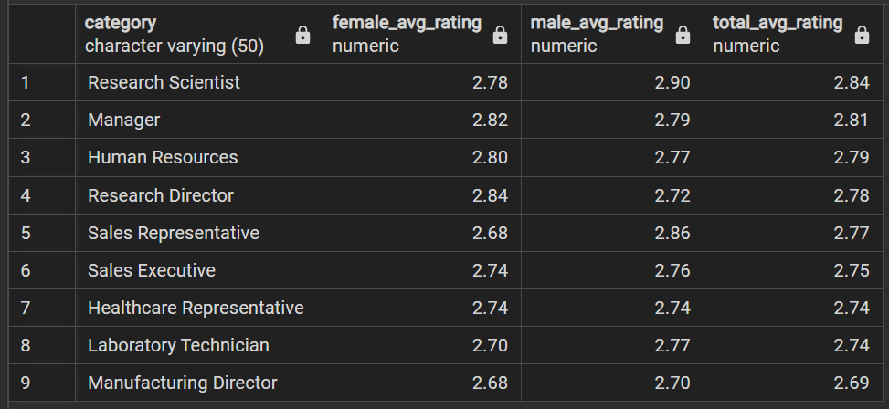

* **Average Rating of Job Involvement by Gender**

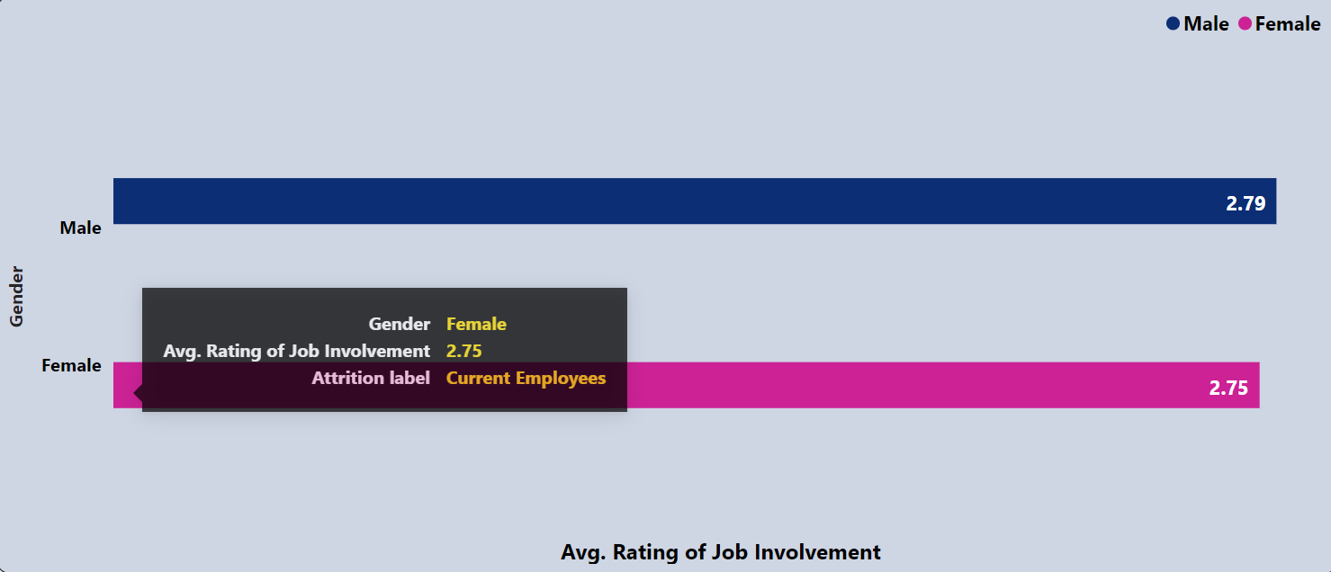

*with*

*hr as (*

*select e.*, s.*, r.* from*

*employees as e join salary as s on e.employee_id=s.emp_id*

*join ratings as r on e.employee_id=r.e_id*

*)*

*select gender as category, round(avg(job_involvement_rating), 2 ) as avg_rating*

*from hr*

*where attrition_label ='Current Employees'*

*group by category*

*order by avg_rating desc;*

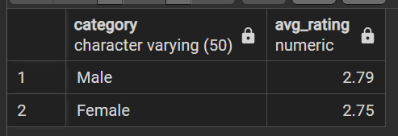

1. **Average Rating of Jon Satisfaction**

* **Average Rating of Job Satisfaction t by Department**

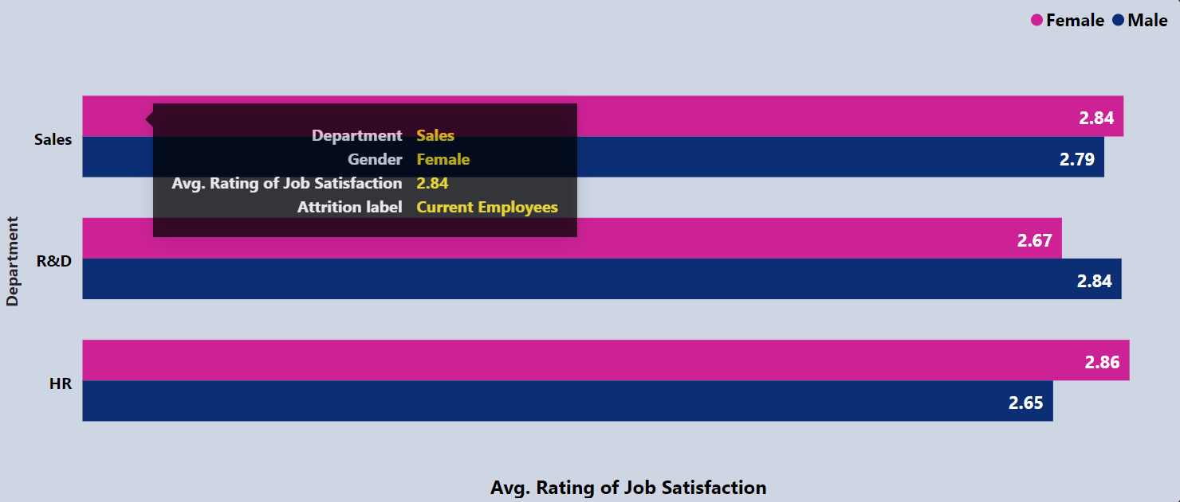

*with*

*hr as (*

*select e.*, s.*, r.* from*

*employees as e join salary as s on e.employee_id=s.emp_id*

*join ratings as r on e.employee_id=r.e_id*

*),*

*male as(*

*select department as category, round(avg(job_satisfaction_rating), 2) as male_avg_rating*

*from hr*

*where gender = 'Male' and attrition_label = 'Current Employees'*

*group by category*

*),*

*female as(*

*select department as category, round(avg(job_satisfaction_rating), 2) as female_avg_rating*

*from hr*

*where gender = 'Female' and attrition_label = 'Current Employees'*

*group by category*

*)*

*select female.*, male.male_avg_rating,*

*round( (female.female_avg_rating + male.male_avg_rating)/2, 2) as total_avg_rating*

*from male join female on male.category = female.category*

*order by total_avg_rating desc;*

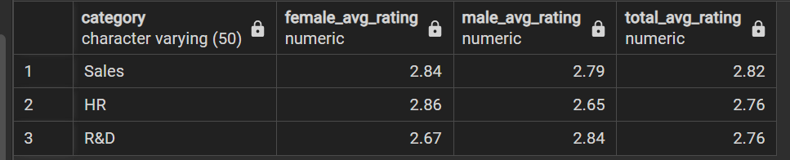

* **Average Rating of Job Satisfaction by Age Group**

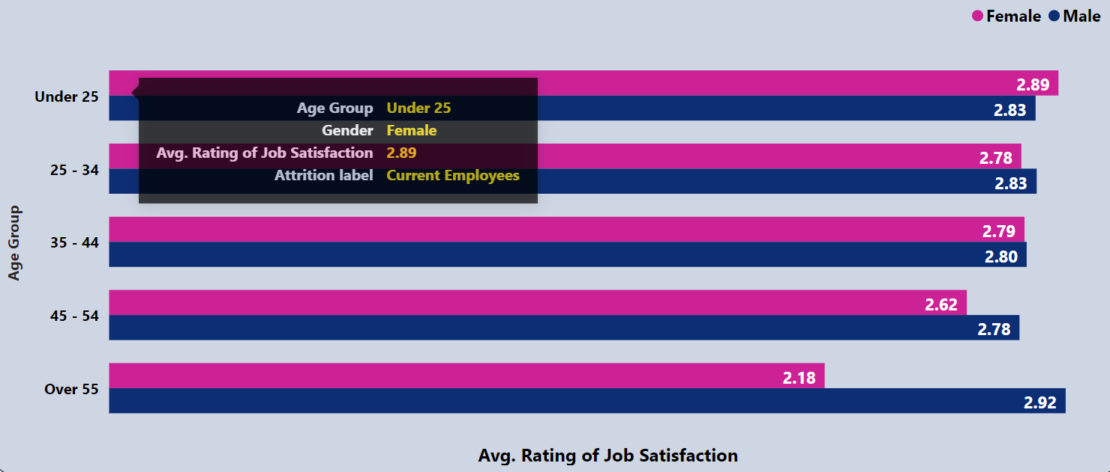

*with*

*hr as (*

*select e.*, s.*, r.* from*

*employees as e join salary as s on e.employee_id=s.emp_id*

*join ratings as r on e.employee_id=r.e_id*

*),*

*male as(*

*select age_group as category, round(avg(job_satisfaction_rating), 2) as male_avg_rating*

*from hr*

*where gender = 'Male' and attrition_label = 'Current Employees'*

*group by category*

*),*

*female as(*

*select age_group as category, round(avg(job_satisfaction_rating), 2) as female_avg_rating*

*from hr*

*where gender = 'Female' and attrition_label = 'Current Employees'*

*group by category*

*)*

*select female.*, male.male_avg_rating,*

*round( (female.female_avg_rating + male.male_avg_rating)/2, 2) as total_avg_rating*

*from male join female on male.category = female.category*

*order by total_avg_rating desc;*

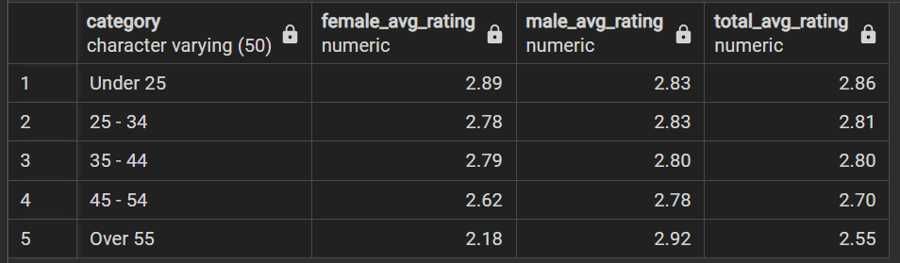

* **Average Rating of Job Satisfaction by Job Level**

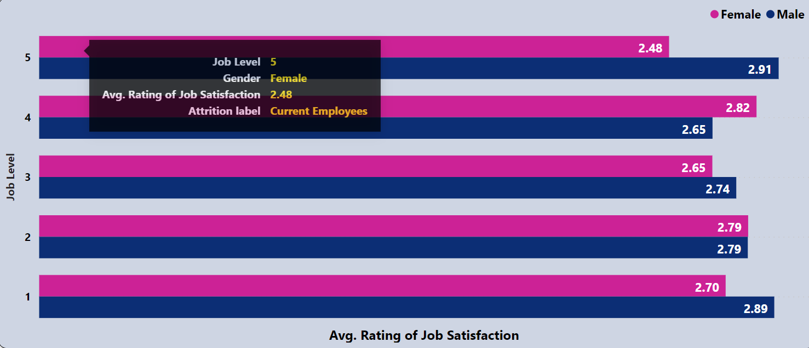

*with*

*hr as (*

*select e.*, s.*, r.* from*

*employees as e join salary as s on e.employee_id=s.emp_id*

*join ratings as r on e.employee_id=r.e_id*

*),*

*male as(*

*select job_level as category, round(avg(job_satisfaction_rating), 2) as male_avg_rating*

*from hr*

*where gender = 'Male' and attrition_label = 'Current Employees'*

*group by category*

*),*

*female as(*

*select job_level as category, round(avg(job_satisfaction_rating), 2) as female_avg_rating*

*from hr*

*where gender = 'Female' and attrition_label = 'Current Employees'*

*group by category*

*)*

*select female.*, male.male_avg_rating,*

*round( (female.female_avg_rating + male.male_avg_rating)/2, 2) as total_avg_rating*

*from male join female on male.category = female.category*

*order by female.category desc;*

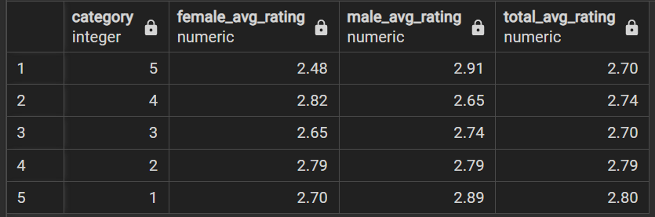

* **Average Rating of Job Satisfaction by Job Role**

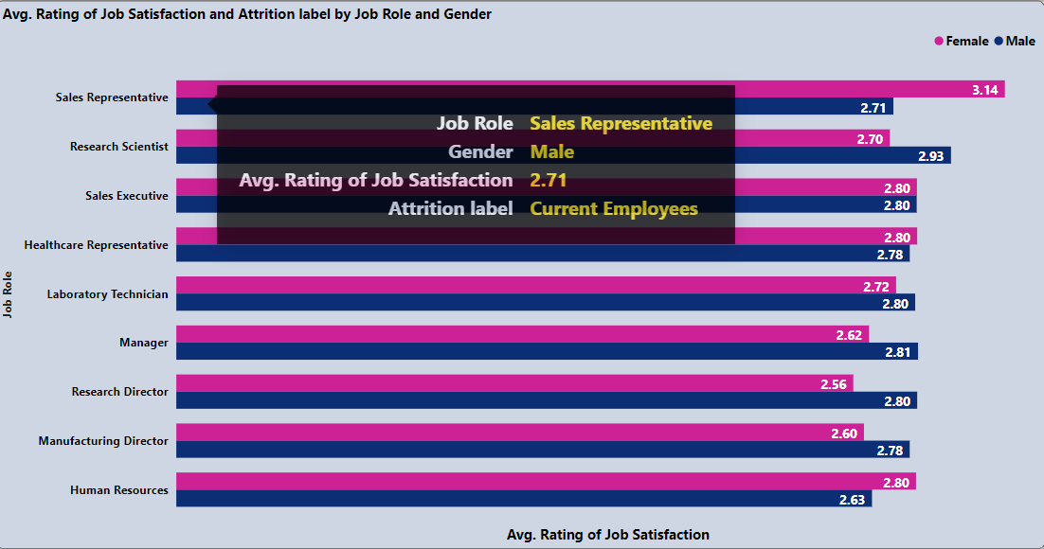

*with*

*hr as (*

*select e.*, s.*, r.* from*

*employees as e join salary as s on e.employee_id=s.emp_id*

*join ratings as r on e.employee_id=r.e_id*

*),*

*male as(*

*select job_role as category, round(avg(job_satisfaction_rating), 2) as male_avg_rating*

*from hr*

*where gender = 'Male' and attrition_label = 'Current Employees'*

*group by category*

*),*

*female as(*

*select job_role as category, round(avg(job_satisfaction_rating), 2) as female_avg_rating*

*from hr*

*where gender = 'Female' and attrition_label = 'Current Employees'*

*group by category*

*)*

*select female.*, male.male_avg_rating,*

*round( (female.female_avg_rating + male.male_avg_rating)/2, 2) as total_avg_rating*

*from male join female on male.category = female.category*

*order by total_avg_rating desc;*

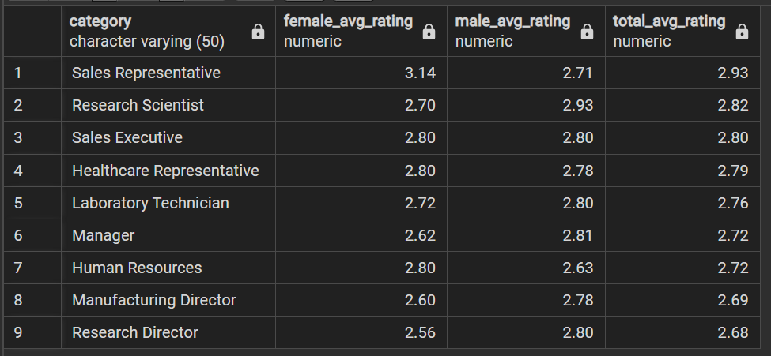

* **Average Rating of Job Satisfaction by Gender**

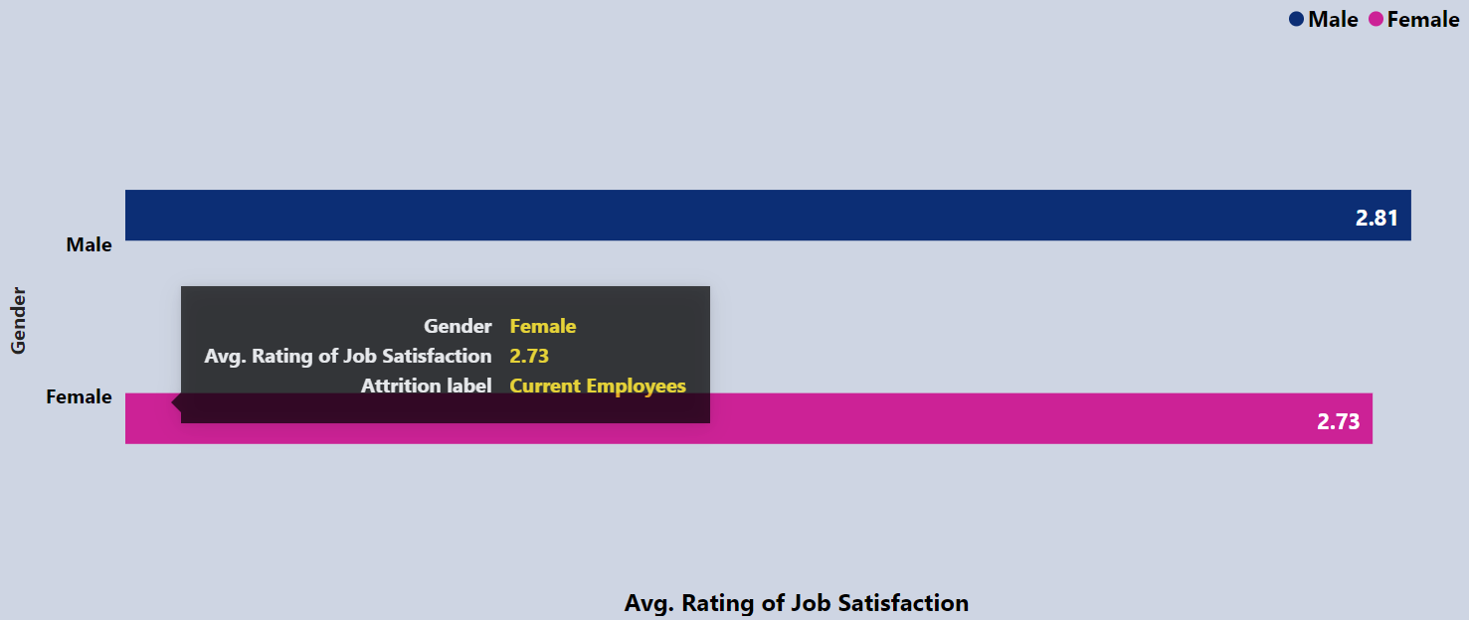

*with*

*hr as (*

*select e.*, s.*, r.* from*

*employees as e join salary as s on e.employee_id=s.emp_id*

*join ratings as r on e.employee_id=r.e_id*

*)*

*select gender as category, round(avg(job_satisfaction_rating), 2 ) as avg_rating*

*from hr*

*where attrition_label ='Current Employees'*

*group by category*

*order by avg_rating desc;*

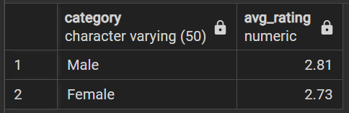

1. **Average Rating of Environment Satisfaction**

* **Average Rating of Environment Satisfaction t by Department**

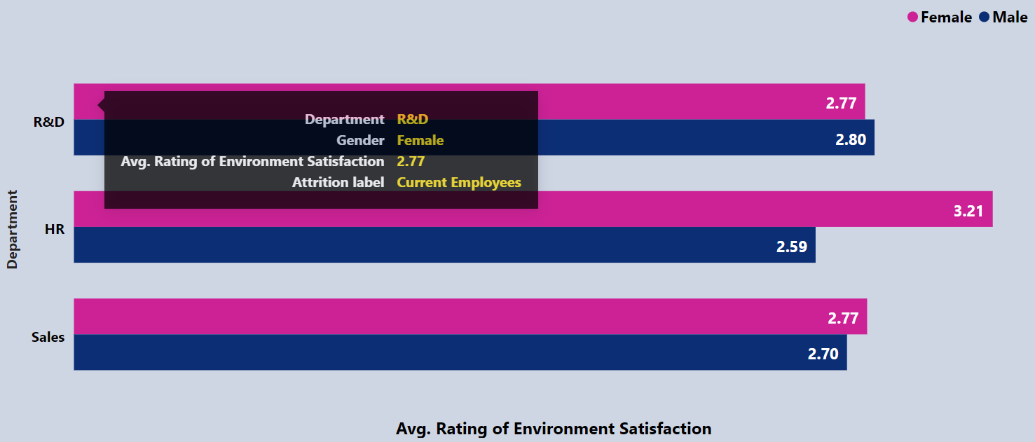

*with*

*hr as (*

*select e.*, s.*, r.* from*

*employees as e join salary as s on e.employee_id=s.emp_id*

*join ratings as r on e.employee_id=r.e_id*

*),*

*male as(*

*select department as category, round(avg(environment_satisfaction_rating), 2) as male_avg_rating*

*from hr*

*where gender = 'Male' and attrition_label = 'Current Employees'*

*group by category*

*),*

*female as(*

*select department as category, round(avg(environment_satisfaction_rating), 2) as female_avg_rating*

*from hr*

*where gender = 'Female' and attrition_label = 'Current Employees'*

*group by category*

*)*

*select female.*, male.male_avg_rating,*

*round( (female.female_avg_rating + male.male_avg_rating)/2, 2) as total_avg_rating*

*from male join female on male.category = female.category*

*order by total_avg_rating desc;*

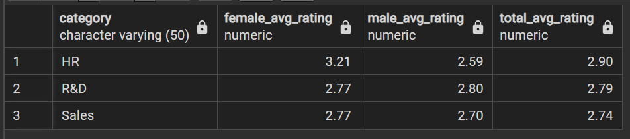

* **Average Rating of Environment Satisfaction by Age Group**

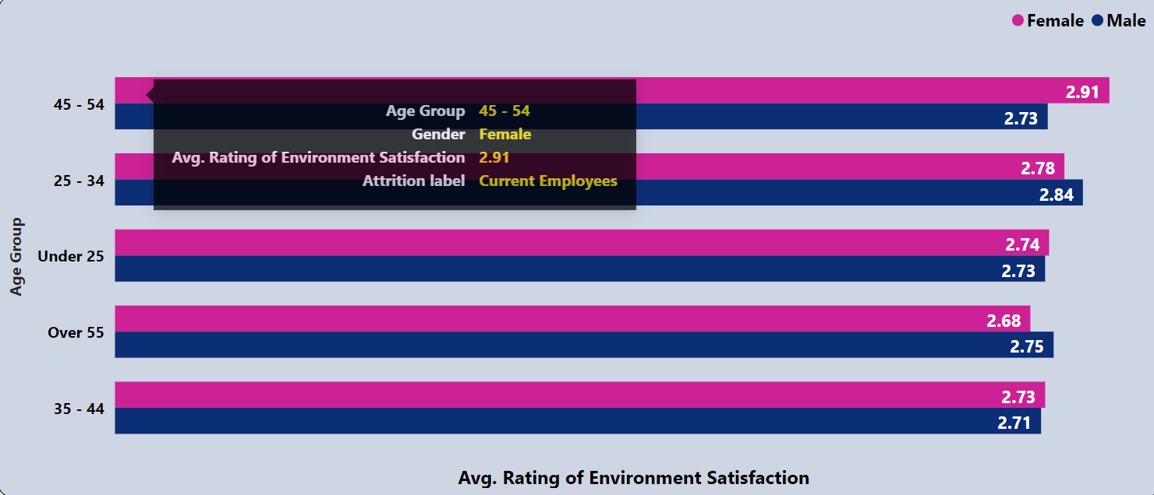

*with*

*hr as (*

*select e.*, s.*, r.* from*

*employees as e join salary as s on e.employee_id=s.emp_id*

*join ratings as r on e.employee_id=r.e_id*

*),*

*male as(*

*select age_group as category, round(avg(environment_satisfaction_rating), 2) as male_avg_rating*

*from hr*

*where gender = 'Male' and attrition_label = 'Current Employees'*

*group by category*

*),*

*female as(*

*select age_group as category, round(avg(environment_satisfaction_rating), 2) as female_avg_rating*

*from hr*

*where gender = 'Female' and attrition_label = 'Current Employees'*

*group by category*

*)*

*select female.*, male.male_avg_rating,*

*round( (female.female_avg_rating + male.male_avg_rating)/2, 2) as total_avg_rating*

*from male join female on male.category = female.category*

*order by total_avg_rating desc;*

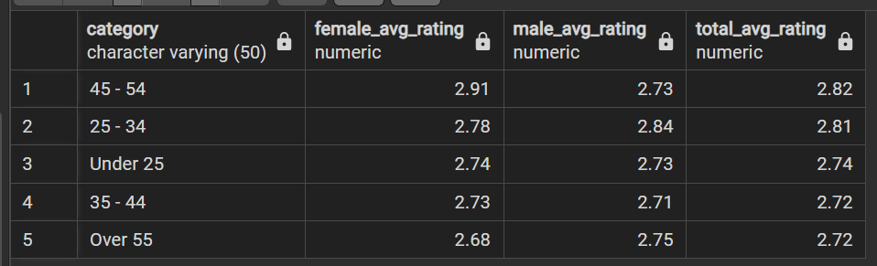

* **Average Rating of Environment Satisfaction by Job Level**

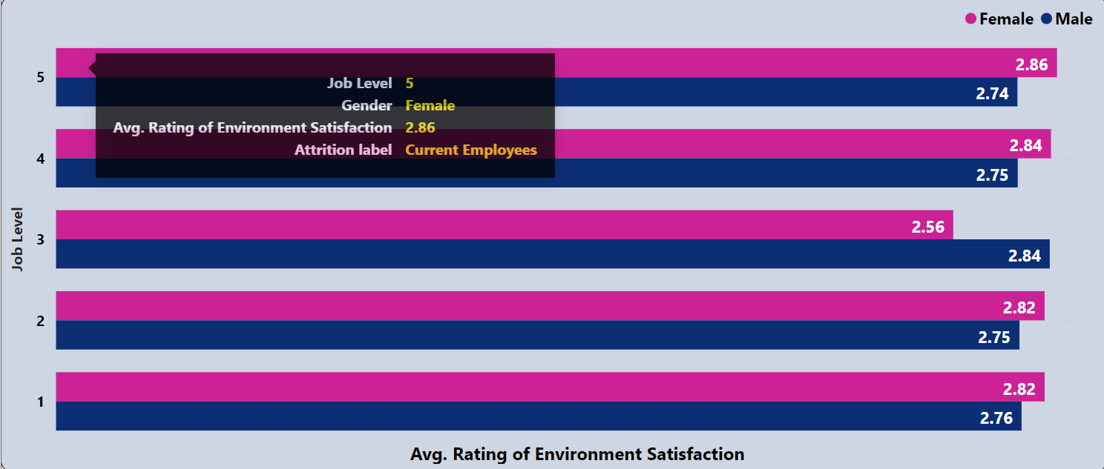

*with*

*hr as (*

*select e.*, s.*, r.* from*

*employees as e join salary as s on e.employee_id=s.emp_id*

*join ratings as r on e.employee_id=r.e_id*

*),*

*male as(*

*select job_level as category, round(avg(environment_satisfaction_rating), 2) as male_avg_rating*

*from hr*

*where gender = 'Male' and attrition_label = 'Current Employees'*

*group by category*

*),*

*female as(*

*select job_level as category, round(avg(environment_satisfaction_rating), 2) as female_avg_rating*

*from hr*

*where gender = 'Female' and attrition_label = 'Current Employees'*

*group by category*

*)*

*select female.*, male.male_avg_rating,*

*round( (female.female_avg_rating + male.male_avg_rating)/2, 2) as total_avg_rating*

*from male join female on male.category = female.category*

*order by female.category desc;*

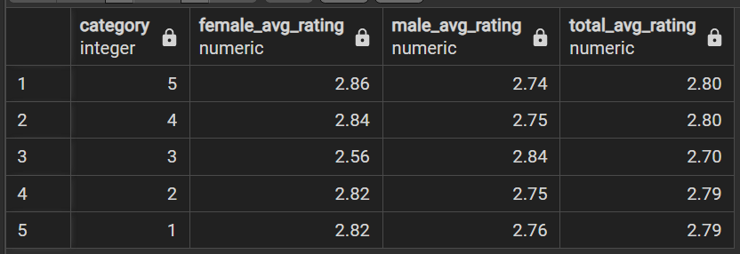

* **Average Rating of Environment Satisfaction by Job Role**

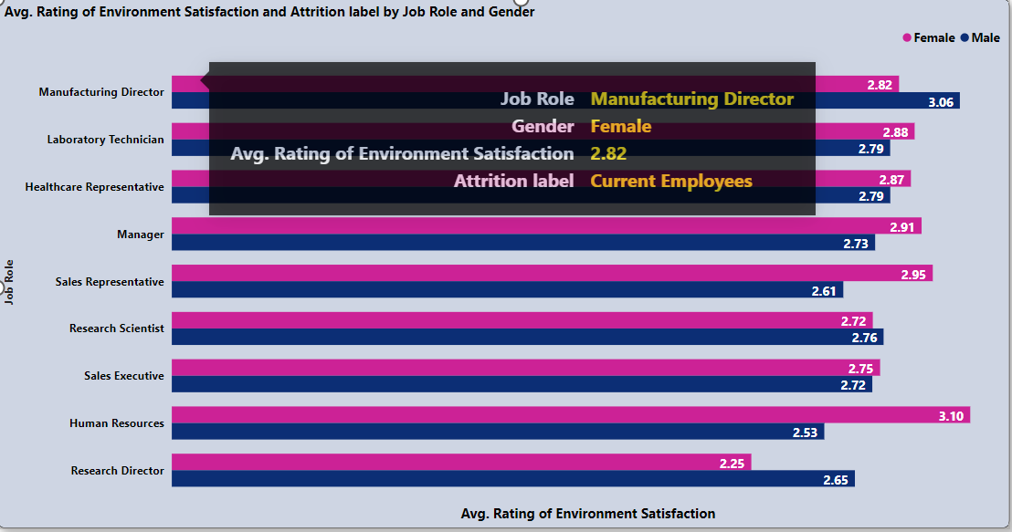

*with*

*hr as (*

*select e.*, s.*, r.* from*

*employees as e join salary as s on e.employee_id=s.emp_id*

*join ratings as r on e.employee_id=r.e_id*

*),*

*male as(*

*select job_role as category, round(avg(environment_satisfaction_rating), 2) as male_avg_rating*

*from hr*

*where gender = 'Male' and attrition_label = 'Current Employees'*

*group by category*

*),*

*female as(*

*select job_role as category, round(avg(environment_satisfaction_rating), 2) as female_avg_rating*

*from hr*

*where gender = 'Female' and attrition_label = 'Current Employees'*

*group by category*

*)*

*select female.*, male.male_avg_rating,*

*round( (female.female_avg_rating + male.male_avg_rating)/2, 2) as total_avg_rating*

*from male join female on male.category = female.category*

*order by total_avg_rating desc;*

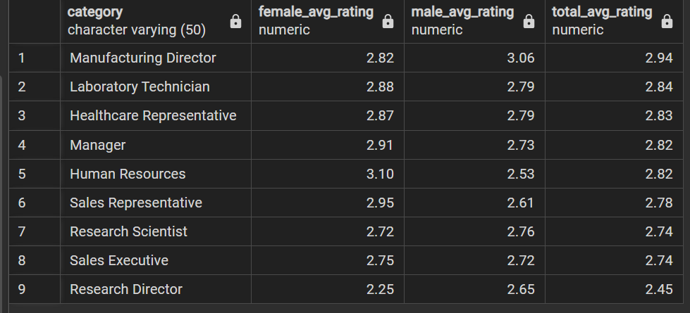

* **Average Rating of Environment Satisfaction by Gender**

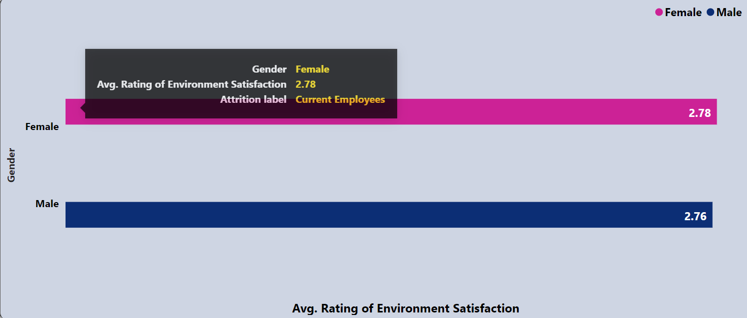

*with*

*hr as (*

*select e.*, s.*, r.* from*

*employees as e join salary as s on e.employee_id=s.emp_id*

*join ratings as r on e.employee_id=r.e_id*

*)*

*select gender as category, round(avg(environment_satisfaction_rating), 2 ) as avg_rating*

*from hr*

*where attrition_label ='Current Employees'*

*group by category*

*order by avg_rating desc;*



